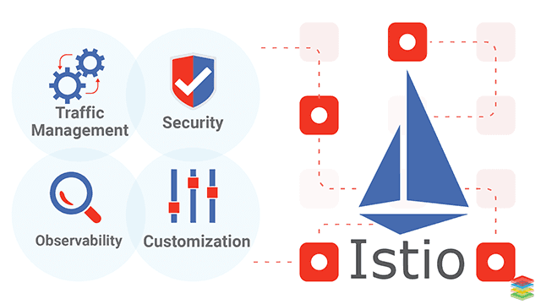

Contents

 *ISTIO* 3

Canary Testing and Rollouts with Istio 6

Launching a K8s Cluster on GCP 15

High Availability and Strategies with Deployments 29

Publishing Applications with Services 33

Pods – Units of Deployment 36

When to run more than one container in a Pod? 40

Kubernetes Internal Service Discovery 45

Assignment - Deploy application for shopping cart 56

Scaling Applications Manually and with a Autoscaler 61

Zero Downtime Deployment 67

Using kubectl – the CLI for Kubernetes 71

Deploying Istio Cluster with Google Kubernetes Engine 75

Setting up Google Cloud SDK for Istio 81

Validating Istios Telemetry Plugins 87

Deploy Canary Releases with Intelligent Routing 94

Testing Application Resiliency by Injecting a Fault 99

Zero Downtime Deployments with Weight based Routing 105

Traffic Routing and Deployment – Kubernetes vs Istio 108

Kubeadm: Bring Your Own Nodes (BYON) 118

Istio – Installation - Quick Start with Kubernetes 123

Quick Start with Google Kubernetes Engine 125

Deploy Sample App – Book Info 132

Managing Incoming and Outgoing Traffic to and from Istio Cluster 135

Configure incoming connections to Istio Cluster with Gateway 136

TroubleShooting Ingress Gateway 141

Enabling Outgoing Traffic with ServiceEntry 146

Understanding service to service communication in mesh 150

Deep dive into traffic forwarding rules for envoy proxy 159

Tracing routes from productpage to reviews with istio configurations 162

Importance of application resilience and use case 167

Configuring and handling service timeouts 170

Adding Circuit Breakers 173

Simulate real load in staging environments with Traffic Mirroring 181

Generating metrics and sending it to handlers 188

Querying Data with Prometheus 193

Troubleshooting apps with distributed tracing with Jaeger 195

Visualizing Metrics with Grafana 198

 MICROSERVICES 199

12 Factor Apps 199

Principles of MicroServices 206

## *ISTIO*

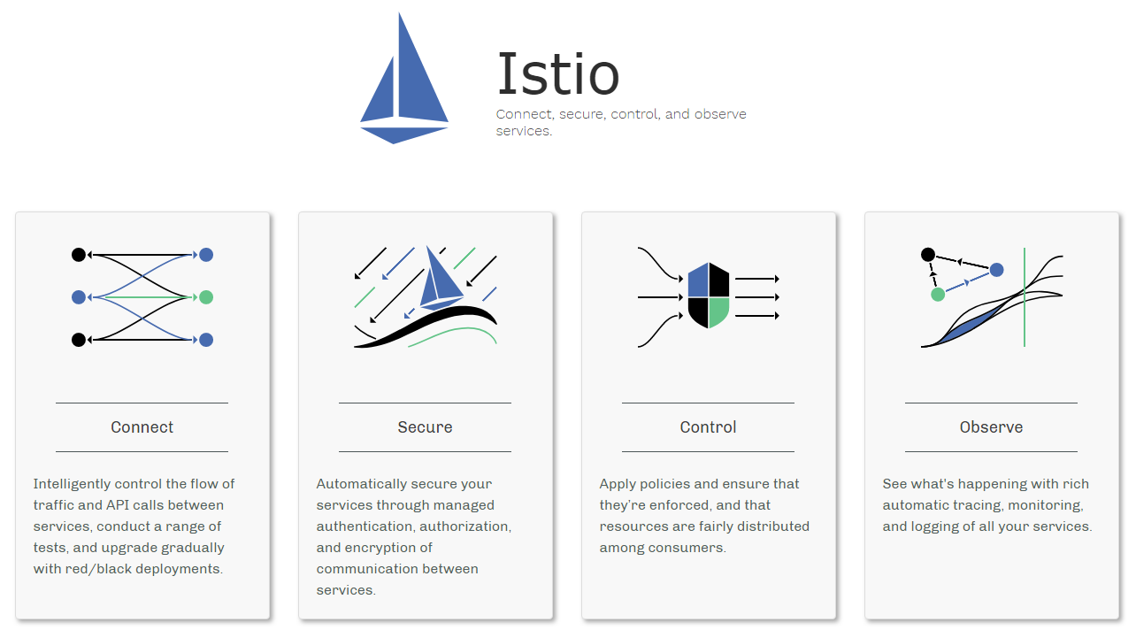

What is Istio?

Cloud platforms provide a wealth of benefits for the organizations that use them. There’s no denying, however, that adopting the cloud can put strains on DevOps teams. Developers must use microservices to architect for portability, meanwhile operators are managing extremely large hybrid and multi-cloud deployments. Istio lets you connect, secure, control, and observe services.

At a high level, Istio helps reduce the complexity of these deployments, and eases the strain on your development teams. It is a completely open source service mesh that layers transparently onto existing distributed applications. It is also a platform, including APIs that let it integrate into any logging platform, or telemetry or policy system. Istio’s diverse feature set lets you successfully, and efficiently, run a distributed microservice architecture, and provides a uniform way to secure, connect, and monitor microservices.

What is a service mesh?

Istio addresses the challenges developers and operators face as monolithic applications transition towards a distributed microservice architecture. To see how, it helps to take a more detailed look at Istio’s service mesh.

The term service mesh is used to describe the network of microservices that make up such applications and the interactions between them. As a service mesh grows in size and complexity, it can become harder to understand and manage. Its requirements can include discovery, load balancing, failure recovery, metrics, and monitoring. A service mesh also often has more complex operational requirements, like A/B testing, canary releases, rate limiting, access control, and end-to-end authentication.

Istio provides behavioral insights and operational control over the service mesh as a whole, offering a complete solution to satisfy the diverse requirements of microservice applications.

Why use Istio?

Istio makes it easy to create a network of deployed services with load balancing, service-to-service authentication, monitoring, and more, without any changes in service code. You add Istio support to services by deploying a special sidecar proxy throughout your environment that intercepts all network communication between microservices, then configure and manage Istio using its control plane functionality, which includes:

* Automatic load balancing for HTTP, gRPC, WebSocket, and TCP traffic.
* Fine-grained control of traffic behavior with rich routing rules, retries, failovers, and fault injection.
* A pluggable policy layer and configuration API supporting access controls, rate limits and quotas.
* Automatic metrics, logs, and traces for all traffic within a cluster, including cluster ingress and egress.
* Secure service-to-service communication in a cluster with strong identity-based authentication and authorization.
* Istio is designed for extensibility and meets diverse deployment needs.

Architecture

An Istio service mesh is logically split into a **data plane** and a **control plane**.

The **data plane** is composed of a set of intelligent proxies ([Envoy](https://www.envoyproxy.io/)) deployed as sidecars. These proxies mediate and control all network communication between microservices along with [Mixer](https://istio.io/docs/concepts/policies-and-telemetry/), a general-purpose policy and telemetry hub.

The **control plane** manages and configures the proxies to route traffic. Additionally, the control plane configures Mixers to enforce policies and collect telemetry.

The following diagram shows the different components that make up each plane:

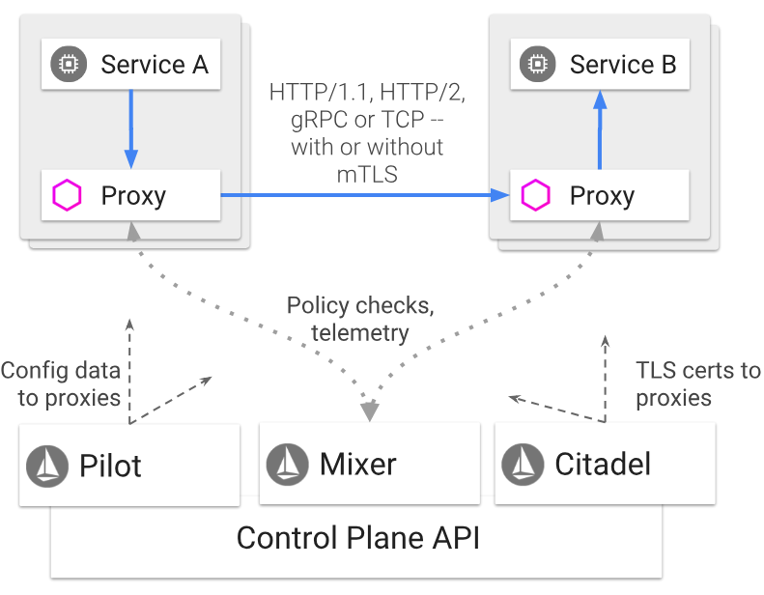

Envoy

Istio uses an extended version of the Envoy proxy. Envoy is a high-performance proxy developed in C++ to mediate all inbound and outbound traffic for all services in the service mesh. Istio leverages Envoy’s many built-in features, for example:

* Dynamic service discovery
* Load balancing
* TLS termination
* HTTP/2 and gRPC proxies
* Circuit breakers
* Health checks
* Staged rollouts with %-based traffic split
* Fault injection
* Rich metrics

Envoy is deployed as a sidecar to the relevant service in the same Kubernetes pod. This deployment allows Istio to extract a wealth of signals about traffic behavior as attributes. Istio can, in turn, use these attributes in Mixer to enforce policy decisions, and send them to monitoring systems to provide information about the behavior of the entire mesh.

The sidecar proxy model also allows you to add Istio capabilities to an existing deployment with no need to rearchitect or rewrite code. You can read more about why we chose this approach in our Design Goals.

Mixer

Mixer is a platform-independent component. Mixer enforces access control and usage policies across the service mesh, and collects telemetry data from the Envoy proxy and other services. The proxy extracts request level attributes, and sends them to Mixer for evaluation. You can find more information on this attribute extraction and policy evaluation in our Mixer Configuration documentation.

Mixer includes a flexible plugin model. This model enables Istio to interface with a variety of host environments and infrastructure backends. Thus, Istio abstracts the Envoy proxy and Istio-managed services from these details.

Pilot

Pilot provides service discovery for the Envoy sidecars, traffic management capabilities for intelligent routing (e.g., A/B tests, canary deployments, etc.), and resiliency (timeouts, retries, circuit breakers, etc.).

Pilot converts high level routing rules that control traffic behavior into Envoy-specific configurations, and propagates them to the sidecars at runtime. Pilot abstracts platform-specific service discovery mechanisms and synthesizes them into a standard format that any sidecar conforming with the Envoy data plane APIs can consume. This loose coupling allows Istio to run on multiple environments such as Kubernetes, Consul, or Nomad, while maintaining the same operator interface for traffic management.

Citadel

Citadel provides strong service-to-service and end-user authentication with built-in identity and credential management. You can use Citadel to upgrade unencrypted traffic in the service mesh. Using Citadel, operators can enforce policies based on service identity rather than on network controls. Starting from release 0.5, you can use Istio’s authorization feature to control who can access your services.

Galley

Galley validates user authored Istio API configuration on behalf of the other Istio control plane components. Over time, Galley will take over responsibility as the top-level configuration ingestion, processing and distribution component of Istio. It will be responsible for insulating the rest of the Istio components from the details of obtaining user configuration from the underlying platform (e.g. Kubernetes).

**Core features**

Istio provides a number of key capabilities uniformly across a network of services:

Traffic management

Istio’s easy rules configuration and traffic routing lets you control the flow of traffic and API calls between services. Istio simplifies configuration of service-level properties like circuit breakers, timeouts, and retries, and makes it a breeze to set up important tasks like A/B testing, canary rollouts, and staged rollouts with percentage-based traffic splits.

With better visibility into your traffic, and out-of-box failure recovery features, you can catch issues before they cause problems, making calls more reliable, and your network more robust – no matter what conditions you face.

Security

Istio’s security capabilities free developers to focus on security at the application level. Istio provides the underlying secure communication channel, and manages authentication, authorization, and encryption of service communication at scale. With Istio, service communications are secured by default, letting you enforce policies consistently across diverse protocols and runtimes – all with little or no application changes.

While Istio is platform independent, using it with Kubernetes (or infrastructure) network policies, the benefits are even greater, including the ability to secure pod-to-pod or service-to-service communication at the network and application layers.

Observability

Istio’s robust tracing, monitoring, and logging give you deep insights into your service mesh deployment. Gain a real understanding of how service performance impacts things upstream and downstream with Istio’s monitoring features, while its custom dashboards provide visibility into the performance of all your services and let you see how that performance is affecting your other processes.

Istio’s Mixer component is responsible for policy controls and telemetry collection. It provides backend abstraction and intermediation, insulating the rest of Istio from the implementation details of individual infrastructure backends, and giving operators fine-grained control over all interactions between the mesh and infrastructure backends.

All these features let you more effectively set, monitor, and enforce SLOs on services. Of course, the bottom line is that you can detect and fix issues quickly and efficiently.

Platform support

Istio is platform-independent and designed to run in a variety of environments, including those spanning Cloud, on-premise, Kubernetes, Mesos, and more. You can deploy Istio on Kubernetes, or on Nomad with Consul. Istio currently supports:

* Service deployment on Kubernetes
* Services registered with Consul
* Services running on individual virtual machines

Integration and customization

The policy enforcement component of Istio can be extended and customized to integrate with existing solutions for ACLs, logging, monitoring, quotas, auditing, and more.

### Canary Testing and Rollouts with Istio

So what people do in coal mines is they put these special boards in there so that they get affected much before the humans do with them. They are sensitive to the carbon monoxide and these are toxic gases. And what happens there is if there is an increase in threshold which is dangerous to the human life it gets detected before with those kinds of these birds. Now if you are a wild life and desist you're not going to like this concept. But that is how it works in real life. Now coming back to the world of software delivery, how does this relate here.

While doing our application deployments this way, let's say you have an application running in production environment. And this is running for 100 percent of your clients on 100 percent of infrastructure and then if we want to release a new version. Now before you deploy this new version and before we do this for all the clients, we want to enable it on probably just a subset of like 20 percent off line. And those are your canneries here right now. How do you achieve this is the question.

And that's where Istio can help us a lot, it is capable of reading the headers from the requests these entire HTTP or GRPC or any of the requests. And based on certain headers on certain clients it can route the traffic to kubernetes. For example if the request comes from say a user X, it actually gets redirected to the 20%. All the other requests from all the other users go to your regular deployment which is 80 percent. Now there are many ways to do this intelligently. And based on different criteria as an attribute of your request it could be based on certain users. It could be based on certain agents.

Let's say you want to route all the traffic come coming from Android agents to the Canary Releases, you can do that or you may want to do that based on based on certain type of request or based on certain region or in or certain users coming from that particular country or you can actually parse the request and based on that you can do this intelligently now.

Can you do this with K8s is the next question. Well it is possible to do it without you as well. But the real question is what it takes to achieve that. And that is where Istio has an advantage because everyone else can do it and K8s can as well. But you will have to make application level changes in order for this to work. You have to write your own logic to that. But in case of Istio this is built into Istio. If we have set up Istio – Control & Data Plane then this is available for you out of the box. And that is the real advantage of using Istio. How does Istio do that, so every part every service, every pod will have an Envoy proxy and that proxy is the one which is managing the traffic here and the Canary testing and rules are sent by a control plane component of Istio called as Pilot. It is this component pilot which is responsible for converting so you define the rules for Canary and those rules get translated into per service specific configuration through that component called as pilot. Now again to summarize, this is what Istio allows you to do in canary testing and then stage rollouts and it can allow you to do that without changing your application.

Resiliency

Let's talk about resiliency. It's very important for your application and the services and your side to be resilient to the failures. Your site and services should intelligently handle the failures. Now one of the features that history offers us for failure handling is what I'm going to talk about in this review. And for that I'm going to take a use case off one of the largest online retailers in India that's Flipkart. Now if you look at Flipkart, Flipkart announces a ‘big billion day’ every year where they have millions of transactions a day. And how do they handle this traffic. How they have made their services resilient is a story which is really interesting because when they launch it for the first year or first time in 2014, their site went down and it was an effect of one of their services going down. Generally if you look at an e-commerce platform you have a lot of services working together. That is a front-end application, there's a card application and when you go to the catalog use you have a different service. If you are logged in you have a service which manages the users. If you are logged in as a particular user, you get recommendations specific to you or your own interest on your search history. That is another service; there is a recommendations service out there. I want to make the transaction. That is a service to manage that checkout process. There is a service which kind of the shipping and so on and so forth. These are services that there's a mesh of services which are inter-connected and so on.

Let's assume that one of your services goes down. How does that affect your other services it might lead to a complete site being down as well? And also that is what happened in the case of Flipkart as well in the first year. But if you look at how they have resolved these issues over the period of time, this year in 2018 they have released an article online in which they mentioned is - let's say if they have a lot of traffic that goes beyond their threshold and there infrastructure is being exhausted. What they simply do is just shut down one of their services. It can be a service which is non-critical. Let's say personalization if you don't see your recommendations for your specific interest it is OK. You're still able to buy something during the sale and do the check out. That's going to be enough. So how do all the other services handle that when the service goes down is what we are talking about. How do services handle failure is where there are three or four features which are quite interesting from Istio point of view. So what you can actually define do is define Timeout between the services. If you can define a reasonable timeout, so let's say there is a few seconds or milliseconds for a response to be back from the service. If not I'm going to timeout. I want to consider that service as not available and handle that failure, maybe not showing that particular feature. That's quite easy, so your site should be up but that feature may not be available. That's quite reasonable to have, that’s quite OK to have that feature.

The second feature is Retries. Now let's assume that you have a service which is connecting to some external API or maybe there is Uber application which is connected to the Maps API which is outside. And if that API is not available there are chances of network failures and all the other issues right now. If your application is connecting to this and if the service is not available momentarily you don't want to show the error on the client side. The clients can wait for a bit and you can actually retry maybe after a few seconds and then get that data back. By that time if the services are available it will still work. So it is also important to have those retries built into your application. Now again coming back to just you know all this goes inside the application that’s the best part. All of these features are available at the infrastructure level through Istio. So your application doesn’t have to define the timeouts. You don’t have to define the retries. You can do that in Istio. That's the good part.

Similarly you also have circuit breakers. Circuit Breakers are basically if say you have a capacity of you know 5000 requests here. If it goes beyond that, you really need to start scaling it. If you start sending more traffic to it, it would becomes slow adding latency to complete application, so you may want to have a circuit breaker which gets triggered if the threshold crosses, then you can you know define the set of rules and the handlers for that kind of a situation.

And another feature that Istio also has from the resiliency testing and making application resilient point of view is Load Balancing. Let's say if you have two instances of this application or let's say we have three and this needs to connect to this so it will keep track of each and every instance and the load balancing is happening at every services level. Again all of this happens to through Envoy as a proxy which runs with your service and then Pilot which is on the Istio control plane side. Now these are the features we talked about four features – Timeouts, Retries, Circuit Breakers & Intelligent load balancing with health checks that Istio offers to add resiliency and failure handling to your site.

Fault Injection – Simulating Realistic Issues to test service Resilience

Let's talk about fault injection in Istio and this is one of my favorite features of you Istio. Now a lot of you might have heard that Netflix introduced Chaos Monkey software. Now what Netflix does and how does it test the reliability and resiliency of its applications. Because Netflix will have a bunch of services, there are multiple services which are inter-connected and working together. So what they do is they have a software especially sitting there and just knocking off the services randomly and just come destroy or shut down some server and the key part here is to test what happens and how does it affect, whether it has a cascading effect to rest of the applications or if it automatically gets mitigated and those kind of things. And this is where this fault injection feature of Istio comes in because you don't need Chaos Monkey to do that, Istio is capable of doing that in automated way and it can actually simulate, it can help you simulate real world situations and problems which is really interesting because in real world what things can go wrong with certain services based on network issue, It could be a service problem. It is maybe you are getting all loaded now. How does your application behave, when that happens? If you best start it is hard to do it without a service like this. And this is where Istio adds a lot of value.

For example if you have let's say you have an application, there's a front end and there are multiple services then each request goes through and connects with maybe different services. Now what happens if there is a delay? Let's say there is a 20 second delay at this leg of your traffic or what happens if one of the services is not available. How do you test that, how your system behaves when this goes down, or your application is not available or whether application is intelligent enough to handle that failure. That is what you want. You may want to test with this fault injection feature of Istio, and talking of fault injection, it has two types of fault injection that it can introduce, one is Delay or it can be an Abort. It can either be a delay or it can be abort. Now who does that? Which component does that is? Again most of the four most of the features that envoi proxy and it's true is you know involved for sure. And apart from that on the control plane you have a service called pilot which converts these rules into actual configurations and asks Envoy to introduce the fault either Abort or Delay. And that's quite useful and interesting. And this is really useful for making your applications resilient by testing them with realistic scenarios. And that is what Fault Injection in Istio is all about.

Mirroring – Testing new versions with Production Traffic

Let's talk about Traffic Mirroring which is another interesting feature of Istio. Now why is this useful and where it is really useful in this scenario, let's consider this basically, let's say we have application running in production with some live traffic. This is your life traffic is and this is where all the action is happening now. Let's imagine you have created a new version. Again you are either deploying it in a staging environment or you are doing some Canary rollouts out in production. That idea is you want to really test it whether it actually works or whether it would actually work in real production environment or not. Now how do you test it. Because in staging we try to simulate the production like load and environment but it's not always possible to do that. A lot of times we also run some low test benchmarking test and so on and so forth. But none of that is a real traffic or real environment with this concept of mirroring in Istio, this becomes really easy. And what you can do here is whatever traffic is being sent here actually gets mirrored in this environment as well. And this is transparent to the user, users don't even know about this. Their traffic is being served out of one particular set of servers. What you're essentially doing is when a request goes here it also gets duplicated to the other particular environment as well. So basically what you're trying to do here are you're trying to test your pre-production or staging environment or before you run it on all the other servers. If you want to test it with or simulate the real or not even simulate to you are testing it with the reload. You can use this mirroring feature of Istio and that's I believe is quite interesting.

Observability – Debugging Effectively with Telemetry Data

Let's talk about Observability and issue observability our telemetry is a very important part of troubleshooting debugging and getting to know what is happening with your applications. Let's take this example and one of the hardest things as part of being or the WAPs and OPS guy of the most difficult parts I have found is troubleshooting the application level issues. I've tried using new Relique and applications like that which are quite useful but again that still remains one of the hardest and difficult parts for all the troubleshooting and or you know debugging part of you. You can get to know information about system monitoring network issues, network monitoring logs as well. But the actual time you spend so let's take this example. Let's say you have an application which show and every request that you send to your about location follows multiple services. It has probably five services and it has to go and connect with each of that. Now there are situations when the request will stop either in or it will take really long time there's a high latency and you've released a new version of your application and suddenly the latency has gone up.

So how do you troubleshoot those kinds of issues? You really want to find out where the problem is you need to be able to pinpoint there. So you will have to have an audit if you have a tool which gives you exactly this. How long it took Let's say this took you know two seconds and this two are two milliseconds, this is 20 milliseconds and this is you know and milliseconds but this is where the problem is it has actually gone up to 300 milliseconds. Now we are able to point out where the problem is you can actually go and start looking at the logs here. You know all the other metrics for that particular service and that will certainly make your life easier and you're actually just you know pointing or focusing or zooming into this service and looking at it. So that narrows down your focus area when you're trying to troubleshoot that is very important. Now Istio actually gives you all of this out of the box. You might have to make a few changes on the application side yes but most of the tooling which is required to make this happen is that for example there's a concept of far Distributed Tracing. And this is where Distributed Tracing is all about, it traces your request and it shows you the spans – how long it took from this application to that and for each request how it traverses inside, so this is what is quite useful. It uses an application called as Jaggar and that is what is again configured with Istio by default. But from that it does have integration with monitoring tools Grafana, Prometheus so it sends the data so it has an adapter.

Basically again all of the data is collected by Envoy, the services your application route the traffic to Envoy and Envoy collects and hijacks all the traffic and sends all that information to the control in service called as Mixer and this mixer is interesting because you know this has a configuration and this has a concept of plug ins and this can connect with your let's say Prometheus or it can connect with Hipster it can connect with your cloud or it can connect with external sources such as Data Dog. So it can if we can find the rules you can find the handlers. And based on certain event and this Envoy proxy sends all attributes and properties of the request to this mixture. And then also reports after the request has proceeded with the telemetry data and mixer is the one along with all these handles the telemetry information – it sends the data to Jaeger - It sends the information to Prometheus and that information then can be uploaded with Grafana. This is where you start monitoring for your services. Now the great thing about this Istio is it comes with this as a package. It also has a concept or Service Graphs and other components which are quite useful. And if you look at even Istios monitoring console configured with Grafana it comes with a lot of data and dashboards preinstalled pre-configured, so you don't have to do this and is like a heaven for a operations guy. So if you are a OPS guy this is why you should love Istio, and this is why you should care about it really because it's going to make your life easier.

Istios Architecture

Well it's important to understand why you should care about technology before actually getting into it. And now that you know what is to offer then why you should really care about it. And if you're convinced that you really want to get started with it, it's time to start talking about the Istios architecture. How does it really configured and what are the components really are there in this Istios architecture. Let's start with services. Let's say you have an application deployed on Kubernetes, you generally deploy that using Pods. And in the pods you generally have the containers. So let's say you have two applications or two services, two applications installed as two services and two deployments different running inside K8s. Now when you run those, you run it in the form of Pods. Now what Istio does in order for it to work? Is injects a side cart container into this.



So every pod is going to have a side cart container. And this is where it adds the Envoy proxy. Envoy is a proxy created by a company called as Lyft. Istio is a combination of a tool created by three different companies - Google, IBM and Lyft which created Envoy so Envoy is a core part of it. Services do not talk to each other directly, Envoy is the one hijacks any outgoing or incoming request before it goes to the service. How do they do that? It just sets a bunch of IP table routes which sees that any traffic coming out of here, send it to me. That’s how it works. Now what do you do with that traffic. That is where the components of the control plane come in. What are the components? So for every request it’s going to send that data to a component called as Mixer. So even before a request is processed it sends the data to a mixer. Mixer has a set of policies that it knows and based on the request it validates that and things like that. And if it OK or if required it can also send the request to someone else to handle it before the actual request is handled.

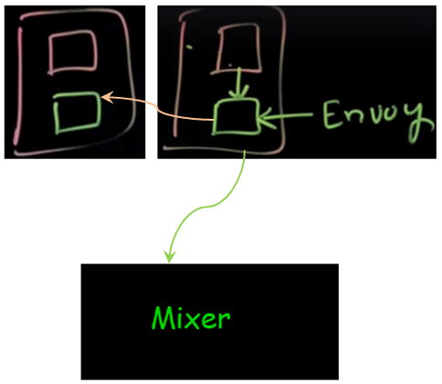

Istio also offers security features - encryption and mutual TLS and authentication and so on. So this is where you can actually encrypt the traffic using mutual TLS and it handles and does load balancing everything in here. The second component and what happens after the request has gone through, it also sense that elementary data. So it sends it. So this is basically known as check-in report. So first it checks, before the request is processed it checks and after the request is processed it will report what happened and then that can be sent to Prometheus or ELK or some other Data Dog or some service through the mixer's adapter's – this is where the mixers plugins or the adapters come in right. So that is the component and every envoy is talking to the mixer for almost every request. That is a core component of your Istio plane.

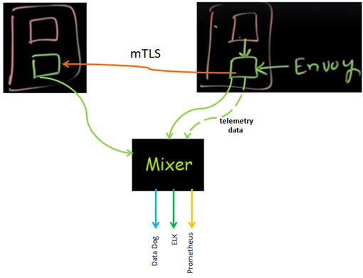

Now the next component in this call is pilot. So what Pilot does is, you can define the rules and policies and everything else and those rules are then translated to service specific configurations. That is what it actually does. That is a service which is again part of a Istio control plan. Now when you do the mutual TLS authentication and authorization there has to be some central service that keeps and maintains all the data up, and that is what Citadel is really all about – all about security. And the next component of issue is called as Galley – it is a configuration manager. So when we make a change it validates that the configuration it can ingest that configuration. So that is what the galley is going to do. Galley is mainly the configuration manager so these are the components of CIOs control plane and as part of the plane you mainly has Envoy and Envoy is constantly talking to the mixer. And this is how Istios architecture looks like again all the service to service communication is handled by Envoy and it is created as a side cart, once its injected it hijacks the traffic and starts managing on so it doesn't allow this to manage it, it will allow it on its own. And this is where it starts communicating with the mixer, mixer can define, has policies as well as it sends the telemetry data to the adatptors, pilot is the one which defines the traffic routing. So you defined the rules like you can read it as you may want to do traffic shifting gradually. All of that goes here and the pilot then can watch those rules into something that envoy takes up. Citadel is all about security authentication authorization. Galley is all about configuration. That's how it's Istios architecture looks like.

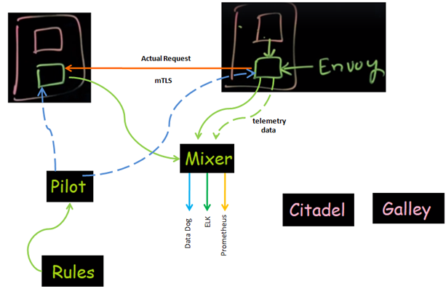

Istio Architecture

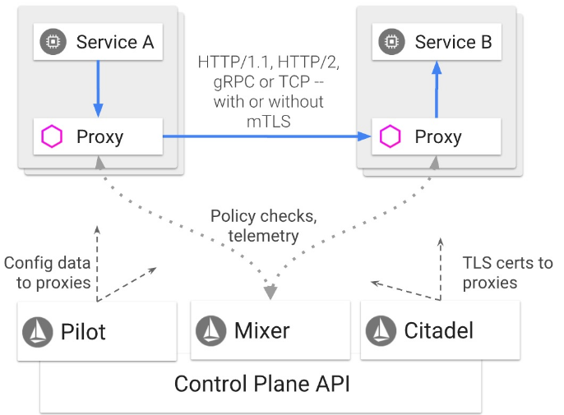

In sections above we have already built the images for the application, we have started organizing the applications. Now it's time to get beyond development because now you can build image around it locally or with Dcoker you can launch it again with other services interconnected to each other but on the same node. If you want to go beyond development you need to have another tool which converts those nodes into one big cluster and starts deploying your application to it and that's where K8s comes in.

So in this section we get started with K8s and this is what we are going to learn. We are going to setup a K8s cluster on Google compute engine which is a managed environment and then deploy a node application, after deploying that node application we will understand the concepts related to deployment, services, pods and service discovery. You'll also learn how to scale an application either using a manual approach or using auto scaling feature of K8s and do a zero downtime deployment. And finally get a quick dive into kubectl which is CLI management tool for K8s. Now that doesn't make you an expert at K8s but that definitely gets you started with the quickest way using Google compute engine. So let's get started with this section and K8s is the way forward from here. So you should definitely know about it and understand at least the fundamentals of it. Let's get started.

|  |  |
| --- | --- |
|  | Let’s see the key concepts related to Kubernetes that is by actually taking an example of an application stack and deploying that using Kubernetes.  So this is what I have, this is that application that I want to deploye and this is an e-commerce application which has a front end application that is made up of all these micro services which are interconnected. And this front end application is written in node js and the catalog the actual catalog the images and the products are served using another service that is the catalog. This is created using a go-lang and catalog uses MySQL as a database backend, the other service that it uses is we have is the cards. This is a shopping cards service which is a Java Spring based application which uses MongoDB as the backend. This is how the application looks like after it has been deployed. |

This is the front end that you see and the products and the catalog the screens that you see here all are served out of the catalog application. And then once the application is deployed you will see a shopping cart up here on the top right part of the screen as well.



So the source code is available. It's been written for each of the application that is a repository. This is for the front end and one for the catalog, one for the Cards application and so on and so forth. Apart from that are deployed these application the first step is to write the Docker files and the Docker files for all of these applications have been written and using the Docker files I already have created images as well which have been published here.

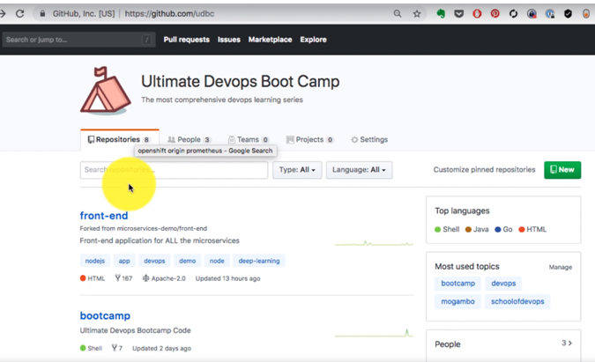

So for each of the application that includes let's say front end, catalog, cards there is a respective docker image. In fact catalog has two components. One is the database one is the application, each of that has its own image. So the pre-req before we started deploying is that the images have to be available somewhere on the registry and this is a public registry that is Docker hub.

<https://hub.docker.com/gouravshah/dashboard>

<https://hub.docker.com/r/gouravshah/carts>

<https://hub.docker.com/r/gouravshah/catalogue>

<https://hub.docker.com/r/gouravshah/frontend>

<https://hub.docker.com/r/gouravshah/catalogue-db>

Apart from that to compile, before I started building the images I have already created the pipelines for each of the application. This is one example pipeline for the Cards application.

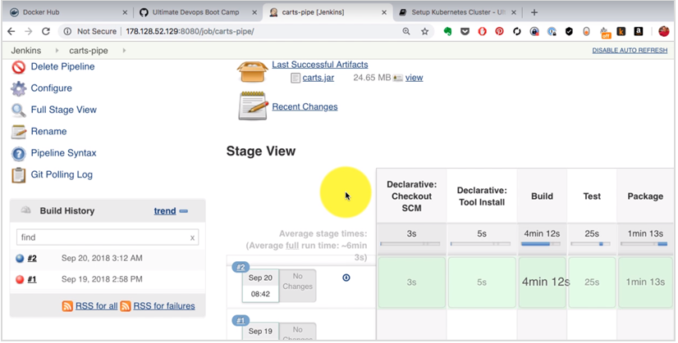

So the Cards application goes through the continuous integration on this Jenkins platform where it goes through the tests. So I have a pipeline stages which are build, test and package. It creates an artifact which is a jar file and apart from that there is another job which creates and publishes the image to Docker in the automated way. So this is what happens when I make a change. It goes through the continuous integration process. If everything is OK it publishes the image on the doctor hub here. And this is exactly what I start to deploy. I want to deploy at scale with K8s and that is where I'm going to need K8s. So first of all what is the need and the purpose for using K8. Why do we need it as what we we're going to look at in this video?

Now if I want to deploy these container images, I already have the images created and the way I run those images is if I have just one single machine I could use docker and run that as a container using Docker run command or let's say I have a stack of application which is front end, cards, and catalog. That's one example here. I could use Docker compose and run it along on one machine in an automated way using just one command that is docker compose up –. Now in either of these situations either using docker or docker compose, I'm still restricted to just one machine. It can help you to automate or run the containers on one single host. Now the problem with that is beyond development for local development it's OK but beyond development you're not going to have one node to run the containers on. You'll probably have a datacenter environment with you know 50 different nodes and are definitely more than one node that you want to run the containers on. Containers also follow the, you know immutable deployment which means that every time there's an update, there's a change. You don't go and connect to it and upgrade that. You replace the container with a new one which also means a new deployment every time. Now the situation is I have a group of servers and a group of containers to be scheduled to be run on those. Now my problem here is how do I decide, the first problem that I have is how do I decide which container runs on which host. Now in order to make that decision I need to first know the resource utilization on each of these machines.

Imagine you are in charge of running these containers and and you have like 100s of hosts and you want to run let's say 50 different containers in one hour. Now when you launch those containers, you need to know which machines have a right to run that type of condition because some of these containers might need specific you know resource requirements, meaning it might have a specific amount of memory, CPU etc or even you know IO requirements and so on. So based on the resources needed, based on the availability you will have to start making that decision. Imagine doing making that decision probably you know 50 different times a day, that can get really daunting because you'll have to keep monitoring these nodes and you'll have to make that decision manually which will also take time which can be dependent on a human. So if you are sleeping nobody is there to run those containers and so on. Right so that's not a good position to be in. And this is not a manual work anyways because you can program an application which does that decision on your own.

And that's the first thing that you know that K8s does, that's the primary thing that K8s is useful for. And not only open it is any orchestration engine starts it takes a bunch of servers converts it into one logical entity one cluster. And on that cluster you start running your application so suddenly your job becomes easier because now you're not talking two hundred machines you're talking to just one single entity and you submit the jobs to that entity, that entity in this case it's K8s and is a resource aware and knows that resource availability on each of the nodes it can make intelligent decisions you can. It is programmed to select the right nor for you know for the container that you provide based on the resource requirements and based on availability. So the first thing that I container orchestration engine does is the clustering and the second thing that it does is scheduling. Now apart from this K8s is capable of scaling your applications and nodes and you know load balancing. And it provides these out of the box. It gives you a way to create your application deployment etc. and for all of these reasons you are going to need a container orchestration engine so to simply put anything beyond development that you want to run your applications on containers on. You are going to need a container orchestration engine such as K8s and that is the primary role of K8s and that’s the most key part here to understand about why you need K8s.

**Kubernetes**

Clustering, Scheduling, Scaling, Load Balancing, Fault Tolerance, App Deployment

### Launching a K8s Cluster on GCP

In the previous video I talked about why in container orchestration is needed. Why K8s is needed to answer that question. Now we are going to start talking about how it works and in order to understand that we need to set up an environment. So the first thing that you need do is, the reason why we need K8s is we want it on containers on a group of servers and instead of talking to each other over independently what we are trying to do with K8s is we create a cluster out of that. So that's what K8s does, so now we're not talking to a group of servers we are talking to just one entity that is K8s and behind it, it can be like for servers or 400 or 4000. You can always keep on scaling up as you need it. In fact given it is today supports about 5000 servers now in order to understand K8s practically, we need to create an environment where at least let's say two to three nodes and create a clustered out of that and then start talking to that cluster and then move on with the new next concept. So I'm going to show you how to create a cluster on Google platform in this video.

So we're logged-in to the Google console cloud console. We already have a Google account that is the gmail account. And since I'm logged in with that it already shows me my login on the top right corner. And the best part about this is it allows you to try Google Cloud for free and it gives you $300 credit for one year which is enough for you to run you know keep running the companies cluster for months which is great. So what I'm going to do is sign up to Google Cloud here by accepting the items on the right hand side choosing my country and the tax information and providing that information here.

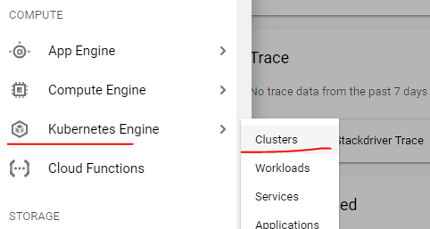

This is the best way to get started with Kubernetes, it is the simplest way to create a Cluster because Google Cloud gives you a managed environment and you can set up the cluster in like five minutes time and once you're logged then. Click on that menu go to Kubernetes engine here.

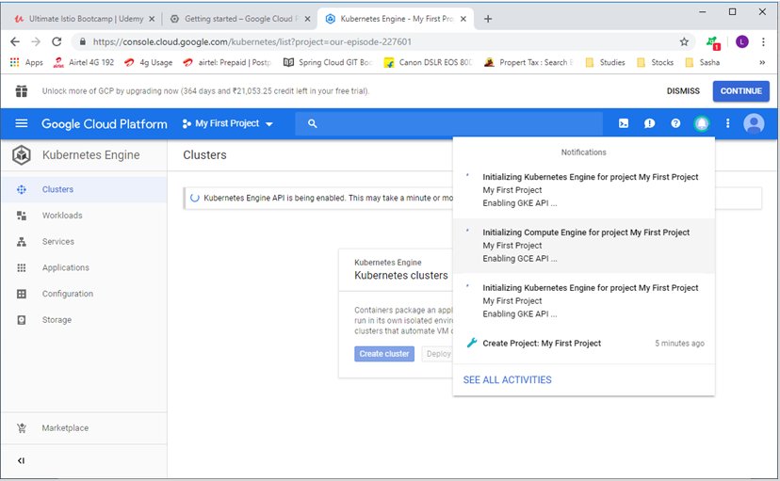

You will see a project and the project offers sort of organization or a name space. And this might take a few minutes for you to get activated. The K8s container engine, once you click on it, you might have to wait for a few minutes here to see that option activated. So you click on Create cluster and it's really simple to create a cluster all you have to do is even if you don't want to provide or choose any options all you have to do is provide just a name for the cluster. Even if you don't do that there are defaults.

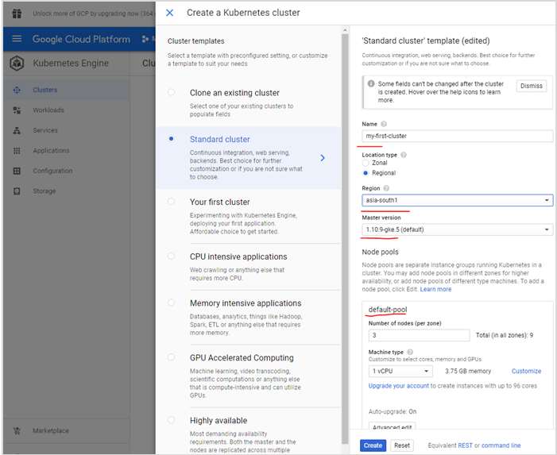

Even the configuration has default including the region in which you want to set up that cluster. Google Cloud has multiple regions and we can pick the region closest to us, or the one of which is closest to your users. And then even if you don't do that you can just choose everything default and just go ahead and click on Create cluster. It also shows you the default pool. This is the actual Node, so Google creates a bunch of nodes. Those are the virtual machines or servers on the Google platform, on top of that it is going to set up your K8s Cluster. So these are the nodes where your containers would be running and I've kept everything default and clicked on create and it has started launching the cluster again. This is going to take a few minutes so I'm going to skip forward and come back after the cluster has been created and then start with the rest of the configurations. So there we have it after a few minutes I have my Cluster running.

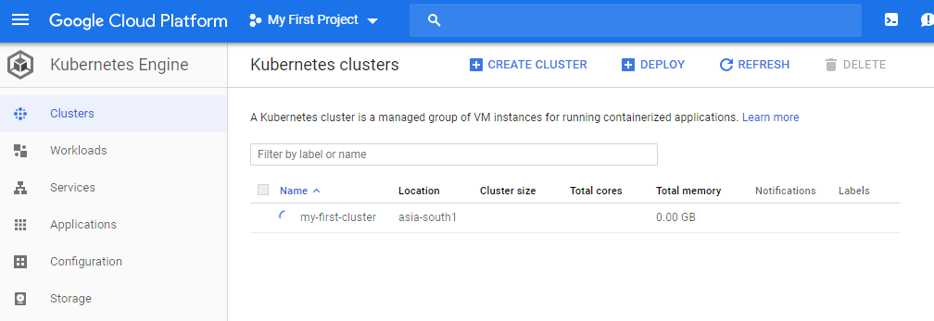

I'll just give you a quick look at the cluster, click on the cluster name and it shows you the number of nodes where it has been created, what are the end points, what are the IP addresses, what is the configuration. These are the default configurations for your cluster.

|  |  |
| --- | --- |
|  |  |

It shows you the pool of nodes which I have as tree and collectively it shows you the number of nodes available for the cluster and the amount of memory. These are the three server vms which are created on Google Cloud compute engine on top of that the K8s environment has been set up so the actual Node and you see the number of sleep an amount of CPU available as well as number of CPU you requested as well as being used consumed mainly by the K8s control plane which is K8s own services.

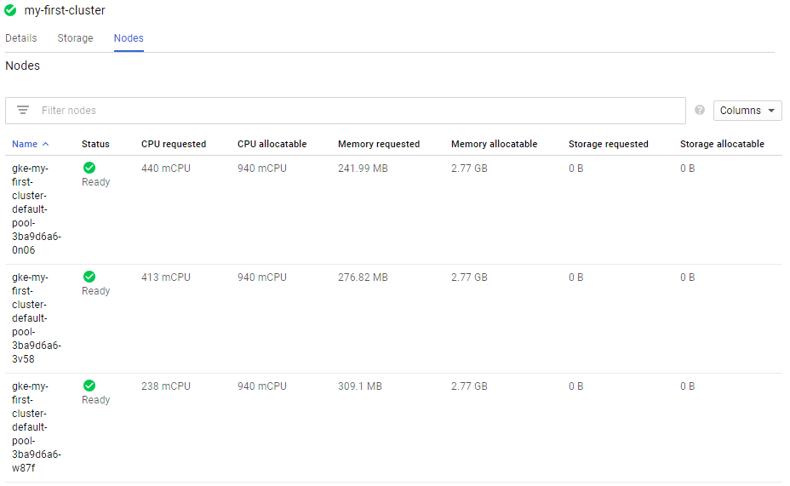

Now if you look at show services - if you go to the workload and show system services you'll see these have been provisioned automatically by default while this managed environment has been launched and these are the ones which are running on the northeast right now including fluidity for collecting the logs stories or monitoring service days or descaler.

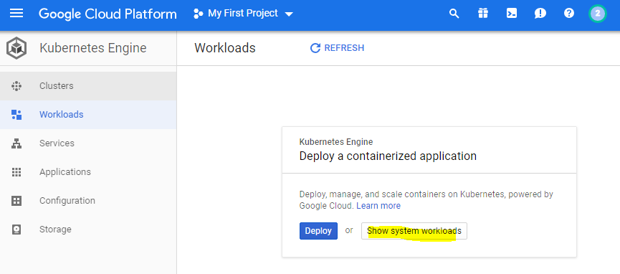

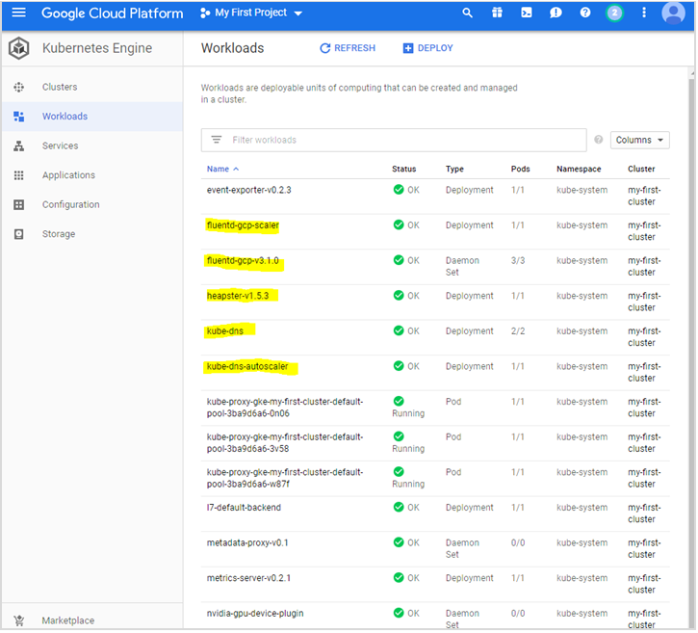

There is a DNS service. There is a metrics server and so on and so forth for monitoring and stuff like that. And so there's a managed service we don't have a control over. Google automatically sets up all of these. If you look at everything else and if you just explore that tabs you don't find much right now. We have just created a cluster successfully in the next video. I'm going to show you how to deploy an application on top of this cluster. Again I'm going to do that completely through the Google console this time which is the simplest way to get started and to get an understanding of how K8s works. And this is in a managed environment on Google Cloud platform.

Lets now see how to deploy the application on top of this cluster using K8s. The application that we want to deploy is already available as an image and that's what I have to start with. So this is the application stack and I have images for each of the application.

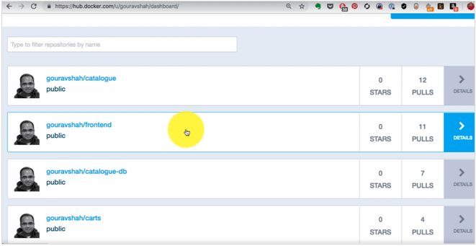

<https://hub.docker.com/u/gouravshah>

<https://hub.docker.com/r/gouravshah/frontend/tags>

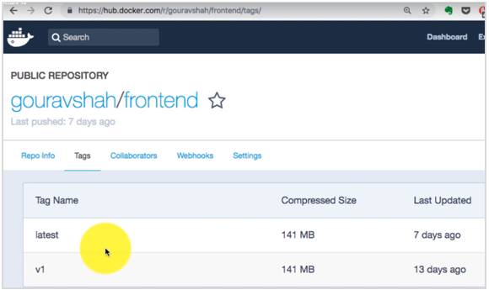

I'm going to apply just one of these applications or one of the services. Let's say the front end service, I already have an image the image already has been tagged. So I'm going to deploy the latest version of the front end applications to workloads, click on deploy, and all I have to provide that image here. In fact if you look at the right hand side it also tells you that you have to have an image ready in order to supply that.

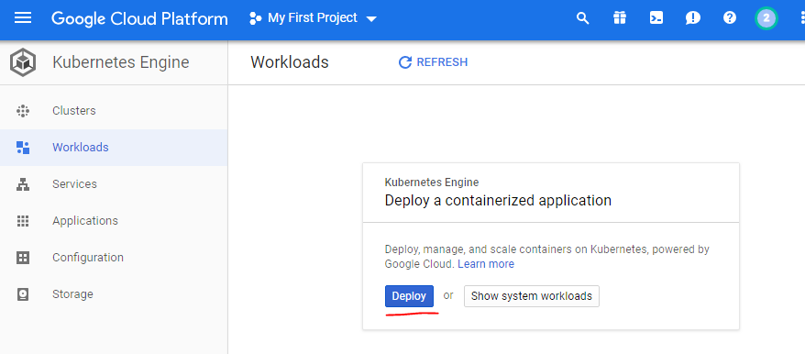

So in the image box I add my image and the tag that is called latest, no environments or anything else that I want to provide.

The initial command is already defined in the image, if we want to override that we can use it here and then we can change the name of the application that's the name the deployment is going to be created.

That if you want to add or labels or tag those you can do that as well. And I'm going keep everything else the same and just click on deploy. So it is creating pods etc right now. And on the right hand side you will also see what is happening and what it creates. If you want to get an understanding of what actually happens you can look at that image and try and figure it out understand what is happening behind the scenes.

|  |  |
| --- | --- |
|  |  |

|  |  |
| --- | --- |
|  |  |

Now this is the deployment which has been created so I have deployed my workload and when it deploys that, it creates it with the high availability as well because it has three application instances and that's what I see if I scroll down in the managed pods section, we see three pods, which means that three instances of that image of my application are running in high available by now.

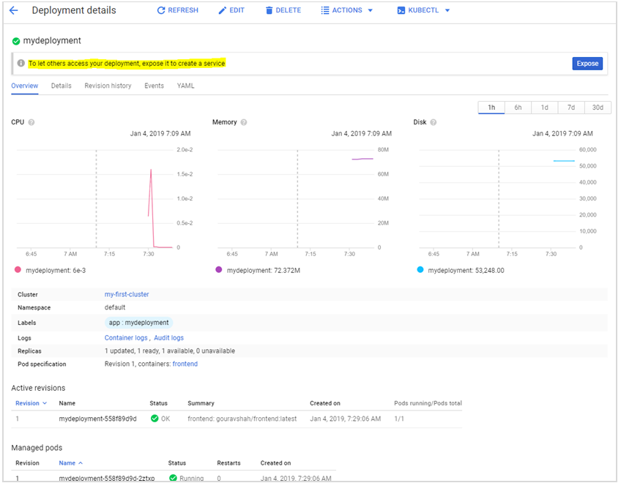

Click on the YAML tab to see the YAML it created

---

apiVersion: "extensions/v1beta1"

kind: "Deployment"

metadata:

name: "frontend"

namespace: "default"

labels:

app: "frontend"

spec:

replicas: 3

selector:

matchLabels:

app: "frontend"

template:

metadata:

labels:

app: "frontend"

spec:

containers:

- name: "frontend"

image: "gouravshah/frontend:latest"

---

apiVersion: "autoscaling/v1"

kind: "HorizontalPodAutoscaler"

metadata:

name: "frontend-hpa"

namespace: "default"

labels:

app: "frontend"

spec:

scaleTargetRef:

kind: "Deployment"

name: "frontend"

apiVersion: "apps/v1beta1"

minReplicas: 1

maxReplicas: 5

targetCPUUtilizationPercentage: 80

Go to the workloads, click on the cluster name and see

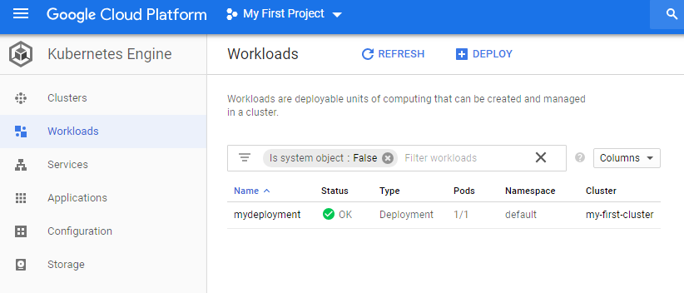

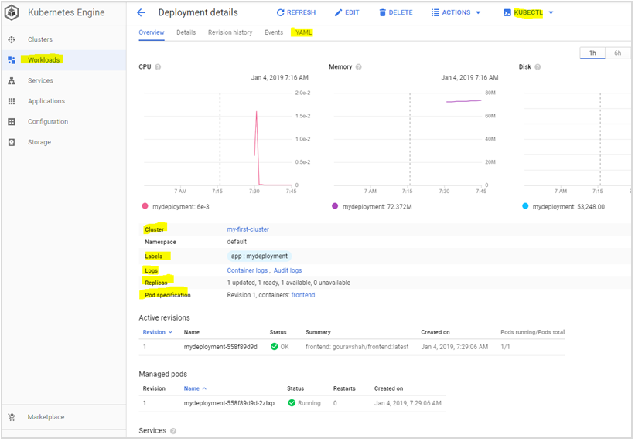

It also configured the auto scaler with the default configuration so if the CPU utilization goes about 80 percent it is automatically going to launch new instances so Google compute engine not only creates the deployment here but also which in turn creates the pods in you know high level manner. It also gives you a way to scale automatically and that's what I see here. So if I go back to workloads this is where I see the number of pods being deployed here. And the type is deployment as well and I should see the graphs being updated in a few minutes now now from now.

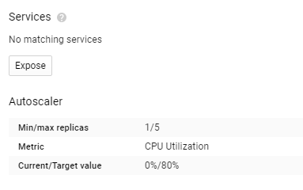

So once I start to using and consuming these parts and application I should see the you know the traffic being generated and CPU memory is being updated. So if you look at the right hand side you'll see the deployments parts etc services here. Now it's time to publish or expose that application. It is important step in order to access data from outside so it will create a load balance. I have three parts but it we create a load balance. This is called as service.

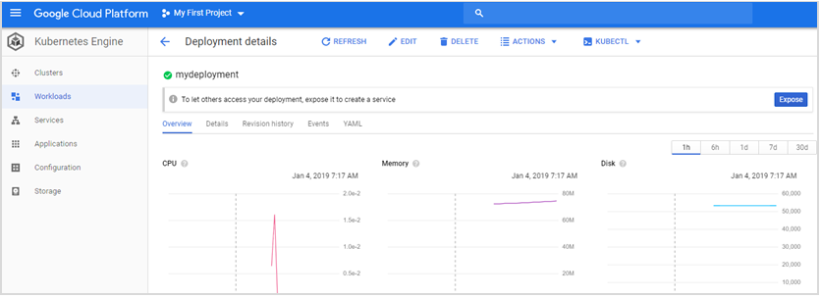

So I need to define which port I want to map this from the Lord balancer to the actual ports. The load balancing port is going to be the one I'm going to access from outside. So I'll just pick 80 port instead of a specific application port so that it makes it easy for me to just use that IP address and port 80 http and it will point to the application, to find out which port application runs on you need to know which port has been exposed as part of the application image which is typically provided in Dockerfile.

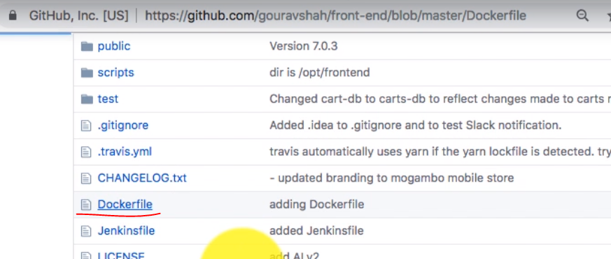

|  |  |
| --- | --- |
|  | So the file has this port number which is which has been exposed that is 8079. So inside each of the container that application is going to run on 8079 which I'm going to make available using load balancer that is Google Cloud engine Google computer and it is going to create a load balancer on its own platform and forward that 80 port to 8079 on each of my pods or containers.  I'm going to explain what pods are and how do they how are they related to containers. But we're trying to expose this application first and see how this actually works at a top level and now that the service is created with name mydeployment-service and I should be able to access it using the load balancer IP and the port that I defined in the configuration which is port 80. |

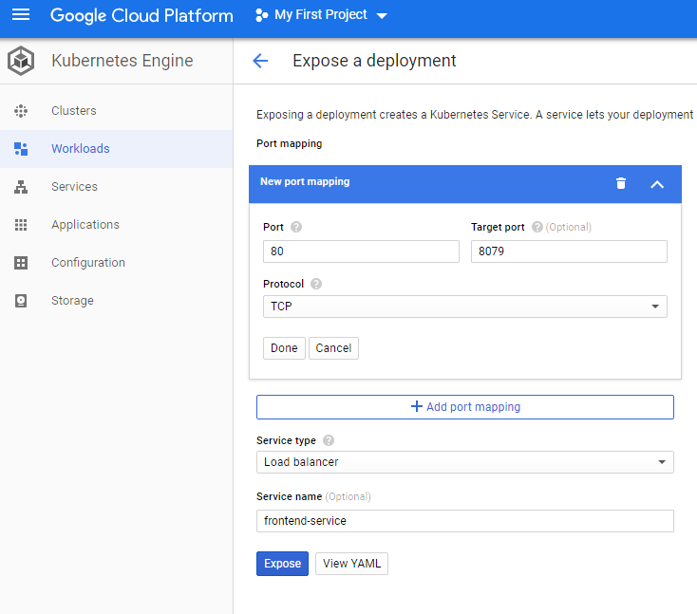

|  |  |
| --- | --- |
|  | Click on the Services to see the Service YAML created. Click on the Workloads and then the YAML tab to see the Deployment YAML created.  So I see that external endpoint and the load balancer IP which is the same IP and then the endpoint is with the port so I can access that application. I should be able to access that application using the end point or the public IP colon 80. So pick the public IP it's going to port 80 anyways and there I see my application deployed. This is our first service which is the front end, it is just a front end which is a scaffold but it has been successfully deployed in a highly available manner. |

Kubernetes cluster is created using Google compute platform. Now if I go back and look at the details of the service I see the labels and I see some type of load balancer. I see some IP addresses defined. And the YAML file, we didn't have to write this one because Google compute engine accepted our you know inputs through our form and convert it into this YAML format. But if you're going to create your own company it is clustered and start diving deeper into it. You need to start understanding the YAML and that is that you could see here or explore from here for now business is going to keep it simple, display everything through Google compute engine and try and understand what actually happened. And that's my service created. And I have deployed the application using two things - One is the workload which created the deployment and the service which published my application.

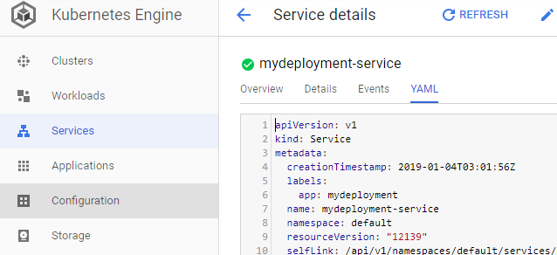

**deployment.yaml**

apiVersion: extensions/v1beta1

kind: Deployment

metadata:

annotations:

deployment.kubernetes.io/revision: "1"

creationTimestamp: 2019-01-04T01:59:06Z

generation: 2

labels:

app: mydeployment

name: mydeployment

namespace: default

resourceVersion: "5270"

selfLink: /apis/extensions/v1beta1/namespaces/default/deployments/mydeployment

uid: 5154b7ff-0fc4-11e9-851a-42010aa0014e

spec:

progressDeadlineSeconds: 600

replicas: 1

revisionHistoryLimit: 10

selector:

matchLabels:

app: mydeployment

strategy:

rollingUpdate:

maxSurge: 1

maxUnavailable: 1

type: RollingUpdate

template:

metadata:

creationTimestamp: null

labels:

app: mydeployment

spec:

containers:

- image: gouravshah/frontend:latest

imagePullPolicy: Always

name: frontend

resources: {}

terminationMessagePath: /dev/termination-log

terminationMessagePolicy: File

dnsPolicy: ClusterFirst

restartPolicy: Always

schedulerName: default-scheduler

securityContext: {}

terminationGracePeriodSeconds: 30

status:

availableReplicas: 1

conditions:

- lastTransitionTime: 2019-01-04T01:59:39Z

lastUpdateTime: 2019-01-04T01:59:39Z

message: Deployment has minimum availability.

reason: MinimumReplicasAvailable

status: "True"

type: Available

- lastTransitionTime: 2019-01-04T01:59:06Z

lastUpdateTime: 2019-01-04T01:59:39Z

message: ReplicaSet "mydeployment-558f89d9d" has successfully progressed.

reason: NewReplicaSetAvailable

status: "True"

type: Progressing

observedGeneration: 2

readyReplicas: 1

replicas: 1

updatedReplicas: 1

**services.yaml**

apiVersion: v1

kind: Service

metadata:

creationTimestamp: 2019-01-04T03:01:56Z

labels:

app: mydeployment

name: mydeployment-service

namespace: default

resourceVersion: "12139"

selfLink: /api/v1/namespaces/default/services/mydeployment-service

uid: 18723ac1-0fcd-11e9-851a-42010aa0014e

spec:

clusterIP: 10.55.251.231

externalTrafficPolicy: Cluster

ports:

- nodePort: 32746

port: 80

protocol: TCP

targetPort: 8079

selector:

app: mydeployment

sessionAffinity: None

type: LoadBalancer

status:

loadBalancer:

ingress:

- ip: 35.244.16.251

Access the application using the Load Balancer IP address

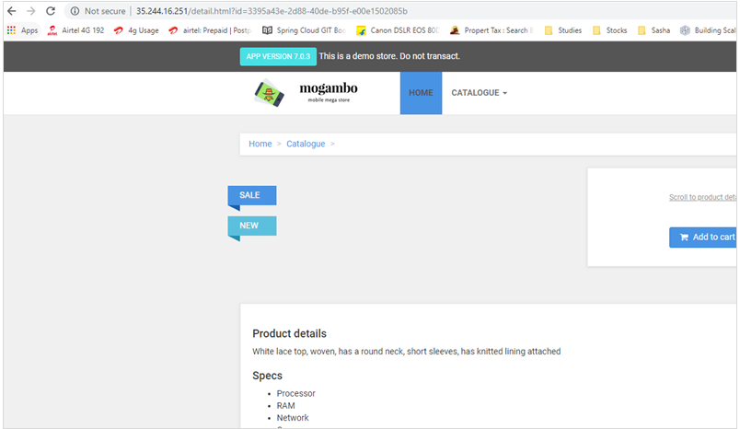

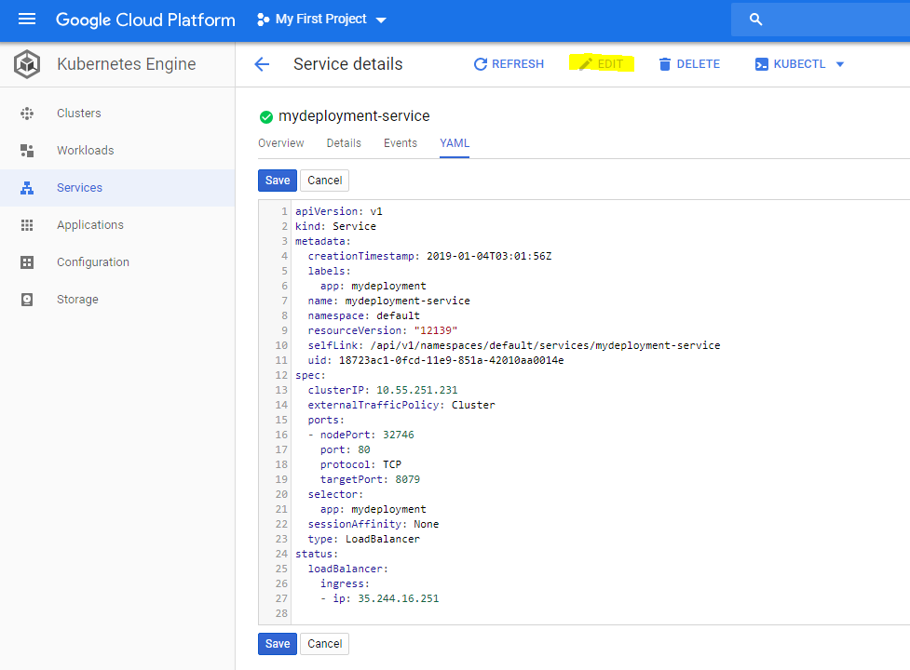

### High Availability and Strategies with Deployments

We deployed the frontend application on Kubernetes. We already have a cluster created and then the work is defined along with the service which exposes this application using a load balancer to the outside world. Now I'm going to start showing you what happens in the background. What's behind the scene and what are the primitives that Kubernetes creates and what does each off that mean starting with deployments. So when we created the workload, it actually created a deployment for it. And if you look at the deployment configuration it shows you how many number of pods you have running for it. Earlier when I created it it showed me three parts running right here. Now it has keeled down to just one. And this is dynamic scaling. And when you create it with Google compute engine and deploy this using this console right here, it by default creates something called as auto scaler, it is also called as hard an iPod or descaler in corporate ITis terminology.The main purpose of this is to maintain the number of replicas and dynamically scale based on the threshold.T he target here we have defined, the threshold, the metric is CPU utilization and since there is no CPU utilization on this cluster right now it has scaled down from three to one instances of that application.

Now whether it scales up or scales down.It does the deployment and maintains that number of replica through something called as a concept of deployments and the purpose of deployments is basically you want to run an application which you run in the form of containers and those are run through pods. But basically if you want to deploy an application with Google that is you create a deployment and deployment in turn creates the replication controller.It has two purposes. One is to maintain the number of replicas. Right now it is one but earlier it had three instances of my deployment. In fact I can scale that manually as well and change the number of instances from this YAML configuration as well.

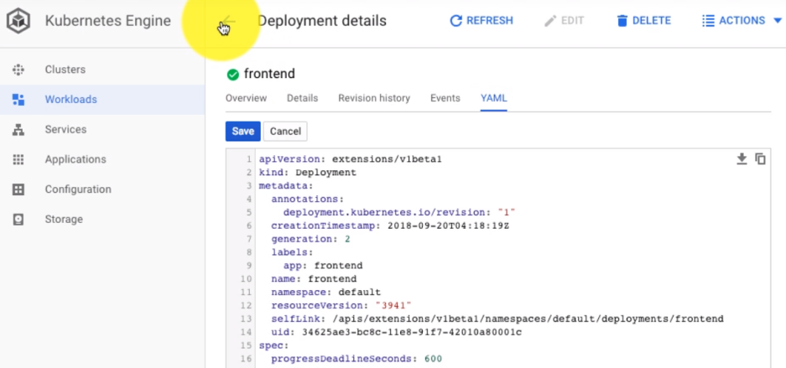

So and that is something I want to show you in another video, the scaling part of this deployment. So two purposes mainly to maintain the number of replicas. And this is useful for fault tolerance and high availability as well because whenever any of these instances goes down it is automatically going to create another one maybe on another node and so on. So one of that is, this is called replication. So deployment maintains number of replicas and an application through something called the replia sets. Like I said it is a type of replication controller.

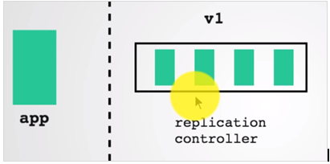

The second purpose of deployment is provide you with an ability to upgrade from version 1 to 2 or from one version to another version and you can create a strategy, you can deploy that without a downtime, you can do that with downtime it's up to you. So it gives you the strategy to define the policy from one version to another one.

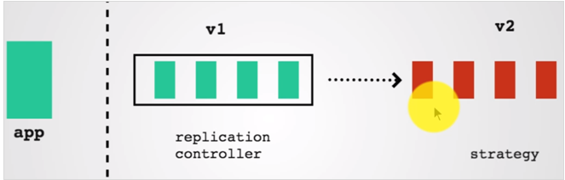

So deployment does mainly two things. One is the replication controller controlling the replicas. And second is it offers you the strategy. And then along with Horizontal pod autoscaler it also gives you an ability to scale out and scale in based on the metrics which include the CPU utilization. And that’s the reason if I want to demonstrate deployment in K8s this is how it looks like.

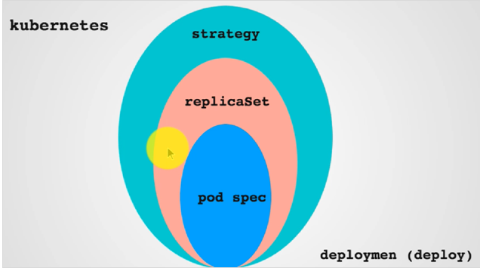

So you created a deployment configuration which provides the strategy and replica sets that are responsible for maintaining the replicas, replicas of what - you deploy it using a pod – so it maintains the pods specification. If you write a deployment configuration it is going to look like, so you create a pod specification and then the strategy. This is an example of a YAML spec for that deployment.

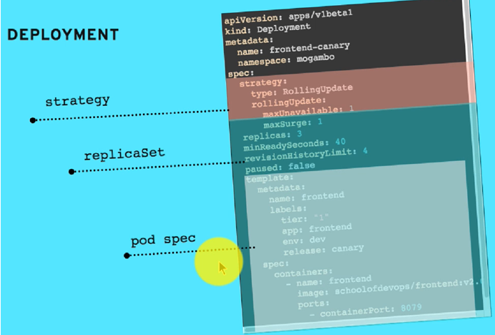

Now talking about the application. It maintains that using a replication controller or a replica set, and the way it works is let's say if you do not have that replication controllers, this is what would happen.Let's say you have deployed three tiers or three services, three applications on kubernetes and they're running on three different nodes. Now if you do not have replication or if one of the application let's say just one instance of this application running here goes down, our node for example has a problem and if that goes down, you're going to lose your instances. And if you lose that instance your availability is affected here your application is down. That could be a problem. So in order to maintain that availability and provide you with a fault tolerance or auto healing replication controllers constantly monitor for your instances, you define the number of instances, let's you define minimum as one, and keep on monitoring. If there is an underlying failure or a node goes down or the container goes down or the instance goes down, it will automatically recreated, reschedule it possibly on other nodes. And that happens in an automated way. So it is constantly monitoring for the nodes and the way it monitors is using labels. So when you deploy your application, you label those and I'm going to show an example of that.

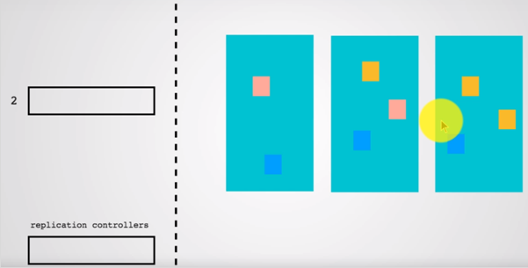

This is an application and when you deploy that application, we label those. It created labels so that replication controller is monitoring for anything which has a label which says app is front end and that's what you would see here as if you go and look at the node.

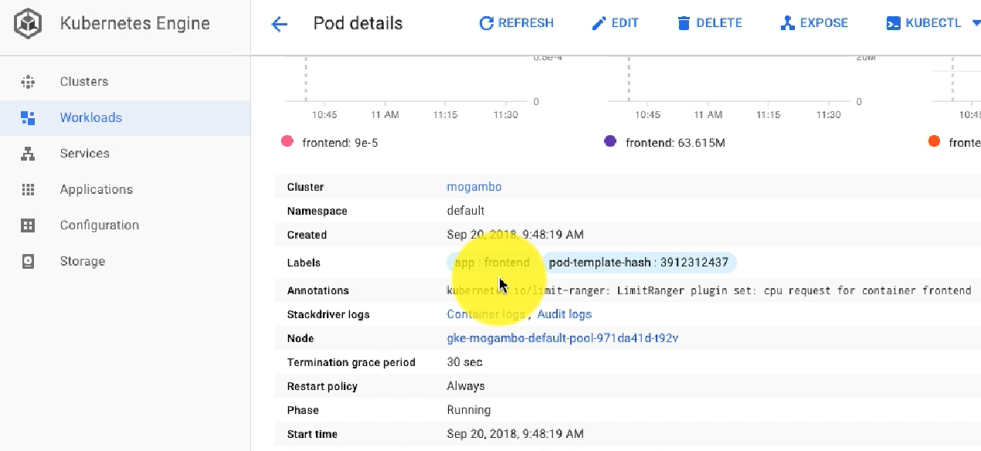

This is a POD configuration part spec. There's one node running you see the you know monitoring graph for that as vote and the label has beenassigned as app friend and there is a replica state, replication controller which is monitoring for these pods and the role of that replica set for that deployment is to maintain the number of replicas as per the specification provided by the deployment or by the auto scaling and it keeps on managing document that by using something called selector.

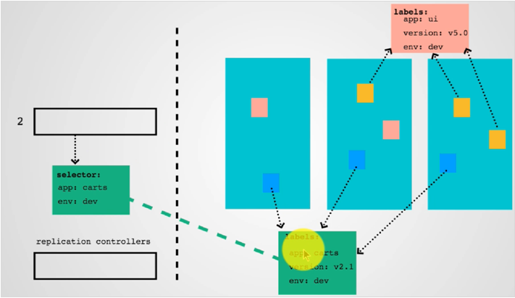

So the replication controller has a selector and through that selector it is going to monitor for the available set of pods. And these are different. So this replicates that is for an application called as cards, so anything which might just stop the card applications or instances would be monitored by this application control. So it has so much. They both have to match the selectors.

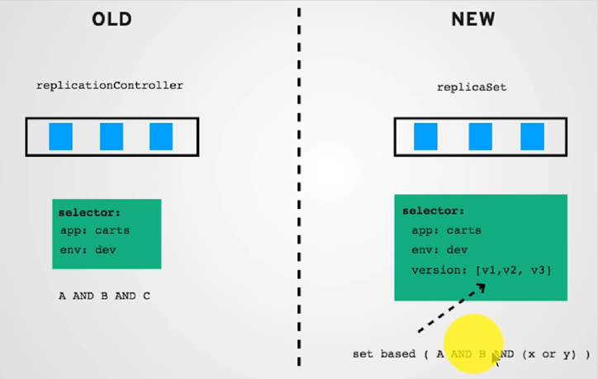

And earlier you know K8s started with replication controllers but now it is replica set, to briefly tell you the difference between the two. This is sort of the advanced version of it and it allows you to do not only a and b. So this is where it selects based on both and A and B, it has to match both of these, versus replica set that can allow you to do a set based selector – A and B and either v1 or v2 or v3. So it allows you to do both &ing and ORing which gives you a better fine grained control over selection criteria and then you can define the strategy which can by default is rolling update, rolling update maintains the uptime of the application. So that when you are upgrading from version one to version two, it does it in batches, so it will start a couple of new instances, bring down the previous ones and then launch the new ones in a rolling manner so that at any given point of time even during the deployment you have a least few instances available either with this version or this version.

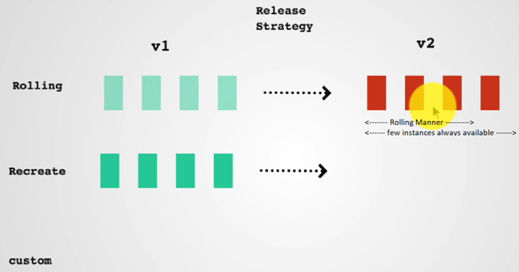

You can also use another replication strategy called as recreate where you bring down all instances you've been getting and then cut over to the next version. So that's what deployments do deployments give you a way to run your application and your workloads in the form of containers and it maintains uptime high availability, and it gives you a way to define your release strategy or deployment strategy.

### Publishing Applications with Services

Deployments offer HA and also define the way to create a strategy for updates from one version to another. Publishing the services is another – in order for us to access the application we created a load balancer.

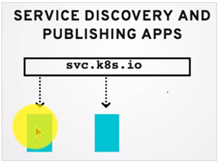

So you create a service and it gives you a way to create a load balancer and then it balances across the number of available pods. And this is the service that I had created with the type as Lord balancer.

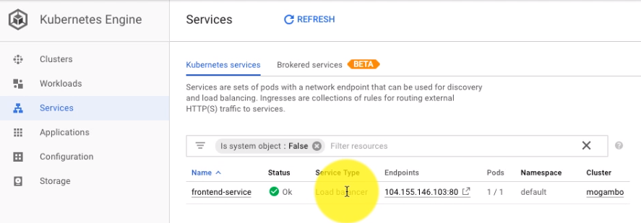

There are many types of services that you could possibly create.And if I look at the service configuration or details, it again uses the labels and selectors to select the pods to send the traffic to, our service has it's IP that isn't done in a cluster.It also has a external IP.This is what I'm using outside. So the purpose of the load balancer IP or the external IP - there are various other ways to expose the service – is to expose and make it available from outside. Versus ClusterIP which is useful for internal purposes and if an application wants to connect to this, it also has its own internal domain name and then Service has a configuration, port configuration and whereas the port 80 points to let's say 8079 on my containers. Basically these are all the services work you create a service when you get a service this is whathappened.

Let's say I had three instances of my application frontend application when I deployed it. And instead of I didn't have a way to connect to this directly so I created created a Service that gave us a load balancer and an external endpoint as well. And my service listens on port 80. It has a cluster IP which is internal and it also would have a domain name which can be used for accessing this service from other applications internally using a DNS service and DNS has already been configured as part of this cluster.

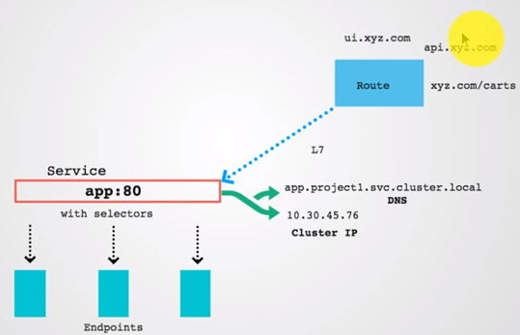

And the way I exposed it was using load balancer. But there are many options to do that. You can expose it using a route or using a domain name and that's called as ingress controller or you can use a node port. In fact when I created this service it also has created a node port. You would see that in the configuration for the service itself. Let's see if I look at the details, I see all the configuration here.

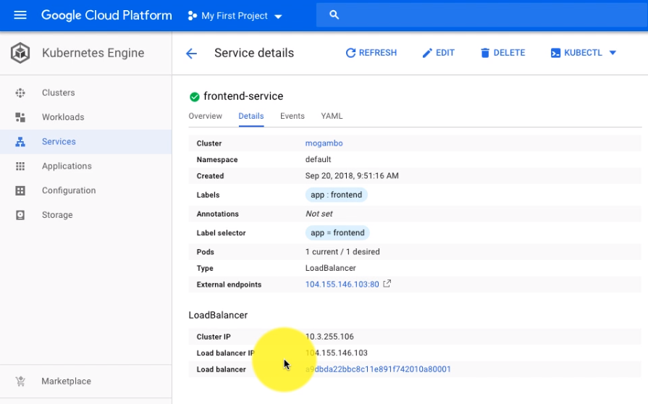

So there is only the load balancer that I see here. But it also has a node port defined here. Let's say 31345. This is useful if I want to go and look at any of the Nodes. Let's say I have three nodes, I can use each of the nodes external public IP address and then use the node to access it.

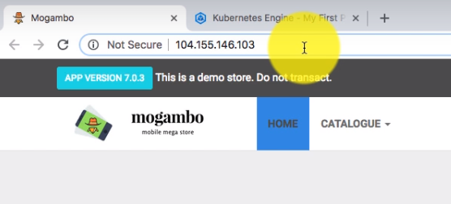

So instead of load balancer, I can also use the node IP, I could do that for the nodes.That is one way of accessing it. So load balancer is only available in the case of cloud – we are using the Google Cloud so it is easy for us to do this. But if you're using optimizers you'd probably expose it using either a nod port or later on using ingress controller or a domain name such as this.

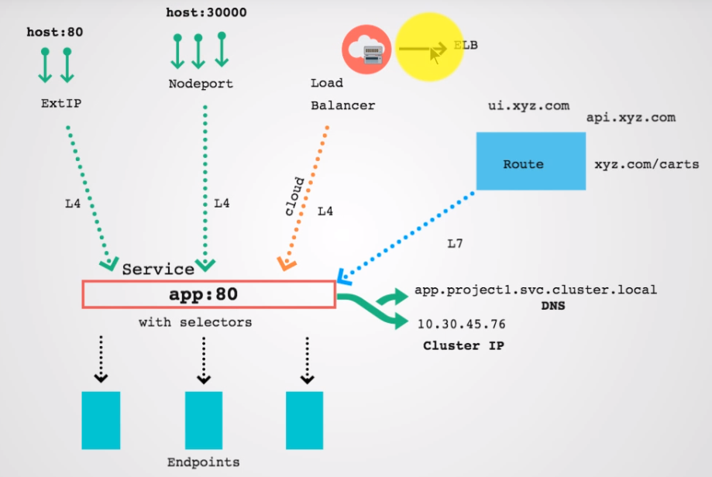

You could also use another option to expose that using external IP. I'm not going to go into details with this course, this is to basically just get a basic idea of K8s and to understand it at a very high level. So to simply put this is what our path is and external load balancer accepts the connection here. And then it passes on to the internal service, that service internally does the load balancing, so whenever I refreshed this page it will go to next pod every time and that is how we expose the application using the service there. Right. And that is how you expose the application using the service right there. Right. So that's the concept of service here. So this is the basic understanding of K8s, we talked about deployment.

|  |  |
| --- | --- |
|  | And so this is useful not only for publishing the application outside but also if you want to connect one application with another, let's say I have an application stack and if I wanted to connect this to the catalog when I reply the catalog it will also create and then also I'll use DNS and connect this application with that using the internal service discovery. I'm going to talk about the service discovery and terms of this discovery in other video but before we do that it's important to understand how our application got deployed and in the form of pods and what the pods are and how do they work and that's what I'm going to talk about in the next video. |

### Pods – Units of Deployment

We've already spoken about deployment and services and now coming back to the deployment when we created a deployment the way it launched the applications is not purely in the form of containers even though these are container application.It lost it as Pods. Now what is the concept of Pods and how that related to containers. And that's exactly what we're going to explore in this section. So what do we do when we want to launch an application with container.

|  |  |
| --- | --- |
|  | Is that you take that application and package it as a container image and that image is what you use to distribute that. Or to others as well as to launch the applications out of that. And when you do that, you typically have a one to one mappings. So when you take an application container you typically have an image which contains one single application. So there is one to one mapping between applications and containers. And that is good for a lot of purposes because if you want to, you know there are certain situations when you want to run more than one application together on the same host and there is no way you can do that on different hosts. And in these situations you might think that oh since I want to run it together why don't I put it in one container image and run it together there. |

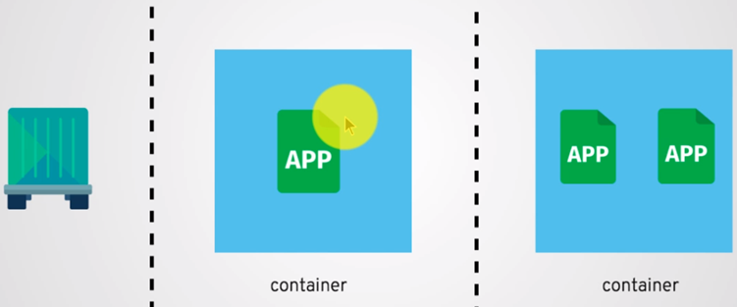

Now that is typically a anti-pattern in terms of container deployments for the reason being it becomes difficult to manage these kind of containers with multiple applications because docker has been created specifically for running one application in one container. It also attaches the applications you know started out and that's how it fetches the logs outside. Docker also manages this process by attaching to it. So whenever the process goes down you can have Docker automatically restarted by providing the restart policies. Now all of that has been designed with one application running in fact one container in mind. The moment you start running more than one applications what happens with Docker is there are additional challenges and docker has to attach to either this or this, and then if it attaches to let's say one application, it is going to manage and monitor only one for restarts for logs for all of these purposes. And that becomes challenging to you know in case this application has a problem or how to get the logs out of this application becomes a challenge. So either you'll have to ignore this or you'll have to have another service like supervisor D or runit or something else running inside which monitors application internally. And even then separating the logs also becomes a bit of a challenge here.

And back on these applications in the same container. But still you may have to run it together.So what is the solution for that. And that's where K8s comes and gives you a solution because K8s you know allows you to run these applications together not in one container but it seems that hey you want to run it together and run it in two different containers. But at the same time allow you to schedule them and host them on the same node and give you some other ways or mechanisms to make it easier for those to connect together.And that is in the form of pods, so you need to have deployment in case of K8s is not a container but a pod and pod allows you to co-locate and run these containers togetther. And this is what you would do. Let's say if I have two applications instead of running it in one container, I'm going to run it in its own container. But those containers will share certain namespaces, it all boils down to namespaces, there are up to five names spaces you can create. A container can have its own root file system, its own network, its own hostname, its on a user namespace and the name space the process isolation namespace.

Now when you run it in a pod what happens here is each of the container would have its own application, have its own root file system, its own dependencies, binary and it gives you a way to separate thatfrom another application.So in the same party you can have two different topic actions running two different operating system.It of course has its own process id namespace.It also has its own you know root file system thats what we looked at but there are certain things which are common as well. So both of these containers will share the same network namespace. It will also share the same UTS or the host names namespace. So that is what makes running pods possible because Pods will have the IP address, IP address is assigned to the pods, hostname is assigned to the pds and inside that pod you would run one or more containers and they can also share the disk space as well. So any amount of file system mount to mount a volume.

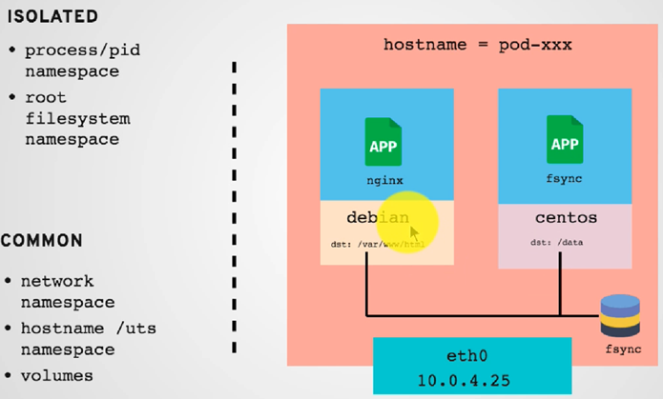

Are you going to mount it on a pod and then you can you know basically make it available and mount it at different locations inside two different containers, same volume can be shared even from different pods.It is all binding to the same volume and that makes it easy to run two applications which are dependent on each other or one application typically depends on another. There is an auxiliary application and then they can communicate with local host they share the same disk space, they share the same host name. And when you deploy it you are going to deploy it on the same node, so anything when you deploy a pod. It is a unit of deployment is a Pod and pos is attached to a node, so you cannot run two different containers in the same pod in two different nodes. That is not possible.

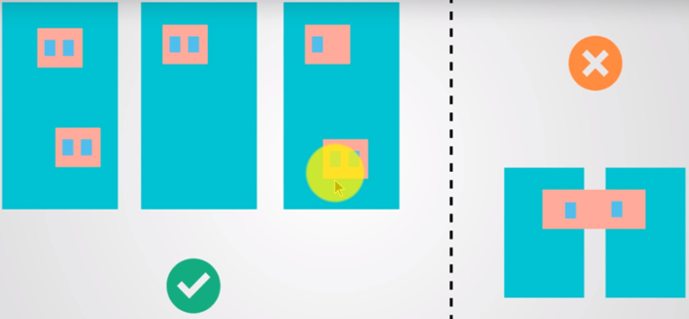

Its not even antipattern, its just not possible. So when we deploy it we are going to run it on the same host, even if you have multiple containers running inside it. Most commonly you're going to have one container running inside a pod but it is possible to co-locate those using K8s, and when you deploy it, you write specs like these so you have a schema

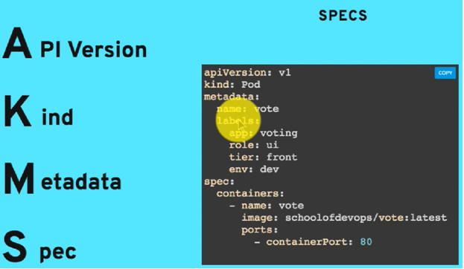

So it's not just for pods but for everything else in K8s. So we have been deploying it using the console that google offers. But if you want to use a generic K8s or if you will have your own installation of the community edition, you would start writing the YAML. Or you can create a JSON equivalent of that, and every spec whether that is a pod, or a deployment or a service can also be broken down into four components - that is a api version kind, kind is pod in this case, metadata - It is where you define the labels and the name for it and the spec is where we define the properties of a pod which contain where it has to run.And that's what you see on this page here.

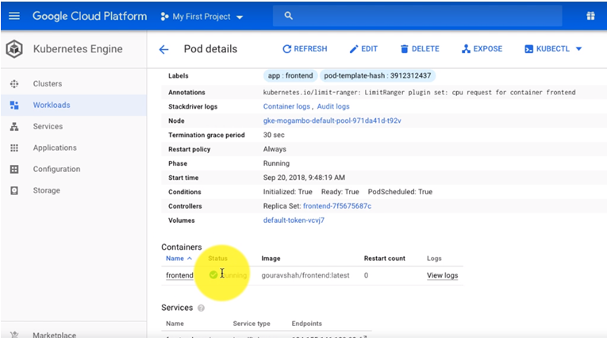

And I can also look at the YAML spec for it and it is just a little more complex version of the specs that I showed you api version, kind, metadata which also has annotations and other configurations.

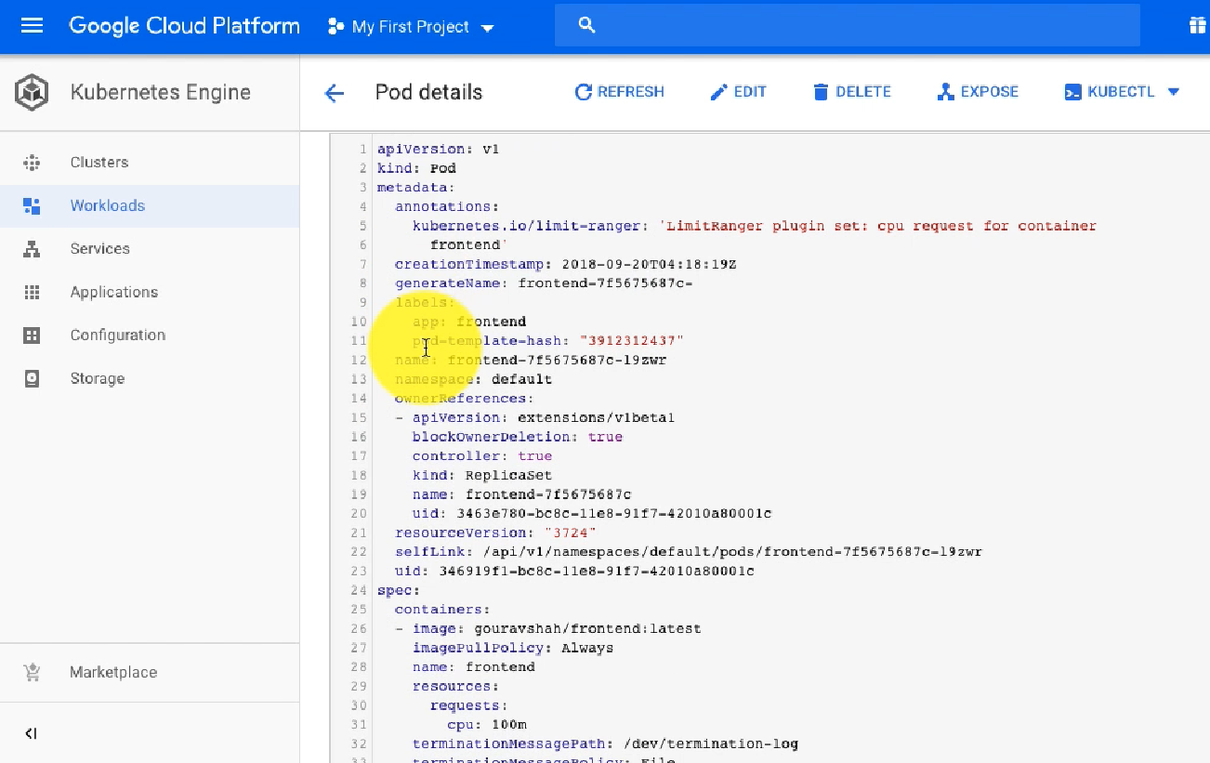

It definitely has Labels and the spec contains which container has been deployed using which image and a few other configurations and the status obviously right here. And you'll see the same YAML for every other object as well. Not only for pods but also for deployments et cetera. So I just described the purpose of using a Pod and what it does. And you know it allows you to co-locate the containers together. Now in the next video I'm going to explain the use cases where you may want to run two containers in one pod. Typically it is one to one mapping, in our example it's going to be all applications will run through the pods and each of pod will contain only one container. But there could be situations where you need more than one. And those are the cases I want to talk about in the next video.

### When to run more than one container in a Pod?

In the previous section we talked about the pods. What is a pod. Why it has been created. Why not run two applications in one container but rather run it in one pod as two different containers. We talked about why and what of pod.

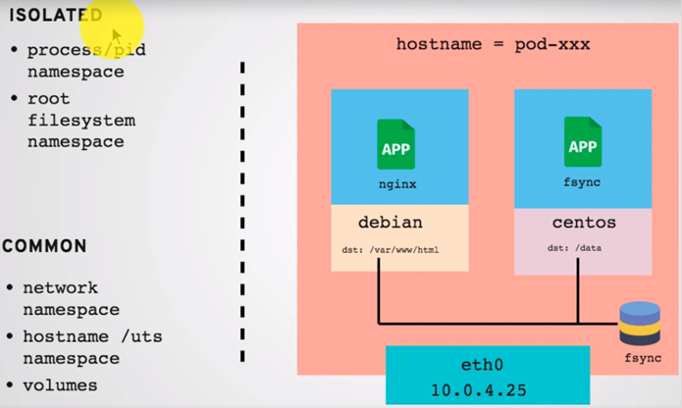

Now we talk about when you might want to create more than one container in a pod. What are the use cases and what are the design patterns. And this is you know the documentation from K8s, its official page. And this talks about three patterns when you want to co-locate more than one containers.

<https://kubernetes.io/blog/2015/06/the-distributed-system-toolkit-patterns/>

You saw the patterns when you want to colocate more than one containers in a pod. Now what is definitely anti-pattern is let's say you have an application that we're looking at here and this application has multiple services.

|  |  |
| --- | --- |
|  | There's one for front end and then there is a catalog and there is a backend and so on, now running these containers which are like this one application with go land and another in Node is definitely strictly a no no. And why is that is because you may want to scale just the front end or catalog or cards and each of this is a Microservice and if you start using it together then you start defeating the purpose of and the advantages of using Microservices, you do the scaling when you are deployed as different pods it becomes just one application whereas if you put together the unit of skill becomes front end and catalogue and then cards, all of these together.  If I want to just scale one of this, it is not possible to do that with individual you know clubbing it together in one pod. And that is when for most of the patterns you're going to run one application in one container in one part the pod. |

But there are situations when you may want to add on more than one containers and that's what we're talking about here. This first design pattern is called as sidecar containers.

**Example #1: Sidecar containers:** Sidecar containers extend and enhance the “main” container, they take existing containers and make them better.  As an example, consider a container that runs the Nginx web server.  Add a different container that syncs the file system with a git repository, share the file system between the containers and you have built Git push-to-deploy.  But you’ve done it in a modular manner where the git synchronizer can be built by a different team, and can be reused across many different web servers (Apache, Python, Tomcat, etc).  Because of this modularity, you only have to write and test your git synchronizer once and reuse it across numerous apps. And if someone else writes it, you don’t even need to do that.

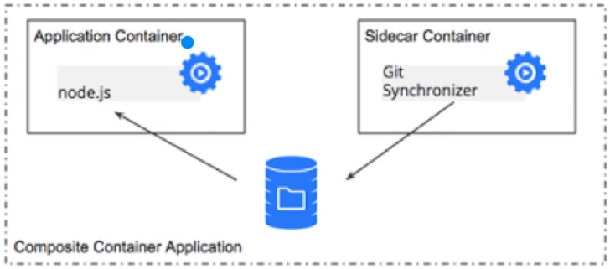

Most common pattern for multi-container is ‘Sidecar Pattern’. Sidecar pattern extends and enhance the main container . For example, the main container might be a web server, and it might be paired with a “logsaver” sidecar container that collects the web server’s logs from local disk and pushes them to Datadog or Splunk Forwarder.

|  |  |
| --- | --- |
|  | Well it is always possible to build the functionality of a sidecar container into the main container , there are benefits of using separate containers. The container is a unit of resource accounting and resource allocation , so webserver can be configured in such a way that it provides consistent low latency responses to the requests which fired on it , whereas the “logsaver” container is configured to scavenge spare CPU cycles when webserver is not busy. Second the container is the unit of packaging , so separating serving the web requests and saving the log into different containers makes it easy to divide the responsibility of developing these individual containers between different teams. Third container is the unit of reuse , so sidecar containers can be paired with numerous different “main” containers. |

Fourth the container provides failure containment boundary , making it possible for the overall system to degrade gracefully (for example, the web server can continue serving even if the log saver has failed). Lastly, the container is the unit of deployment , which allows each piece of functionality to be upgraded and, when necessary, rolled back, independently.

Now sidecar has become more generic word, and even if you look at lets say ambassador and adaptor most of those are also called as sidecar container concept being that you have one main application and let's say this is sertving – node.js does application serving the web pages. And then there's another auxilary application sidecar container is typically an auxiliary application which independently has no use but it works in tandem and supports this application and provide some service to this application. Basically in this case there is a Git synchronizer which collects updates to files. Again we looked at the Pod in the previous video where we talked about two containers in the same pod can share the same mount path, that is really advantageous here because this is responsible for updating the files whereas one application is dedicated to serving it. So we have just split it into two functionalities.

|  |  |
| --- | --- |
|  | And the second question, very important one is when do you decide to run two containers in one part. I ask this question. Can I run these two services on two different nodes. In this case it is of no use, because then you know how would you manage the files, how would you want this application to run along with your main application. Whereas if you decide to use let's say our application stack here you can run this on node or another node and they're connected over the URLs or domains or ports or something like that. And that can easily work fine.  And if you can answer that question let's say, can I run it on two different nodes. And the answer to that is yes. Run it in two different pods. Simple as that. If the answer is No. You might want to consider using one pod. Now this is the auxilary application inside a sidecar. |

Ambassador Containers

|  |  |
| --- | --- |
|  |  |

The second design is called as Ambassador Container. Now in this case there is a PHP application here. This is an example of that. And then the PHP application connects with the Redis shards, there are more than one shards. And each of the shards may have a separate set of database, and if the application wants to connect to it, it just contacts one host instead of keeping track of each of the shards and adding that configuration. It connects with the Redis proxy over the localhost as they share the same network, both containers in the same pod. And this connects to that proxy, the Redis proxy is responsible for connecting to the list of shards and keeping track of it and updating it as needed. So this simplifies the work for the main PHP application. All it has to do is connect to this Redis proxy, and Redis proxy in done is serving as an Ambassador Cart for the Redis cluster here. That's why it is called as an ambassador conainer or Ambassador Service.

Adaptor Container

|  |  |
| --- | --- |
|  | In contrast to the ambassador pattern, which presents an application with a simplified view of the outside world**, adapters present the outside world with a simplified, homogenised view of an application**. They do this by standardising output and interfaces across multiple containers. A concrete example of the adapter pattern is adapters that ensure all containers in a system have the same monitoring interface. Applications today use a wide variety of methods to export their metrics (e.g. JMX, statsd, etc). |

But it is easier for a single monitoring tool to collect, aggregate, and present metrics from a heterogenous set of applications if all the applications present a consistent monitoring interface.

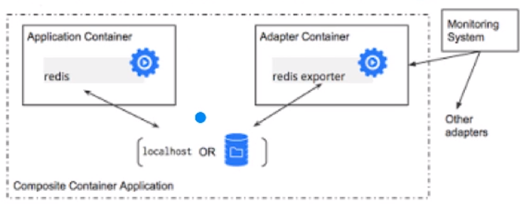

Multi Node Application Patterns

Lets move beyond co-operating containers on a single machine/ node to co-ordinating multi node distributed architecture

Leader election pattern

One of the most common problems in distributed systems is leader election. While replication is commonly used to share load among multiple identical instances of a component, another, more complex use of replication is in applications that need to distinguish one replica from a set as the “leader.” The other replicas are available to quickly take the place of the leader if it fails. There are many libraries which provide the Leader Election Mechanism from the application side.

An alternative to linking a leader election library into the application is to use a leader election container. A set of leader-election containers, each one co-scheduled with an instance of the application that requires leader election, can perform election amongst themselves, and they can present a simplified HTTP API over localhost to each application container that requires leader election (e.g. becomeLeader, renewLeadership, etc.). These leader election containers can be built once, by experts in this complicated area, and then the subsequent simplified interface can be re-used by application developers regardless of their choice of implementation language.

|  |  |
| --- | --- |
| Scatter Gather Pattern  In such a system, an external client sends an initial request to a “root” or “parent” node. This root fans the request out to a large number of servers to perform computations in parallel.  Each shard / server returns partial data, and the root gathers this data into a single response to the original request. This pattern is common in search engines. Developing such a distributed system involves a great deal of boilerplate code: fanning out the requests, gathering the responses, interacting with the client, etc.  These are the design patterns and you might have to look at your architecture and then decide when to run two containers as a part of one pod. |  |

This is another example that I use as part of my course which is one is the nginx application which is serving the pages then is another application called fsync which runs to git sync and updates the files and stores it in the shared mount here. This is the main application. This is the auxilary application.

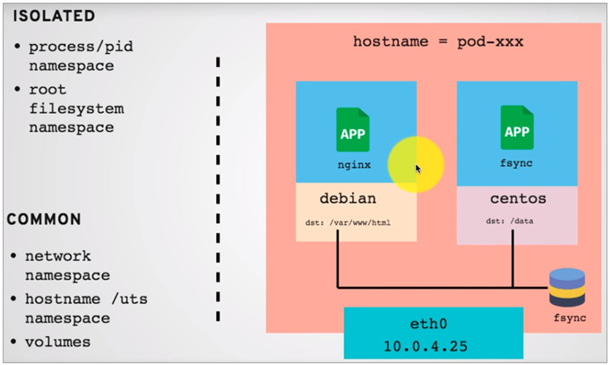

There's another example. Now it's becoming really popular. There is a service called as Istio, maintains and allows you to create a service mesh where when the services are connected to one another, it discovers that, maintains load balancing, routing and a lot of other things and to do all of this it runs a proxy in every pod. So this is again an auxiliary service which maintains contact with this is collect the data that is needed by itself and then sends it to the Istios control plane and in turn that control plane makes intelligent decisions on routing, load balancing and a lot of other things. It gets the monitoring data as well and for making that happen you need, it's like an agent running on every node. And in this case that agent/ that proxy is collecting that data and running along with the main service and that is why this is a auxilary service and this runs in the same pod. So in order for setting up, one of the important step is to basically add this container to the existing pod, the existing pod on existing servers that you're running. So I just give you a couple of examples of when do you run multi container pods. And three design patterns – SideCar Container, Ambassador Container and Adaptor Container.

### Kubernetes Internal Service Discovery

In the earlier videos we saw the services and explained how they are useful for exposing and publishing the applications outside. However that's just one part of the job that services are useful for. The other part of the job is to do the service discovery and that is internal service discovery so when you want front-end to talk to the catalog. How does it work or how front end connect the carts to another application. How does it work is through the Service Discovery.

|  |  |
| --- | --- |
|  | Now why is it needed is let's assume that let's assume that this is the front end application and it needs to connect with the catalog. There are three instances of this front end application and two instances of the catalog. Now in order for each of this instance to connect to the back end application, it needs to maintain some connection information. And the way it is done, in this example, I'm going to show you that configuration file of. So this is the front end application |

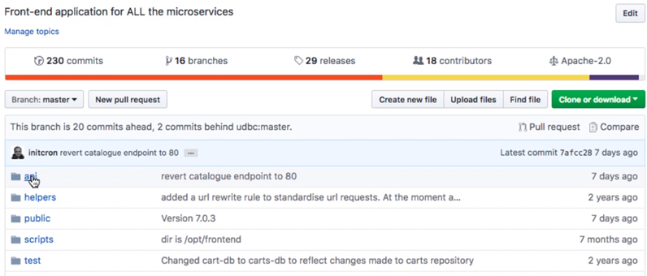

and the way it connects with the back end services right now is using a very simple configuration such as this.

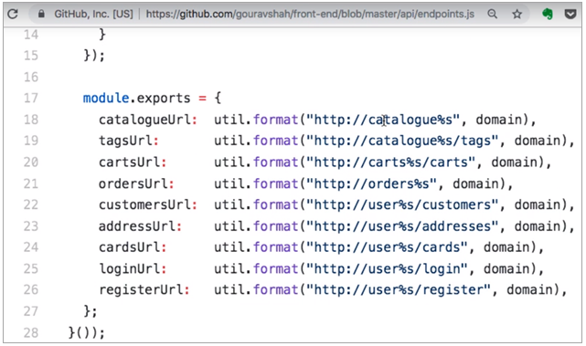

When it wants to go to the catalog. It's just trying to connect to it using a hostname as catalog. Now this is really useful. And this is quite useful, otherwise if you do not have that you'll have to maintain the information. First of all you would have to go and find out the IP address of each of the services here. Each of the pods here. And then for each of your frontend application you would have to add the configuration to these services. And not only that the moment you see the second application you'll have to go back and update the configuration on all of these three, restart the service possibly and that can get really messy quickly with increasing number of instances as well, as whenever you update it, It replaces the container - so it is dynamic.

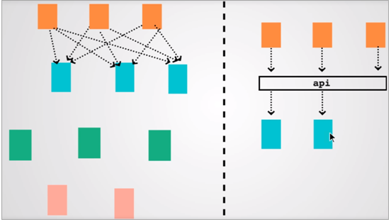

So if you had one single end point by name as catalog and that in turn maintains the list of pods available, that would be much much easier. And this is where service discovery comes into picture. Now for service discovery there are different organizations that use different mechanisms for example Consul and HCD and Zookeeper. But in case of K8s, it comes with the DNS servers and it comes with internal service discovery, which is what I'm going to demonstrate in this video by connecting and by launching an application for catalog and then connecting it with the front end service which is running here.

|  |  |  |  |
| --- | --- | --- | --- |
| |  |  |  | | --- | --- | --- | |  | This is our application and stack with front end that we will connect with the catalog. The catalog application repositories are here as well and the images for both catalog and catalog DB, because even though it is one service, it has a backend application – a back end database that it needs to connect to.  So we need to deploy two services here. One for catalog and another for catalog DB. So I go to the work load and click on deploy from here. And then I have to choose the image so first I'm going to deploy the Catalog DB application and the image for that has been built and published on docker hub already so I pick that image you know from the image repository, which is catalog-db:latest is my image tag. And then I have to provide a few configurations for catalog that includes the environment variables because environment variables allow you to make changes to the images and sort of when you launch the image and if you want to make changes and update application configurations environment variables allow you to do that. |  | |

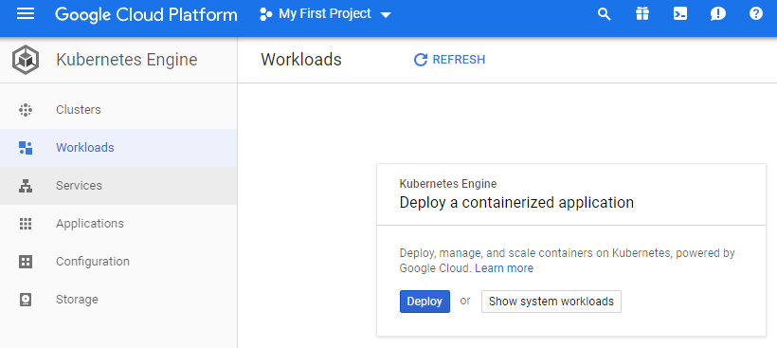

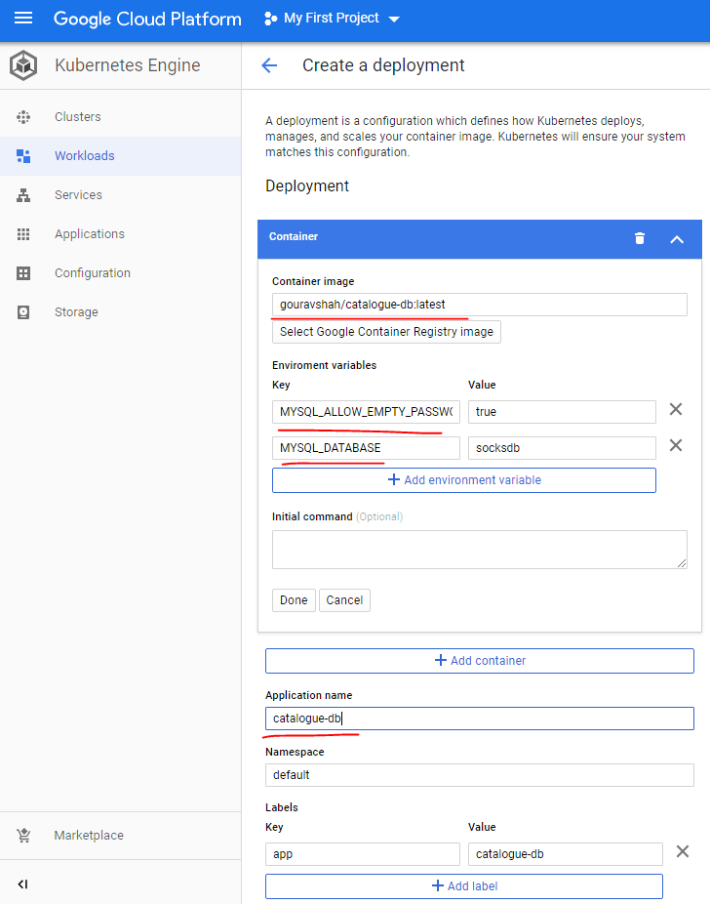

The cluster is specified as frontend-cluster that we created at the end of this screen ( not visible here )

In this case I need to define the mysql empty password is supported and the default database for it through environment variables. I click on environment variables and set that as a boolean property that is MySQL will allow empty password and then provide the database which is socksdb. So this application has been taken from Microsoft's application by Vworks which was ready to sock shop and that's why you see the same configurations there and I provide the name which is catalog-db and that name is extremely important because that is how my application is connecting to the database using name to locate the db.

Click on Deploy

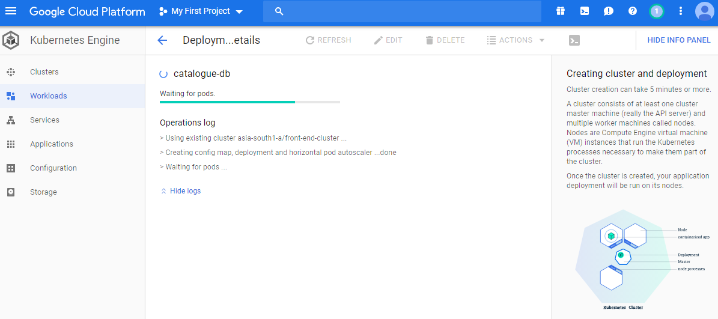

|  |  |
| --- | --- |
|  | And on the right had side you also see what is happening and in the diagram so you have nodes, you have deployments and deployments launch the pods. If I go back to the workload, it's still in progress, so I see some red, it does not have you know minimum availability which means that it is still launching the nodes, sometimes you might have to go and look at your resources and your resources are not enough for the nodes you might have to launch one or more nodes in order to make that available. So from the console you can look at that right now, I have enough capacity available in terms of hardware resources so I just have to wait for the workloads to be available which are not. So the catalog db has been deployed with three pods so it starts with three pods because it has this order scaling configuration and it is scaled down automatically. |

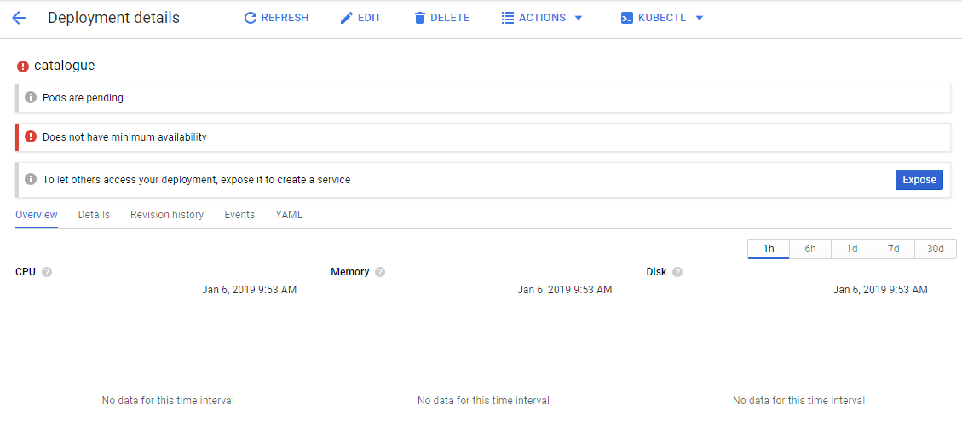

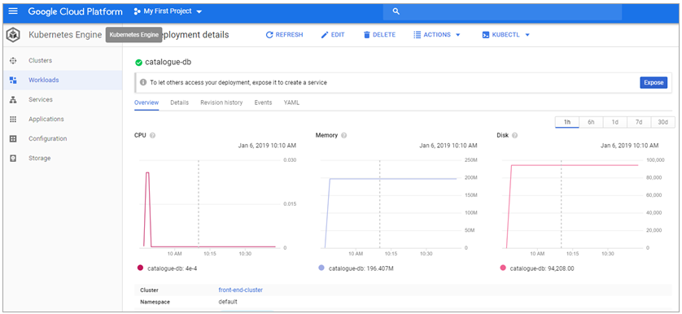

You know I don't have to do anything down now. Next is the catalog application. I repeat the same process. I go back to the workloads and deploy the image from my image repository which is my user name / image repository and color latest, provide the name for the application that is to be deployed so catalog. Again make sure you use the same names in order for everything to work perfectly OK. Select the cluster that we had created for this deployment ( not visible in screen below )

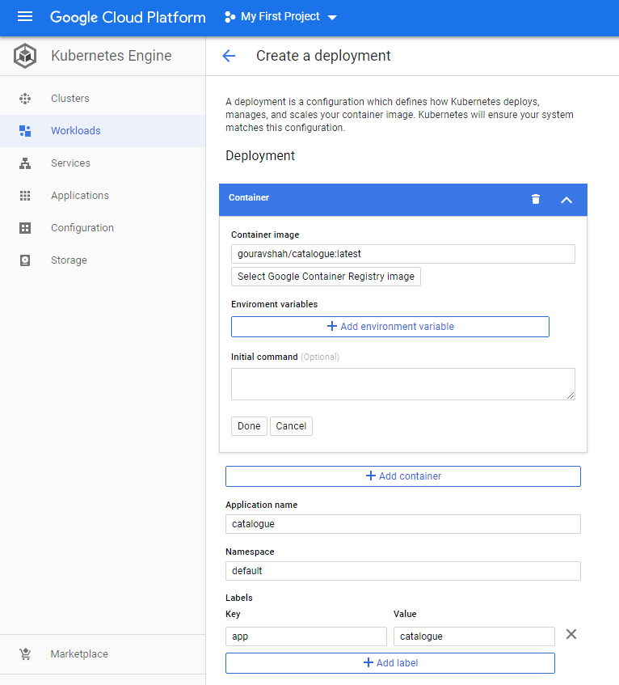

Click on Deploy.

And I started deploying my application the catalog and I'm going to show you how my front-end connects with the catalog application. It uses service discovery, it uses a hostname rather. So fronend wants to to connect to catalog and it's going to connect to port 80. Now in order for this to work I need to expose the application using service, I need to create the internal load balance and then also just using cluster IP mechanism. I need to do that for both the catalog as well as catalog-db, anything that needs incoming access we need to create a service for that. Frontend connects to catalog using port 80 so that's why the port defined is 80. But the application catalog itself might be running on some other port. If I want to find out that port. I need to go and look at the Docker file or the Docker image and find out which port is supposed to be exposed in this case. It's exposed instructions has 8081.

<https://github.com/gouravshah/catalogue/blob/master/docker/catalogue/Dockerfile>

FROM golang:1.7

ARG user=app

ARG group=app

ARG uid=1000

ARG gid=1000

RUN mkdir /app

COPY . /go/src/github.com/microservices-demo/catalogue/

COPY images/ /images/

RUN go get -u github.com/FiloSottile/gvt

RUN cd /go/src/github.com/microservices-demo/catalogue && gvt restore

RUN CGO_ENABLED=0 GOOS=linux go build -a -installsuffix cgo -o /app/main github.com/microservices-demo/catalogue/cmd/cataloguesvc

RUN groupadd -g ${gid} ${group} \

&& useradd -u ${uid} -g ${gid} -m -s /bin/bash ${user}

RUN chown -R ${user}:${group} /app/main /images

USER ${user}

CMD ["/app/main", "-port=8081"]

EXPOSE 8081

So I pick that port and add it to the configuration as target port. Target port is the application port. That's where the parts and application will go online. I choose the type of service as Cluster IP because I don't want to expose the service outside. I don't need to do that.

|  |  |
| --- | --- |
|  | **Equivalent YAML**  ---  apiVersion: "v1"  kind: "Service"  metadata:  name: "catalogue"  namespace: "default"  labels:  app: "catalogue"  spec:  ports:  - protocol: "TCP"  port: 80  targetPort: 8081  selector:  app: "catalogue"  type: "ClusterIP" |

Click on the Expose button now

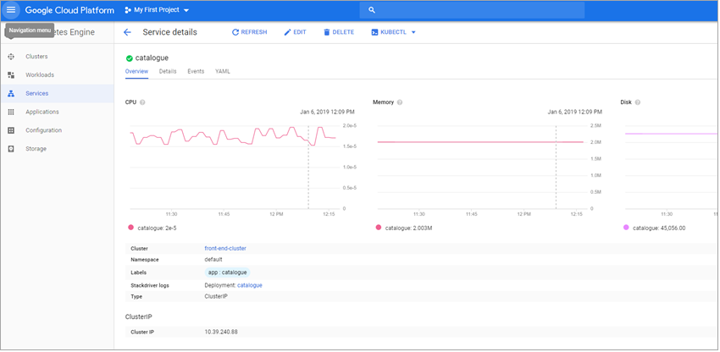

And this is important. The ‘catalogue’ name of the service is extremely extremely important because that is the hostname that the front end is looking for. If you missed that part, if you configure it incorrectly the service itself will not be available and the application won't be able to connect to that, because it's looking for a specific hostname.

I need to repeat the process for catalog-db as well. I have this is my application deployment. I see the pods running for the catalogue.

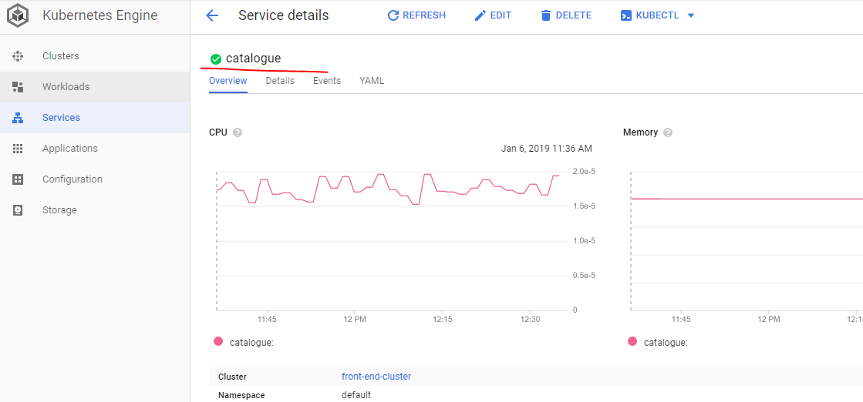

I have a service created for catalog as well which shows me the internal end point. This doesn't have a lot of configuration it shows me which parts it is sending the traffic to and that happens based on labels and selectors labels and selectors are extremely important.

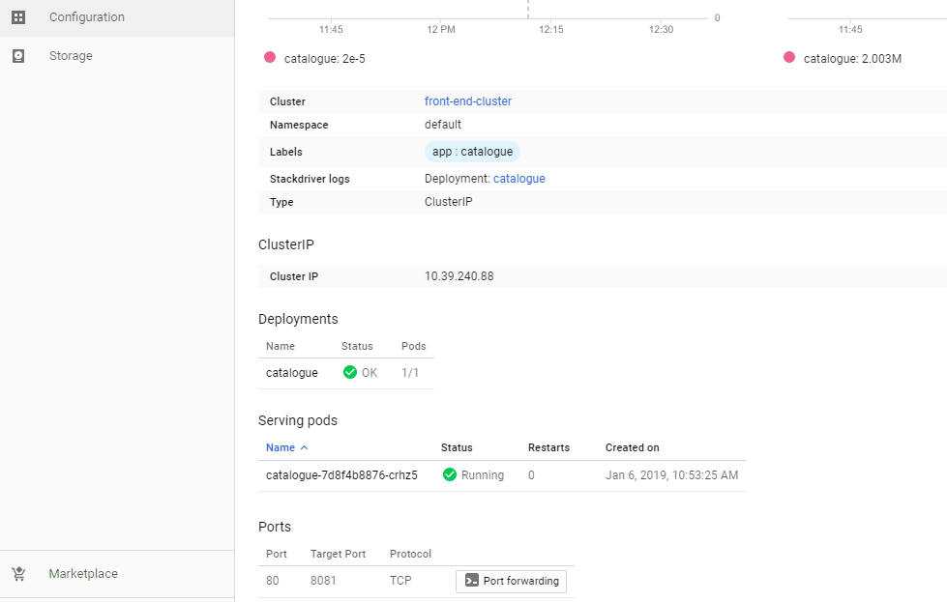

Now I go back to catalog-db and click on exposed application where I choose the port that my database would be running on.

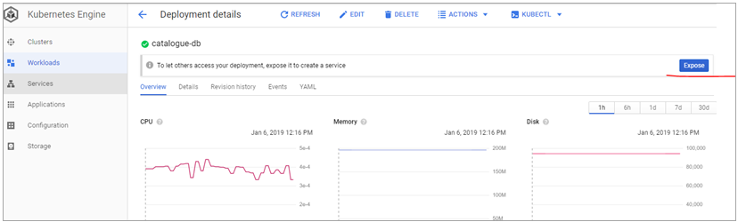

Now if I go back and look at my file for catalog-db It points to another image which is MySQL 5.7. Now I can go to Docker Hub that is [hub.docker.com](https://hub.docker.com/), and search for MySQL find out the docker file for tag 5.7 which gives me the exposed instruction which is 3306.

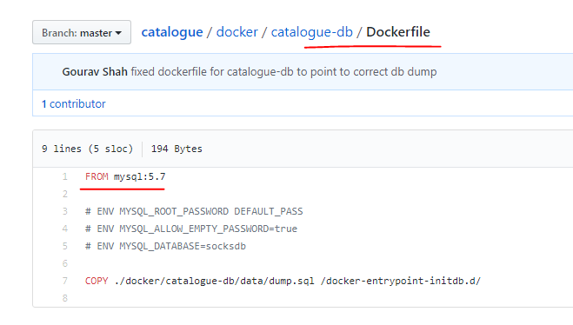

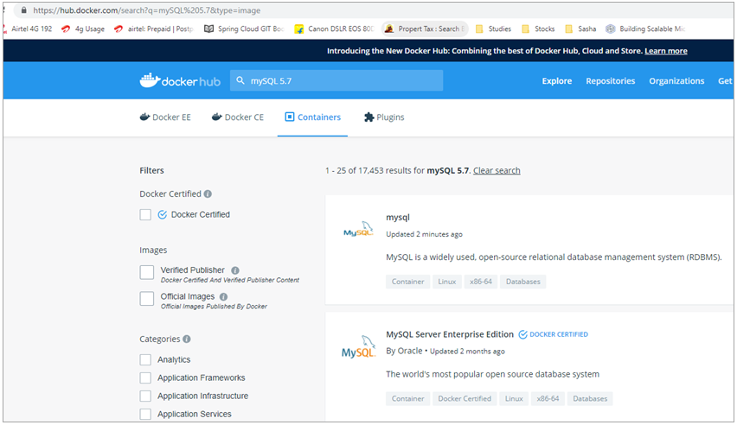

That is the default port MySQL database runs on and I have to provide that one.

<https://github.com/docker-library/mysql/blob/696fc899126ae00771b5d87bdadae836e704ae7d/5.7/Dockerfile>

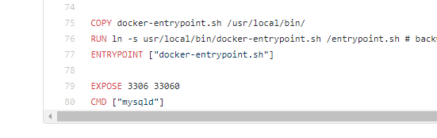

If the parts are the same, I don't have to provide it here, that is optional only if the ports are different it is to be provided.

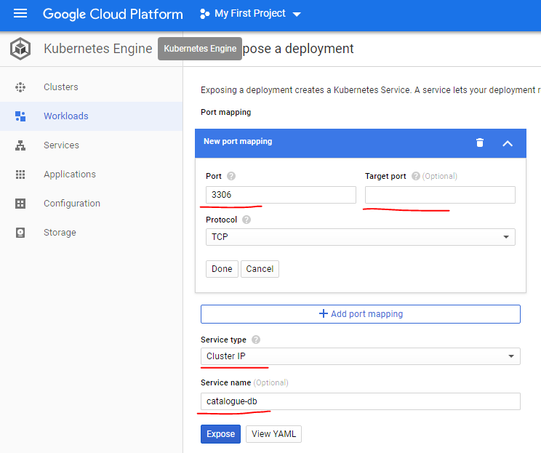

Again I'm going to use cluster IP as their service type catalog. Hi friend. This name is again important. In order for the catalog application to be able to connect to this back in service and now that I have both services running and sending the traffic to their respective pods I should be able to access this application from you know the Web browser where I have right now just the frontend application running. I can go back and try and access it from here.

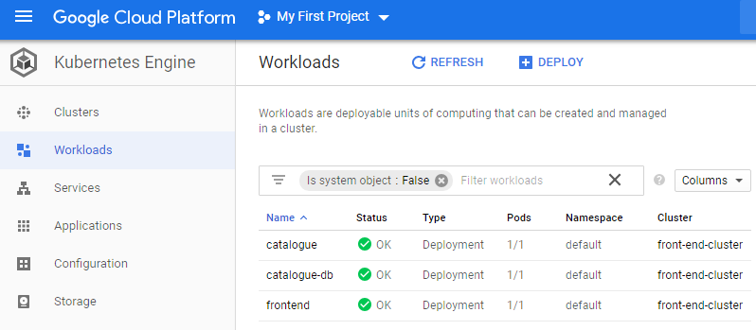

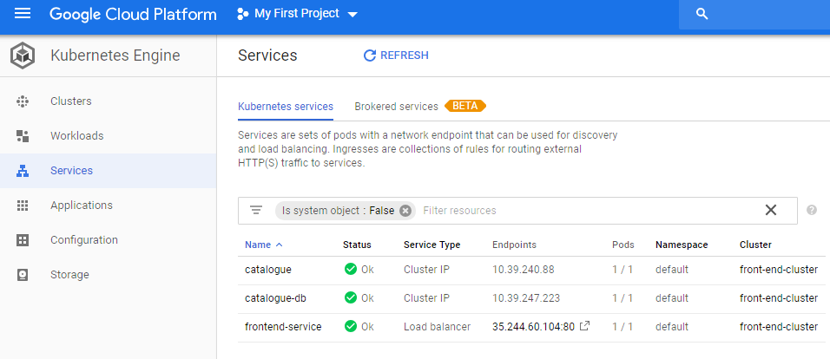

So this is all internal service discovery using the host names, and I have three applications and three services running. If I go and refresh this page it loads the catalog. There you go.



That last look at Lague it will start showing up for the catalog with the you know the products and their description and some images related to that as well. And that is how the internals of this discovery work. So services are not only useful for exposing the application, publishing the application outside but also for internal service discovery. And we have three services running with their internal discovery as well as external publication using Load balancer and for each application that's what you do - you create a deployment, you create a service. Typically you have at least two components deployment and a service unless your application does not need to be discovered.

### Assignment - Deploy application for shopping cart

|  |  |
| --- | --- |
|  | I've shown you how to create a cluster on Google Cloud Platform Kubernetes and deploy applications on it. So far we've created or deployed frontend. And the catalog, along that the catalog data.  Now I'm going to give you an assignment where you would add another application that is God's application not ours has to competence guards and guards.  Once you deploy the cart, it should start showing cart to the top left of the menu, this is how we can validate it. We won’t be able to use it till we add the database, but that is ok. |

The images are already available here. The GIT url is at

<https://github.com/gouravshah>

<https://github.com/gouravshah/carts>

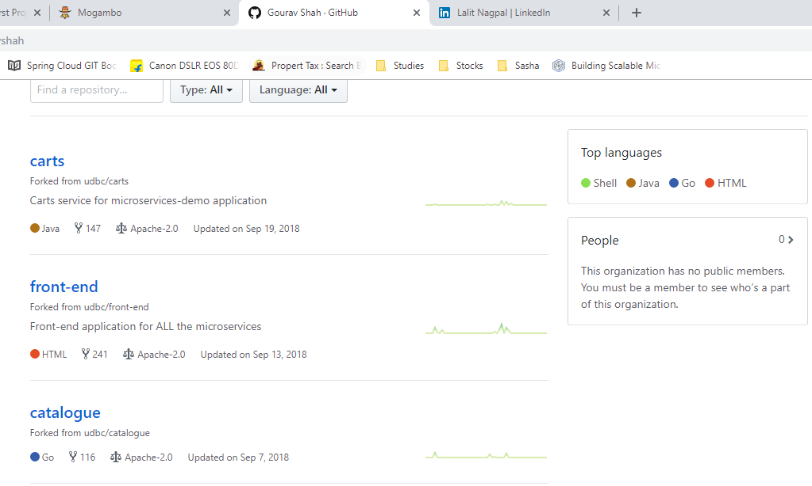

The image is here

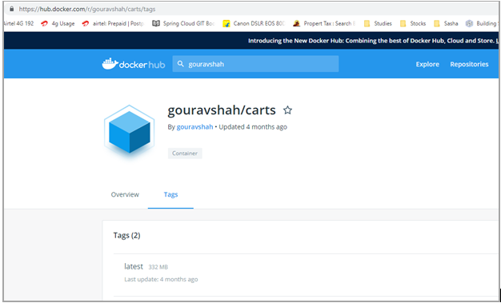

To connect this to the front-end, we have to see in the front-end/api/endpoints.js file

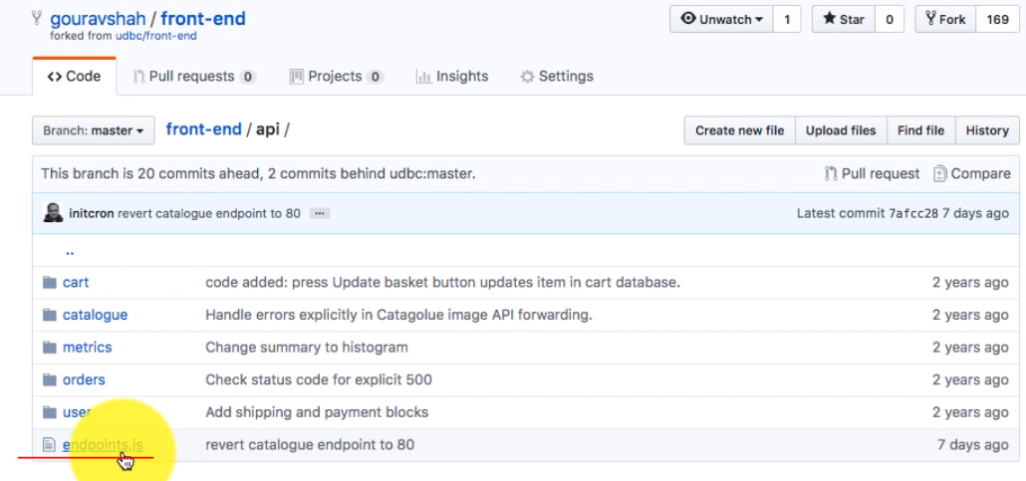

And this connects with the carts application using the hostname as carts and on port 80, so its going to use port 80, remember that

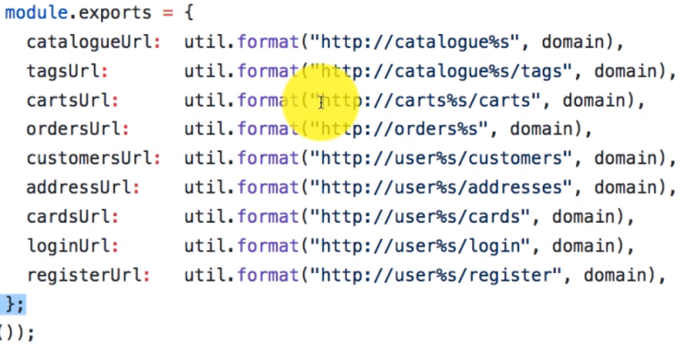

Lets also look at the port where Docker has been configured to expose here – it is port 8080

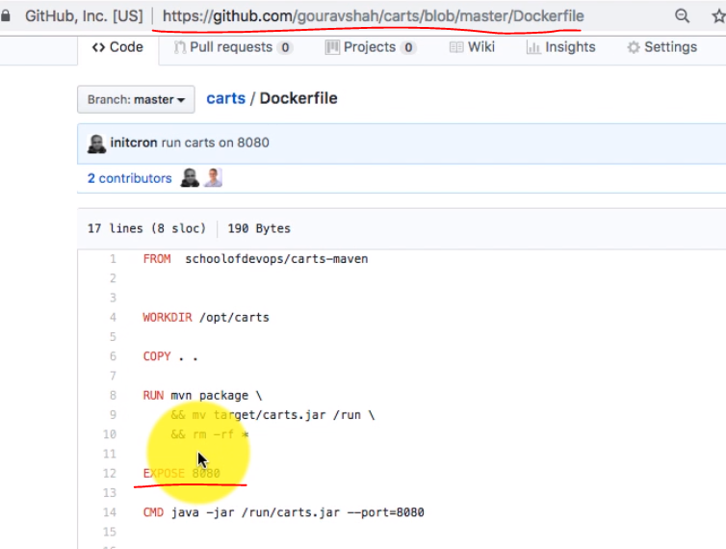

So the service has to map port 8080 to 80 for this to work, for the connection to work – so lets create the deployment for carts and then also the service to expose it properly and we should be able to see the cart on the top left if it is successfully deployed.

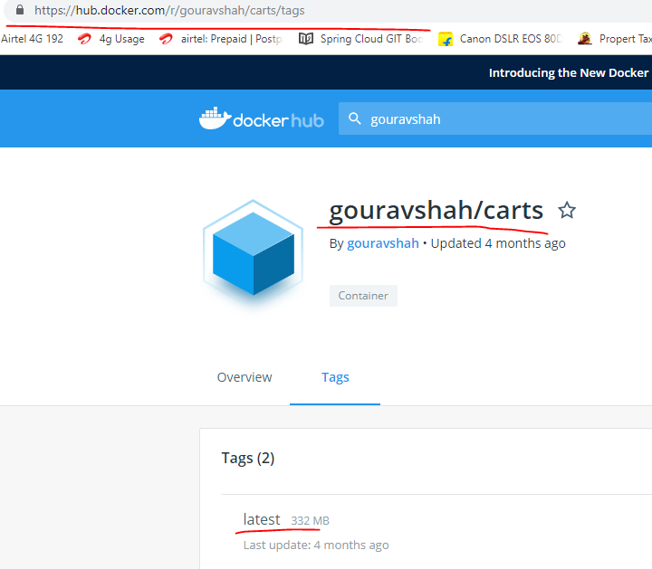

Lets deploy as below

|  |  |
| --- | --- |
|  | Provide the username with the tag  <username>/<tag>:<version>  Provide the name of the application as carts, and that is it  Click on the deploy button  This starts creating the workload, creating the pods and the pods would be available after some time. It takes a few minutes to get them ready |

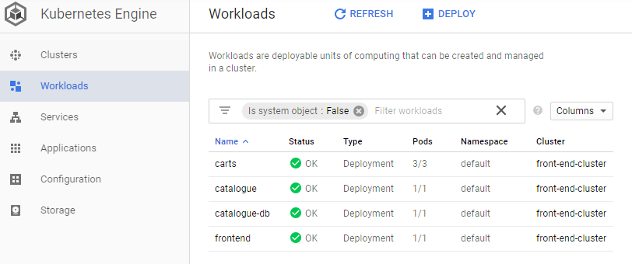

Now lets expose this as a service

|  |  |
| --- | --- |
|  | The actual application is running on 8080 ( per the Dockerfile ) and we expect the port at 80 so we have mapped it that way  We have defined it on a LoadBalancer and the name has been provided as carts and that is all that we would need. |

We have the services as well now

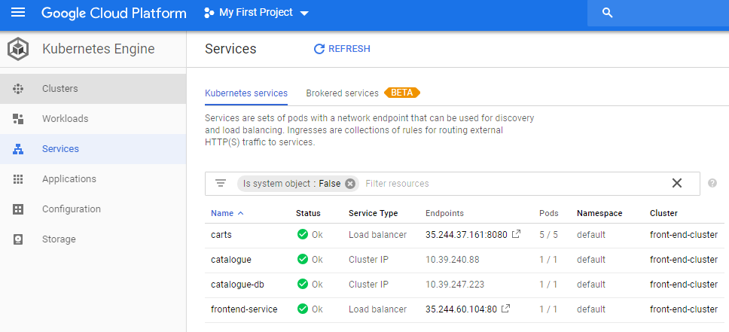

We have this working now and also functioning



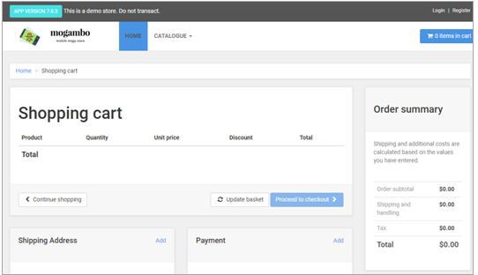

This is how this is deployed now

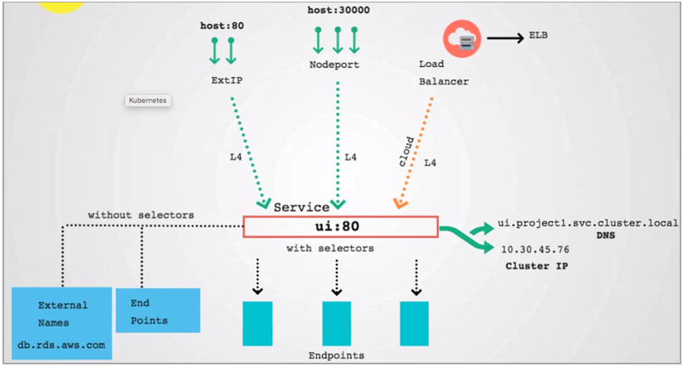

### Scaling Applications Manually and with a Autoscaler

Lets see how to scale the application both automatically and also manually, first lets look at manually scaling this.

If we want to scale this manually, all that we need to do is to edit this

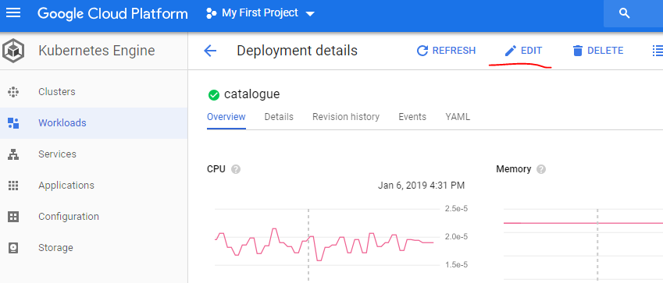

And this opens the YAML file which contains the spec as with replicas as 1, change that to 3

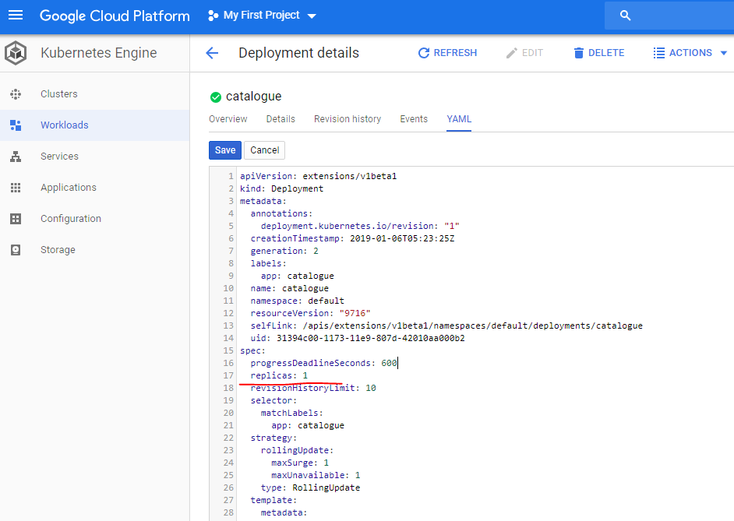

And it starts processing additional pods

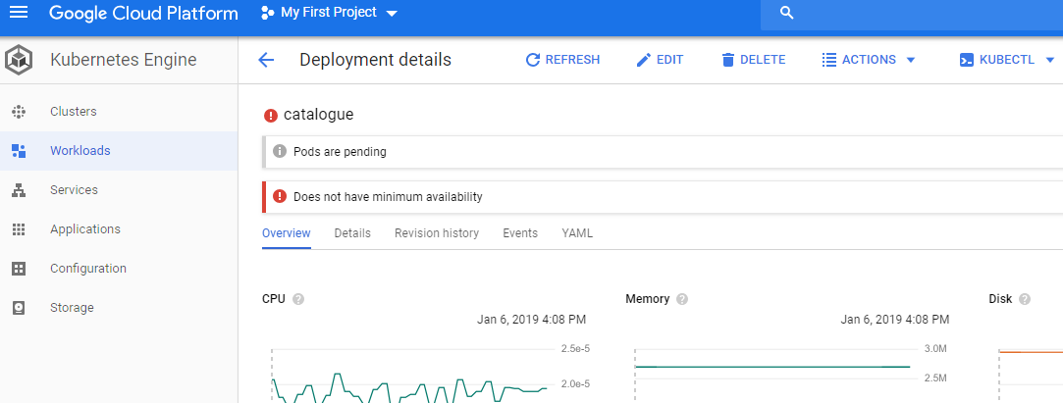

These are visible down in this same screen

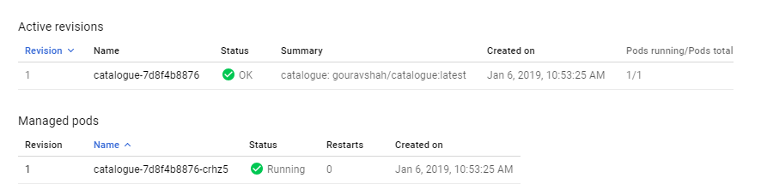

Note that the pods are not running on the same node, it automatically gets distributed to different nodes

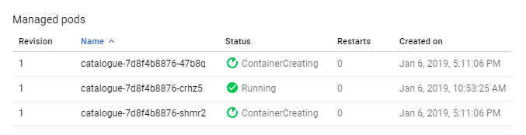

Click on the Node to see the details

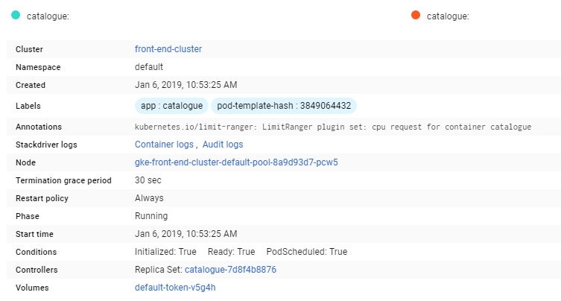

We can also click on the cluster and click on the nodes to see the details. We have been able to manually scale the application this way now. This also scales back to 1 since there is no load on the server.

Lets put some load on the auto-scaler ( simulate/ generate load for it to scale automatically ).

Use the image available on docker hub here <https://hub.docker.com/r/schoolofdevops/loadtest>

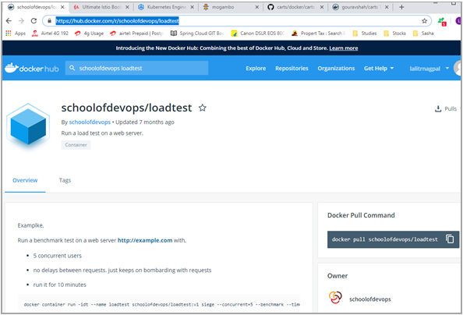

This needs to be run on the Google Cloud Console cloudshell

docker container run -idt --name loadtest schoolofdevops/loadtest:v1 siege --concurrent=5 --benchmark --time=10m http://35.244.60.104/category.html?tags=Samsung

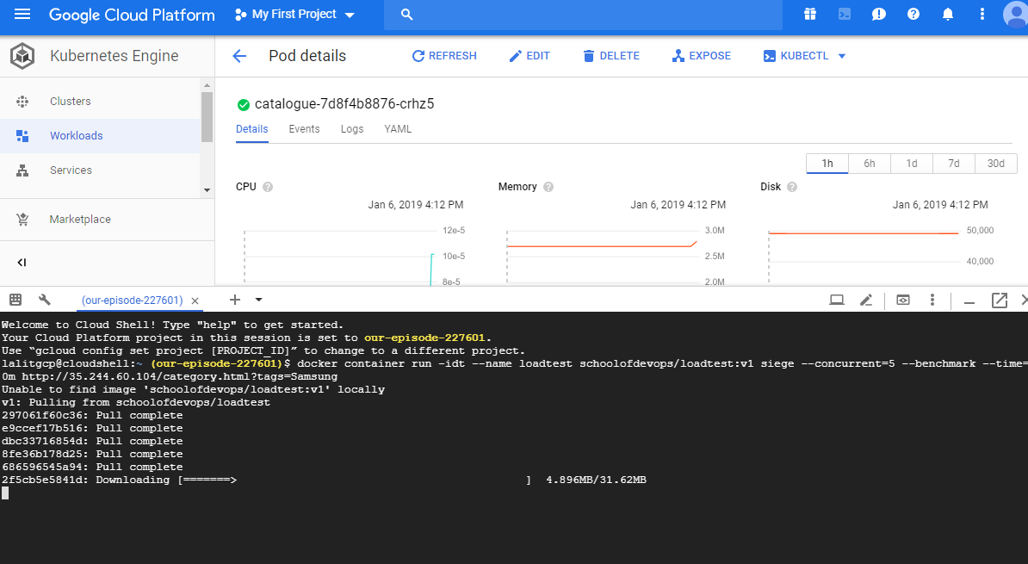

To see whats happening run the following command on the google cloud cloudshell

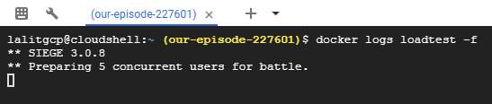

We can monitor this by getting into the workloads > click on catalogue and go to the bottom of the screen

We do not have any load at the moment

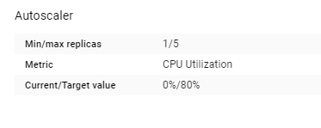

We can see the spike in CPU and Memory

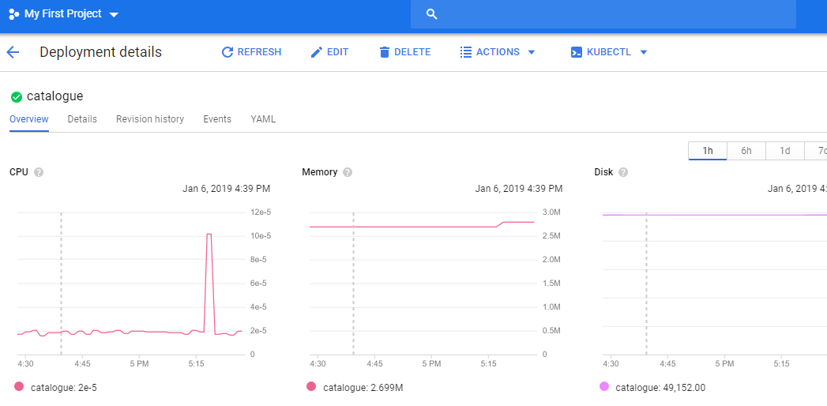

We can also click on the log link and see whats happening by hitting this link

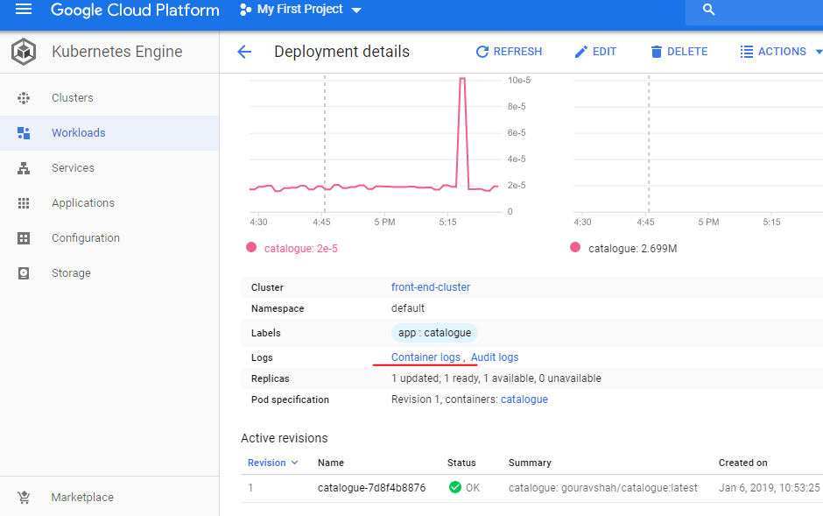

This brings us to the following page

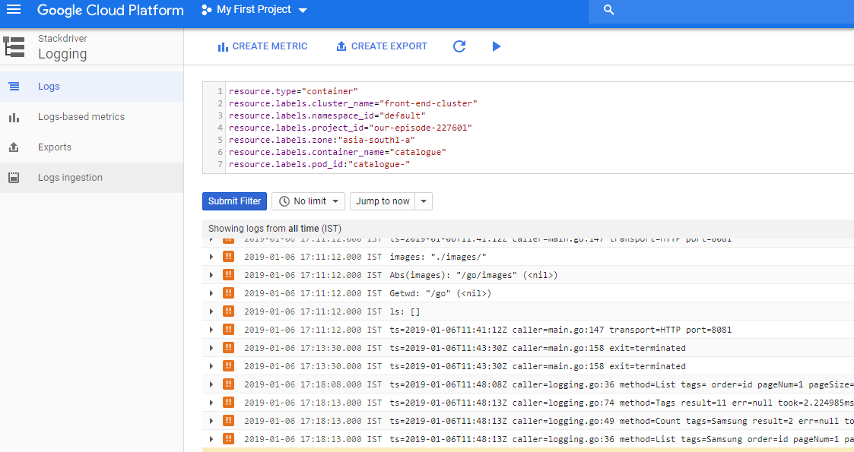

This lists the logs for the applications that are running in the container

To list the containers use the command

docker ps this would list the active containers

docker ps –a –q this would list all the containers

docker ps <container-id> this removes the container

We can see the front-end scaling now

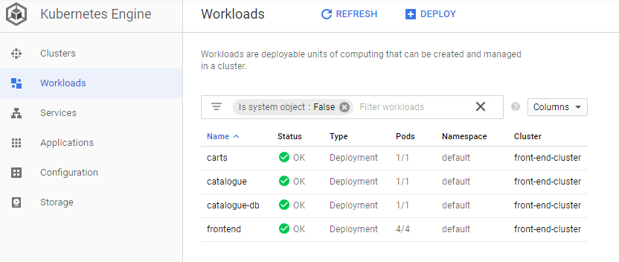

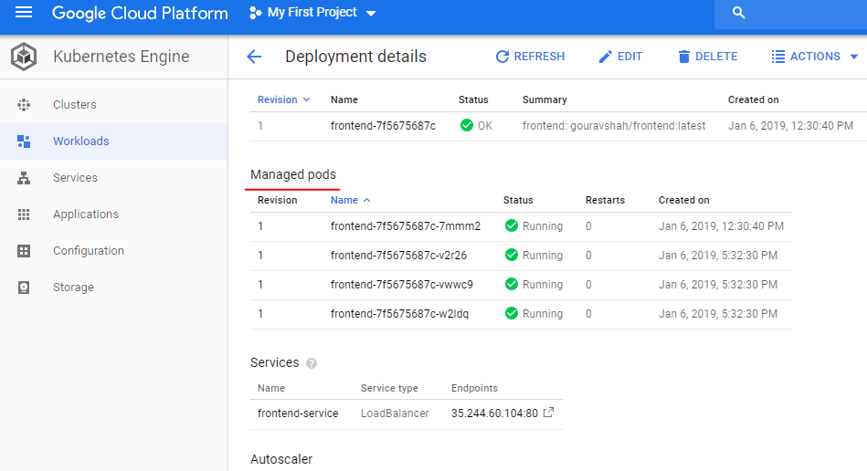

We just saw how the autoscaler scaled our frontend containers and would also descale them after a while automatically

Stop the container and we can see after a while that this descales back to 1 container

docker stop <container-id>

docker rm <container-id>

docker ps –a –q

It is taking up the load too slow, so maybe we need to supply more number of concurrent users. It also takes a while i.e. 2 to 3 minutes to descale back to 1 after the load is over.

### Zero Downtime Deployment

In the previous section we saw the scaling of application on Kubernetes either doing the manual killing or using auto scaling feature. Lets see another feature where you can deploy your application upgraded from one version to another without causing the downtime. It's also called zero downtime deployment. Let's have a look at it, list of deployed workloads that I have on my K8s cluster and I'm going to kill and deploy the front end application using rolling updates or 0 downtime deployment, in order to do that first thing that I'm going to do is scale this application.

Click on Edit, Edit the YAML and change replicas to 5, save and it starts to create the replicas

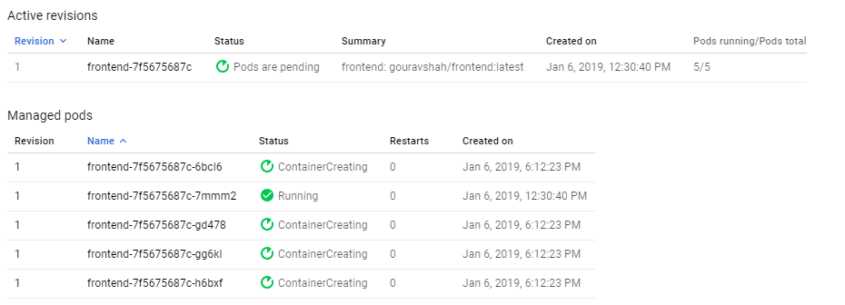

Right now there's only one instance running. There's no fun in deploying one instance in a rolling update at all. So I'm going to change that to eight replicas those replicas actually get reduced to five later, automatically actually does that configuration. So when you started deploying, it would be five replicas, that is desired. That is my desired number of replicas.

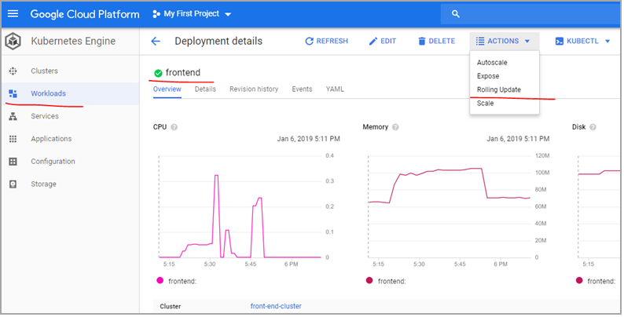

Let's zoom at five and I'm going to go ahead and create the rolling update configuration. This is where I defined how to update what is my body size. How much time I want to wait between each of that batch. Let's see if I have about size of two. One maximum search and one available. I define 20 second terms as that minimum ready second. It would deploy in a batch of two. So it will keep on repeating that process after every 20 seconds, so it would keep on deploying after 20 seconds, so it is going to deploy in four batches here. I also need to choose the image that I need to apply here.

|  |  |
| --- | --- |
|  | Minimum seconds ready - The minimum number of seconds for which a newly created Pod should be ready without any of its containers crashing, for it to be considered available.  Maximum surge - The maximum number of Pods that can be created over the desired number of Pods. The value can be an absolute number (for example, 5) or a percentage of desired Pods (for example, 10%).  Maximum Unavailable - The maximum number of Pods that can be unavailable during the update process. The value can be an absolute number (for example, 5) or a percentage of desired Pods (for example, 10%).  Specify a new image now |

Now after I made those changes if I keep on refreshing now the desired state has changed to 2:5 the image that I have for front-end has only one version. That's not very useful if I want to try out with different versions of the application. I'm going to give you another image which has been created with school of devops as an organization. If you go to school of devops slash Front-End, that image has many versions – see in tags and we are going to deploy the version 3 and version 4 using rolling update configuration. Now this is self-heal so I don't have to worry about those errors. And ultimately I would have five instances of that front end running. Right now version 7.0.3 on the UI of the frontend, that's the default version that I have with my image. I'm going to also set up a refresh interval so I have a plugin which keeps on automatically refreshing the browser page at the regular interval I have defined the interval to be four seconds.

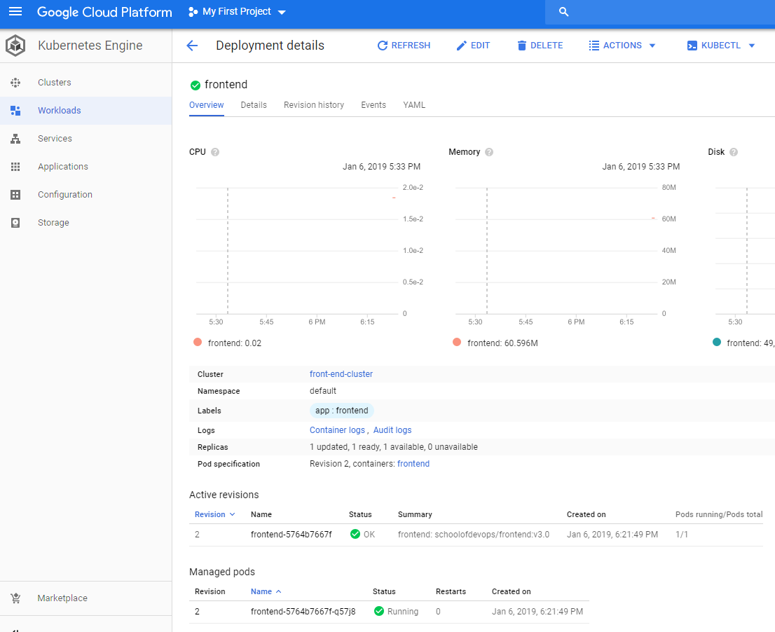

It says 1 updated, 1 ready and 1 available as we can see

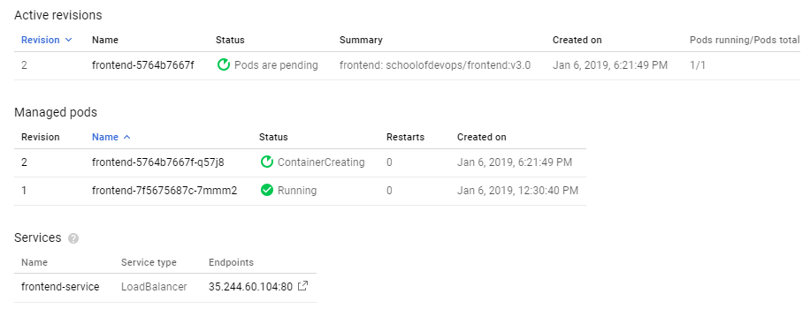

You can also manually refresh it or install a chrome plugin to do that. Now I have moved this to another window and I'm going to define the rolling update configuration this time actually I'm going to commit that configuration. Last time I was just showing it to you I have changed the image to school after slash friend and version 3.0. So version 3.0 and it has started applying the new version already. I see the next new version details here and this is without downtime, it is refreshing every four seconds. And as you see that application does not go down it is still available, sometimes it chose one and 3 that's a new version. Sometimes it shows the older version that is expected because it is just doing a rolling update and all of the available replicas of the parts would be added to the Lord balancer and would be live. That's the best they expected. You know version for rolling updates so you can have either or you know the previous or the new version but you won't have any downtime.



If we look at revision history we can see the revisions updated

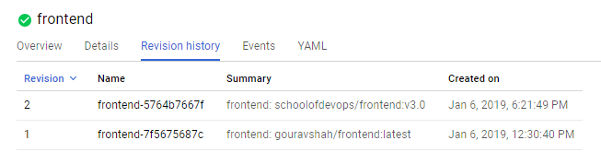

Now if you go back and keep on refreshing you'll see that every 20 seconds a new update is rolled out and some of these replicas are at version 2 some of those are at version 1. So we have a configuration where I want to have a surge of one so it has created six in total 4 updated, 6 in total and 2 updating. And eventually all five would be in their desired state. And then the additional serged replica would be deleted eventually. The services are also pointing to the newer versions now. One is in error because it is being deleted or removed which is absolutely fine and expected. Thats the first roll out with we want to. I'm going to deploy.

On updating to v4.0 now



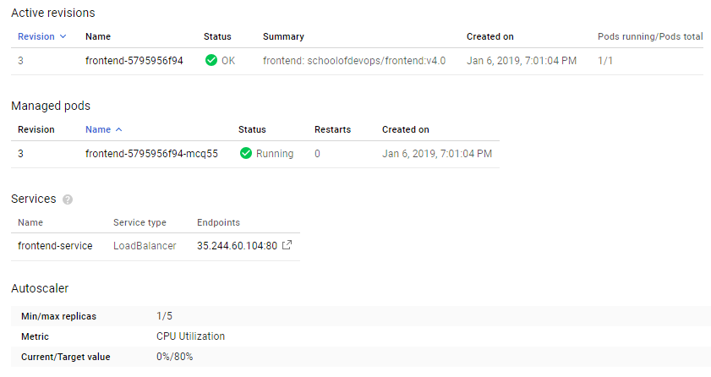

### Using kubectl – the CLI for Kubernetes

We demonstration Kubernetes cluster so far using the GCP console and created the services. We've also tried scaling the application as well as updating it using rolling updates. Now all of this so far that you've seen is been done using that GCP console. Now I'm going to show you how to actually manage K8s cluster using the kubectl, it is kubectl the CLI tool for Kubernetes, and to install that you have an option to do that using this cloud shell. Cloud shell is a great option because you don't have to install anything locally with local cloud, it will give you or set up an interface or a shell environment on the browser itself through the browser itself. So you don't have to install anything and it configures everything on its own. So I have just clicked on that cloud shell and it has that set up already. So it comes with the utilities but you still need to provide the configurations.

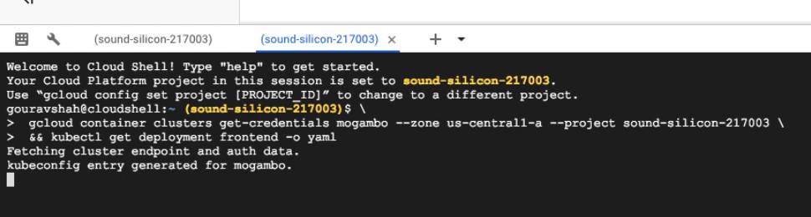

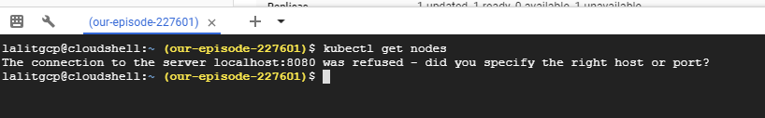

Click on the following link to setup your kubectl to point to the cluster

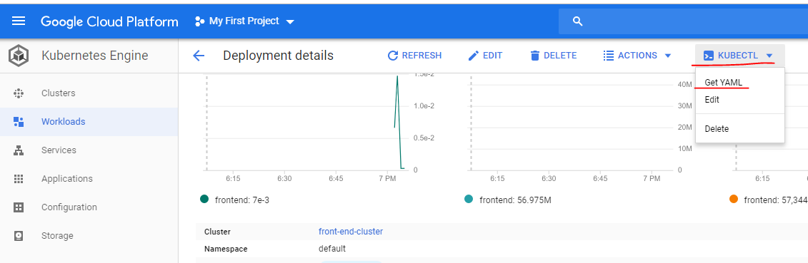

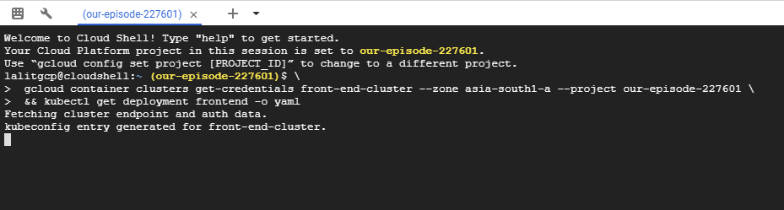

I choose that option to set up and that would help me create a shared environment set up for easier to operate. So all I have to do here is press enter because I already seee those command for gcloud container cluster and kubctl get deployment frontend etc. So it basically goes ahead and sets up the environment for itself for kubectl to operate.

So if you want to validate the set up you run kubectl get nodes, that will show your three nodes that are part of this group and that is cluster.

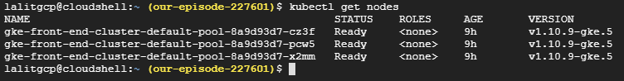

And if you just run kubectl, it will show you all the help including options that it supports and most commonly if you want to get you know information about something you generally use get and describe.

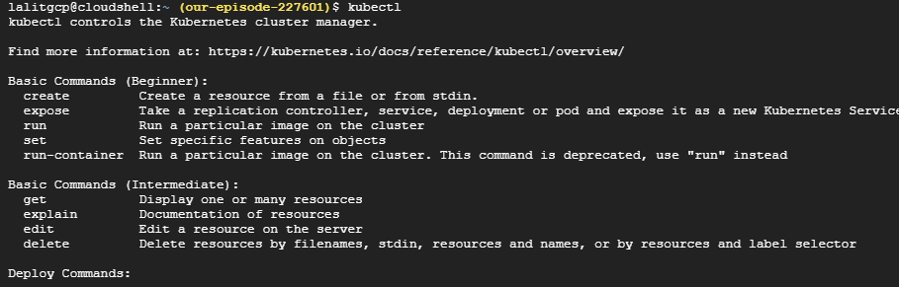

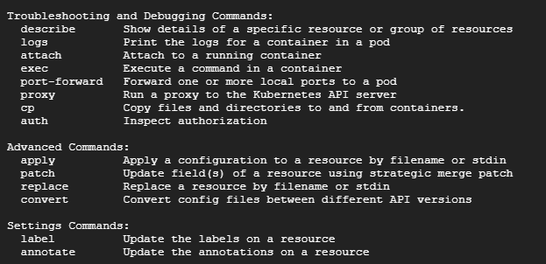

Apart from that you can also use clustered info to get status of this cluster so I'm going to start with kubectl cluster hyphen info to shows me the status of the K8s master, the load balancer, heapster which is a monitoring service Koob DNS and metrics. So all of these components have been deployed as part of the K8s control plane which has been set up and managed by GCP itself K8s engine to be precise, Google K8s is indeed to be precise.

If you just run kubectl get command it shows you all the objects that it can get information for.

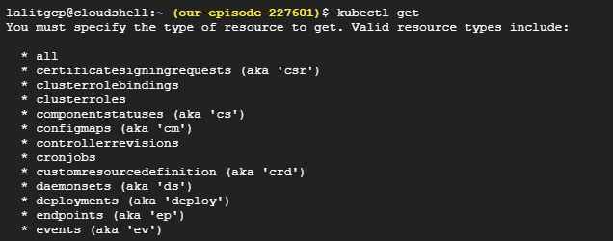

And it's going to be similar to what what is displayed here when you choose let's say services or workloads and you're going to pick the objects. For example deployments, either use deployments or short form is deploy, services is another important thing you can use either as services service or svc as the shortform. So if I could get deployment, it's going to show me the same details that we see on the Google Console GUI.

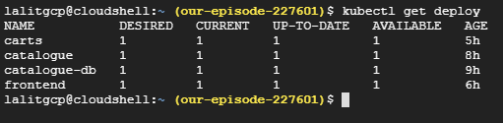

And if I want to get more information about it I can always use to describe. So I'm describing a deployment whose name is frontend.

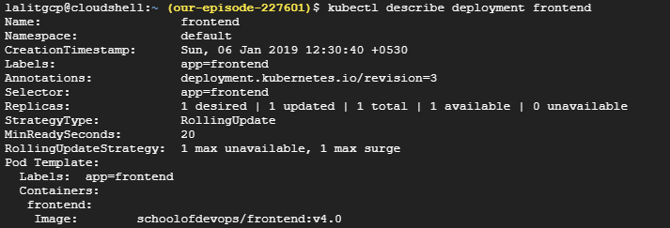

And this shows me the details about the deployment and how many replicas are running. What is the desired size and. well you know what each of that replica is running. So that configuration again if you drill down into the workloads and click on any of the deployment, it's the similar output that you can see there. Similarly if I were to get information about services I could use describe or get.

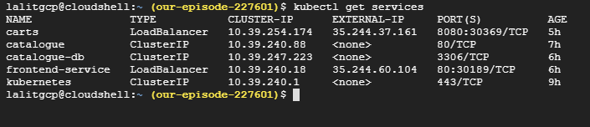

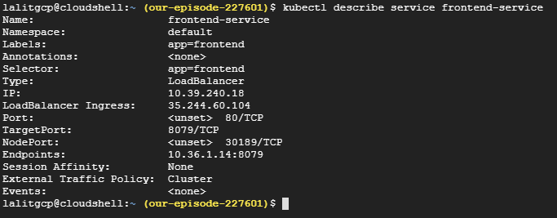

If you just use describe services it's going to show you the details about each and every service. I don't want that much of the details. I just want to get a list of services, I'm going to use kubectl get services, which shows me all the services services act as a load balancer and services having endpoints out of these.

Most of those are clustered IP internal services which have internal IP and only one has a external IP which is the service that we have exposed for the Front-End application. I could also use kubectl get svc which is a shortform for services. So only one service has been exposed outside using load balancer, that's the one which has external IP. I can also get a list of things by adding a comma separated items, so this time I'm listing pods, services and deployments so I'm using kubectl get svc,deploy,pods and I see four pods running. I can also manage the scale and replicas, so I could scale the replicas, deployments, specific deployment with a number of replica. This is a manual scaling so I'd use

kubectl scale --replicas=4 deploy/frontend

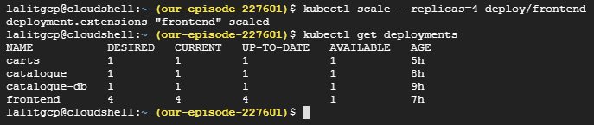

And that deployment has been scaled if I refresh it here I should see it is active scaling that gradually. And if I run get commands again, I should see 4 different pods running for the frontend. And I see all four pods running for the front and it will appear here if I refresh a couple of times.

### Deploying Istio Cluster with Google Kubernetes Engine

Lets see how to setup a Istio Cluster on Googles Kubernetes Engine

See the Istio page here - <https://istio.io/docs/setup/kubernetes/quick-start/>

Follow these instructions to prepare an GKE cluster for Istio.

<https://istio.io/docs/setup/kubernetes/platform-setup/gke/>

Or we could install this directly using the command ( picks the latest Istio )

Istio is installed in its own istio-system namespace and can manage services from all other namespaces.

Go to the Istio release page to download the installation file corresponding to your OS. On a macOS or Linux system, you can run the following command to download and extract the latest release automatically:

$ curl -L https://git.io/getLatestIstio | sh -

Move to the Istio package directory. For example, if the package is istio-1.0.5:

$ cd istio-1.0.5

The installation directory contains:

* + Installation .yaml files for Kubernetes in install/
  + Sample applications in samples/
  + The istioctl client binary in the bin/ directory. istioctl is used when manually injecting Envoy as a sidecar proxy and for creating routing rules and policies.
  + The istio.VERSION configuration file

Add the istioctl client to your PATH environment variable, on a macOS or Linux system:

$ export PATH=$PWD/bin:$PATH

lalitgcp@cloudshell:~/istio-1.0.5 (our-episode-227601)$ export PATH=$PWD/bin:$PATH

lalitgcp@cloudshell:~/istio-1.0.5 (our-episode-227601)$ echo $PATH

/home/lalitgcp/istio-1.0.5/bin:

/home/lalitgcp/gopath/bin:/google/gopath/bin:/google/google-cloud-sdk/bin:/usr/local/go/bin:/opt/gradle/bin:/opt/maven/bin:/usr/local/sbin:/usr/local/bin:/usr/sbin:/usr/bin:/sbin:/bin:/usr/local/nvm/versions/node/v8.9.4/bin:/google/go_appengine:/google/google_appengine

Create a new cluster.

gcloud container clusters create istio-cluster \

--cluster-version=1.10.9-gke.5 \

--zone asia-south1-c \

--project our-episode-227601

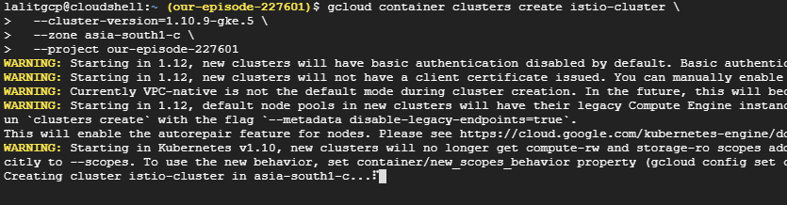

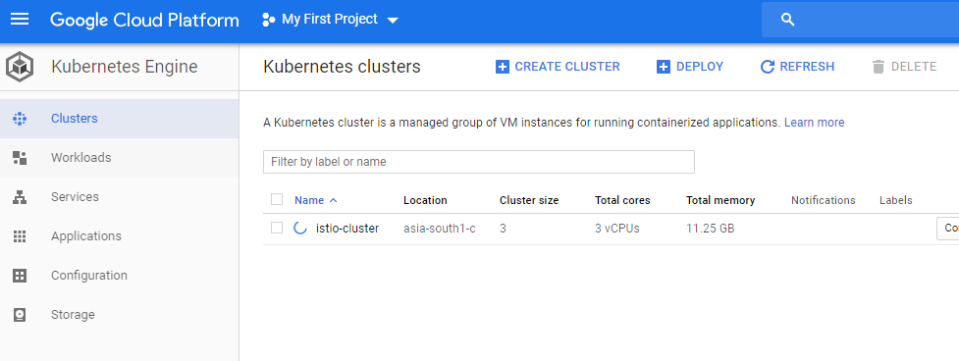

Retrieve your credentials for kubectl.

$ gcloud container clusters get-credentials istio-cluster \

--zone asia-south1-c \

--project our-episode-227601

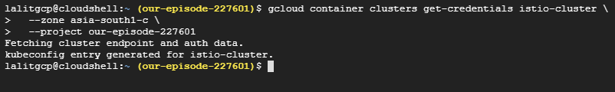

Grant cluster administrator (admin) permissions to the current user. To create the necessary RBAC rules for Istio, the current user requires admin permissions.

$ kubectl create clusterrolebinding cluster-admin-binding \

--clusterrole=cluster-admin \

--user=$(gcloud config get-value core/account)

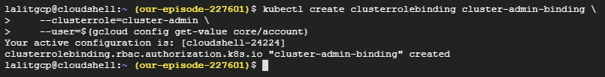

This can also be done via the GUI as follows

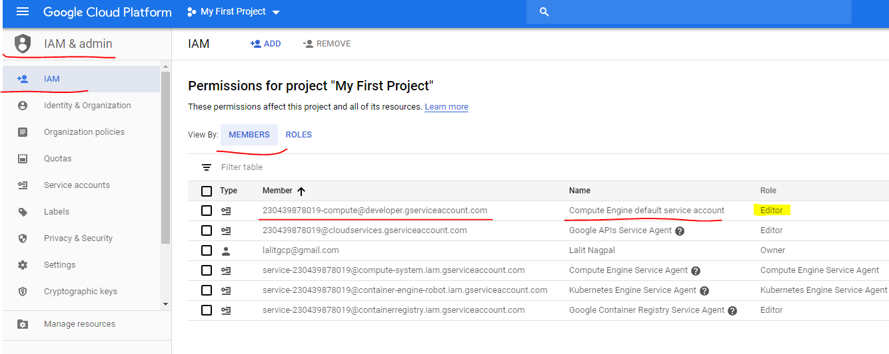

Click on edit and add another role of administrator for Kubernetes

This is all documented here > <https://istio.io/docs/setup/kubernetes/quick-start-gke-dm/>

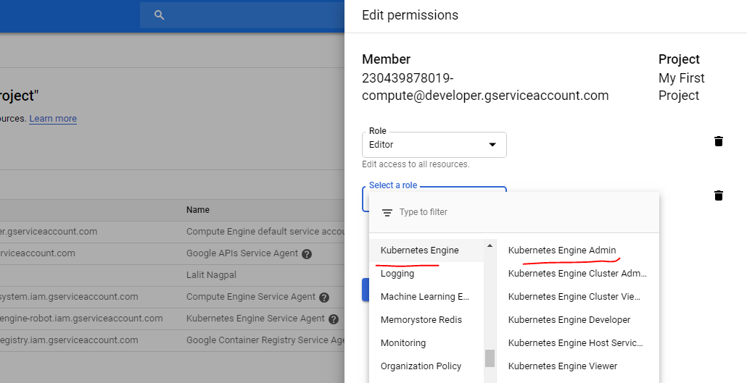

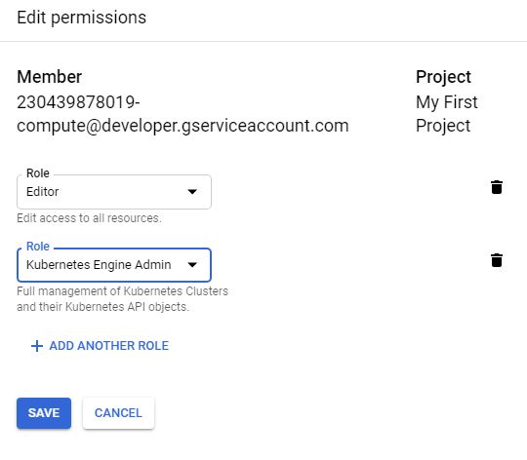

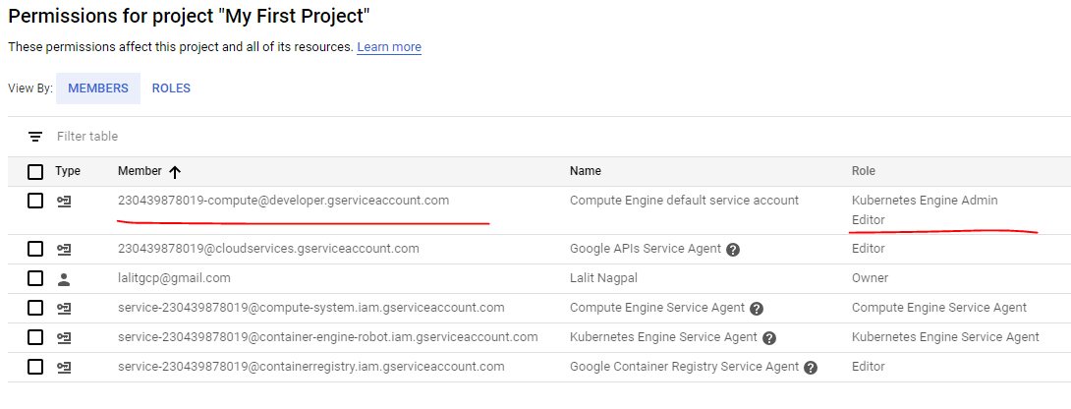

Setup

Go to the Marketplace and search for Istio

Launch Deployment Manager > [LINK](https://accounts.google.com/signin/v2/identifier?service=cloudconsole&continue=https://console.cloud.google.com/launcher/config?templateurl=https://raw.githubusercontent.com/istio/istio/release-1.0/install/gcp/deployment_manager/istio-cluster.jinja&followu)

Once you have an account and project enabled, click the following link to open the Deployment Manager.

|  |  |
| --- | --- |
|  | **Istio GKE Deployment Manager**  We recommend that you leave the default settings as the rest of this tutorial shows how to access the installed features. By default the tool creates a GKE alpha cluster with the specified settings, then installs the Istio control plane, the Bookinfo sample app, Grafana with Prometheus, ServiceGraph, and Tracing. You’ll find out more about how to access all of these below. This script will enable Istio auto-injection on the default namespace only.  Click Deploy: |

This will take some time to install

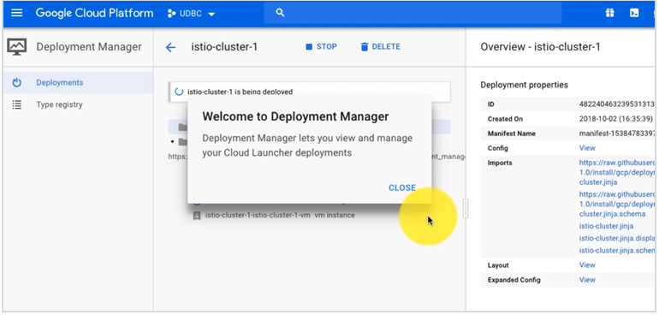

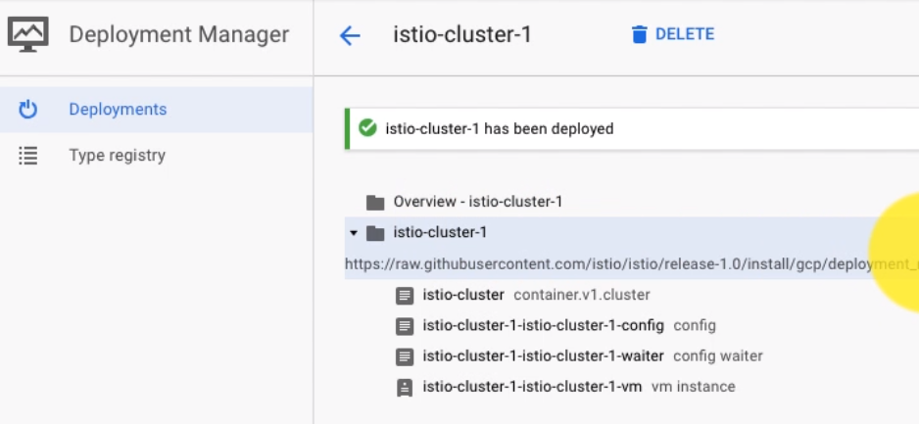

On the right hand side we see all the components that have been enabled for this

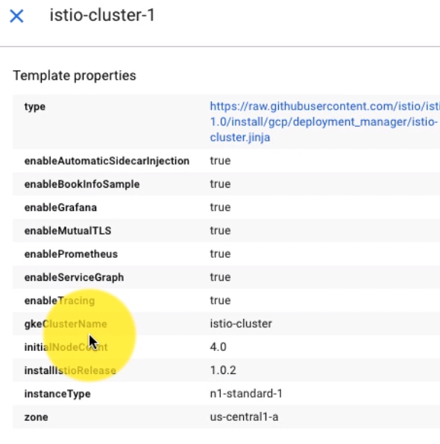

The cluster can be seen here under Kubernetes Engine > Clusters

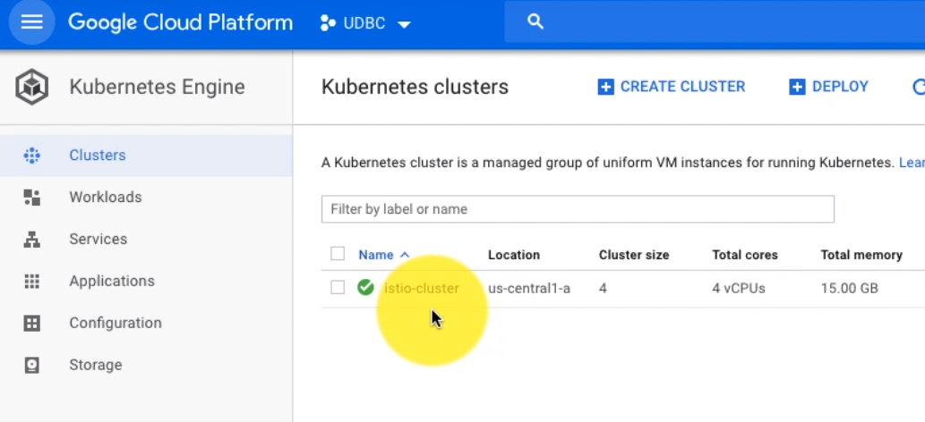

Under Services, we will see a lot of services created for us – lot of Istio related services like citadel, galley, pilot, prometheus, Jaeger, tracing, zipkin, grafana and so on are visible here. All of these have been launched automatically by the Istio template that we have used. This is all a part of namespace – a lot of this is a part of istio-systems namespace.

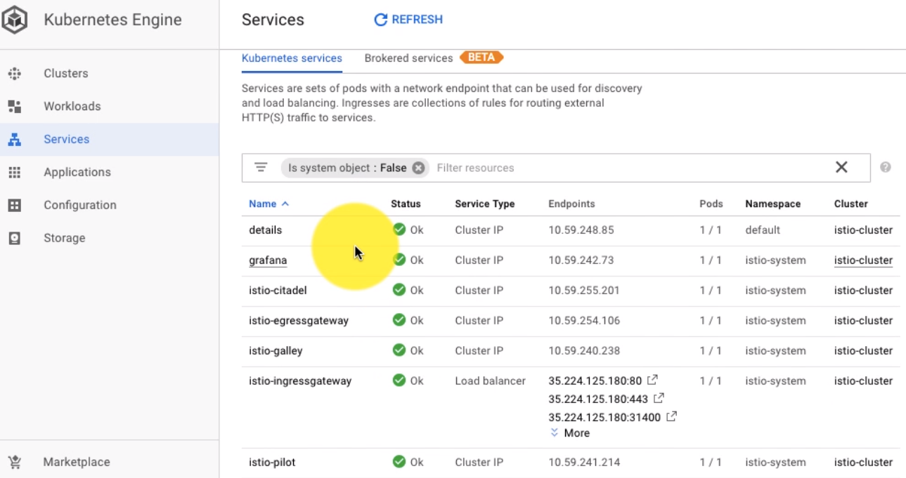

This is the quickest way of setting up Istio with GCP

### Setting up Google Cloud SDK for Istio

We can open the google cloud shell in the browser and work using that or we could install the Google Cloud SDK –

1. Download the Cloud SDK installer. The installer is signed by Google Inc.

<https://dl.google.com/dl/cloudsdk/channels/rapid/GoogleCloudSDKInstaller.exe>

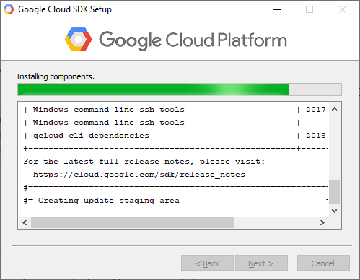

1. Launch the installer and follow the prompts.
2. Cloud SDK requires Python 2 with a release version of Python 2.7.9 or later. The installer will install all necessary dependencies, including the needed Python version, by default. If you already have Python 2.x.y installed and want to use the existing installation, you can uncheck the option to install Bundled Python.

*Note: As of Cloud SDK version 206.0.0, the gcloud CLI has experimental support for running using a Python 3.4+ interpreter (run gcloud topic startup for exclusions and more information on configuring your Python interpreter). All other Cloud SDK tools still require a Python 2.7 interpreter.*

After installation has completed, accept the following options:

* Start Cloud SDK Shell
* Run gcloud init

The installer starts a terminal window and runs the gcloud init command.

1. The default installation does not include the App Engine extensions required to deploy an application using gcloud commands. These components can be installed using the Cloud SDK component manager.

*Note: On Google Compute Engine instances running Windows Server, Internet Explorer is set for Enhanced Security Configuration. This setting prevents you from running the installer above. Disable Enhanced Security Configuration first, restart Internet Explorer and then run the installer. For instructions on disabling Enhanced Security on your Windows Server Instance, open Windows Help and Support and search for "IE ESC".*

You can also install the latest version from a downloaded .zip file:

1. Download google-cloud-sdk.zip and extract its contents. (Right click on the downloaded file and select Extract All.)
2. Launch the google-cloud-sdk\install.bat script and follow the installation prompts.
3. When the installation finishes, restart the command prompt (cmd.exe).
4. Run gcloud init:

C:\> gcloud init

Select your account and you should be authenticated

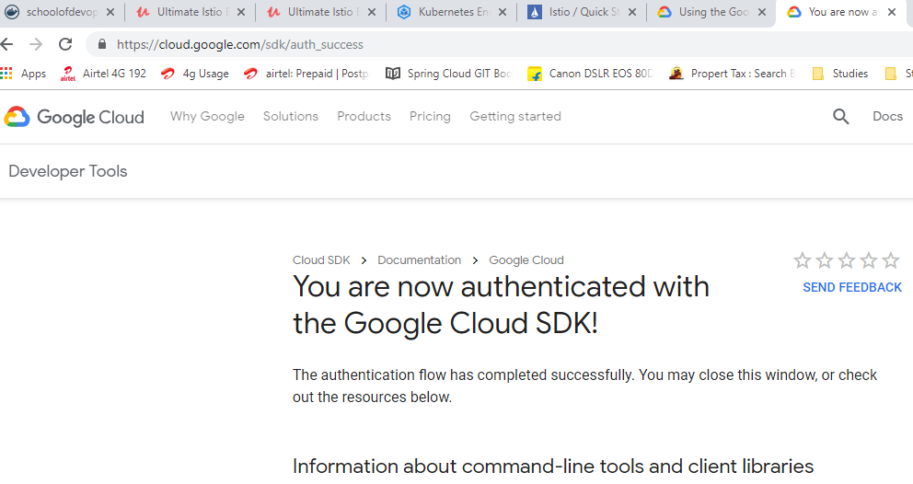

Specify the default region

Specify the Project

And we are done

We also need to install kubectl which is a different software. Since we installed Docker we already have it installed

<https://kubernetes.io/docs/tasks/tools/install-kubectl/>

C:\> gcloud container clusters list

C:\>

We do not have any Cluster at the moment but list projects

C:\> gcloud projects list

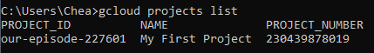

So this is running from our desktop and fetching from GCP

Run the command

C:\..> kubectl get pods, svc, deploy, ing –n istio-system

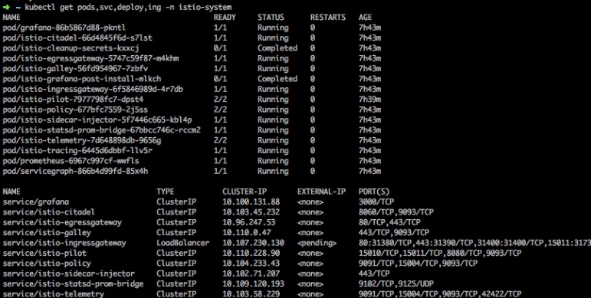

Getting Namespaces

C:\..> kubectl get ns

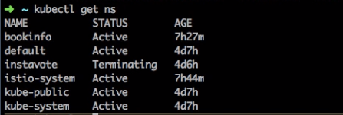

C:\..> kubectl get deploy,svc

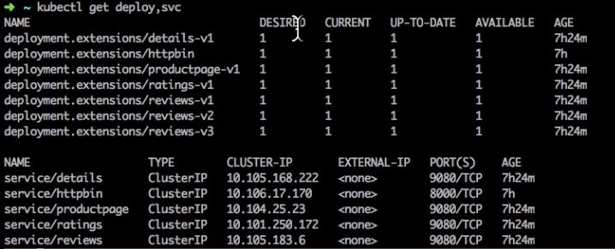

There is a sample application a book information application – web browser microservices based application – these are the services deployed for that application

This is the architecture of that application

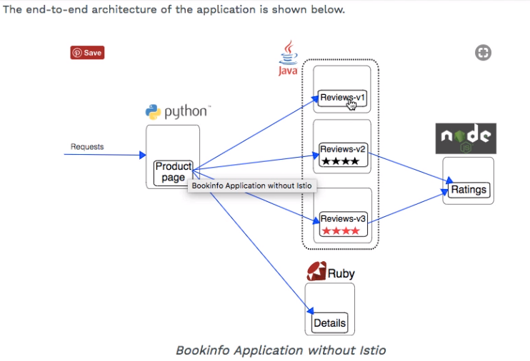

There are 4 different components of this application and it has been deployed with multiple deployments as well and the services has been created.

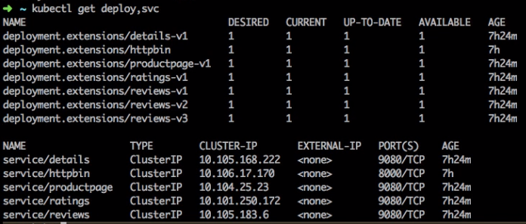

We can describe any of the service to see its details

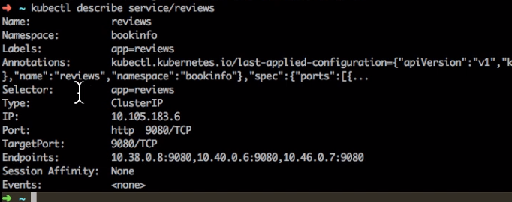

**Examining the Ingress now**

We will examing the ingress now, as we need to connect to this application and to do that we need to use the ingress controller which in this case it is a load balancer. If we are not using cloud we would have to use NodePort or some other configuration related to Kubernetes.

This is the workload, this is the ingress controller

C:\..> kubectl get svc istio-ingressgateway –n istio-system

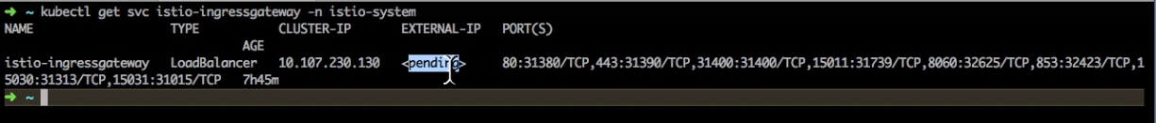

The external IP here is still pending but we have the Load Balancer created, and so we can go to the services and look at that, this actually shows you the status of the load balancer being active and with these ports, so if we want to access the application we can use the endpoints here

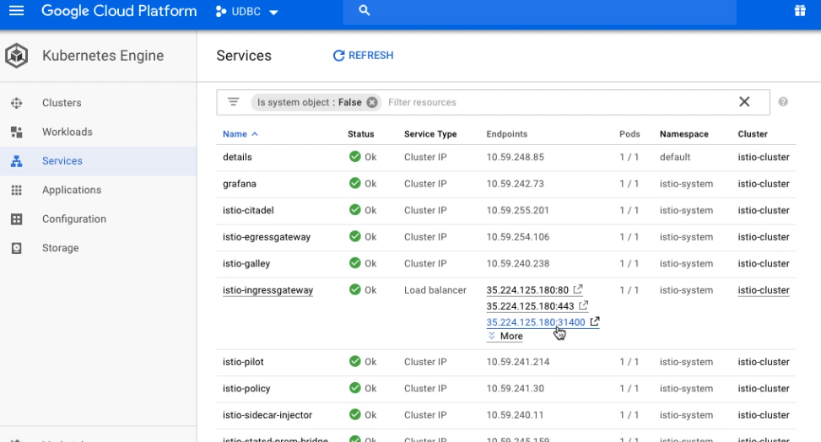

This is the frontend for the book application

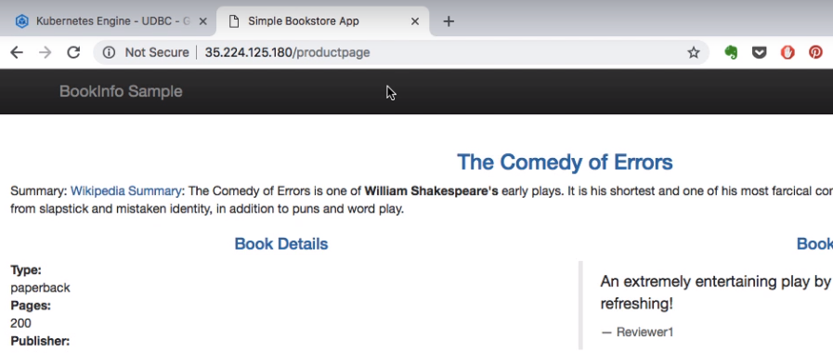

On this page we have a command to load test this application, lets use that

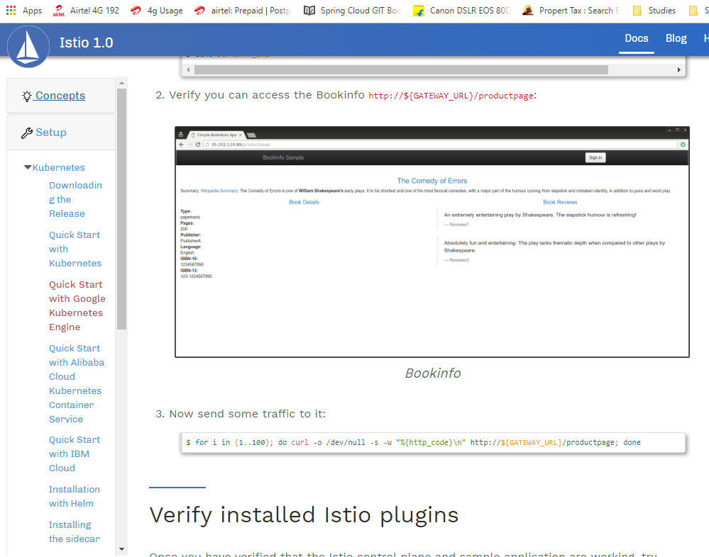

for i in {1..100}; do curl -o /dev/null -s -w "%{http_code}\n" http://${GATEWAY_URL}/productpage; done

This will generate some data that is useful to examine Istio later, we are generating some load

Now when we come back and validate Istio we would be able to see some details

### Validating Istios Telemetry Plugins

Verify installation

We have the following services running

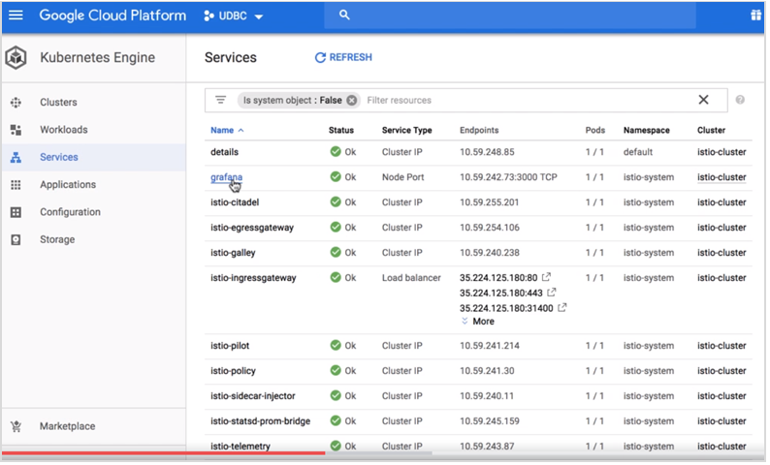

Verify Istio is installed in its own namespace

$ kubectl get deployments,ing -n istio-system

NAME DESIRED CURRENT UP-TO-DATE AVAILABLE AGE

deploy/grafana 1 1 1 1 4m

deploy/istio-citadel 1 1 1 1 4m

deploy/istio-egressgateway 1 1 1 1 4m

deploy/istio-ingress 1 1 1 1 4m

deploy/istio-ingressgateway 1 1 1 1 4m

deploy/istio-pilot 1 1 1 1 4m

deploy/istio-policy 1 1 1 1 4m

deploy/istio-sidecar-injector 1 1 1 1 4m

deploy/istio-statsd-prom-bridge 1 1 1 1 4m

deploy/istio-telemetry 1 1 1 1 4m

deploy/prometheus 1 1 1 1 4m

deploy/servicegraph 1 1 1 1 4m

Now confirm that the Bookinfo sample application is also installed:

$ kubectl get deployments,ing

NAME DESIRED CURRENT UP-TO-DATE AVAILABLE AGE

deploy/details-v1 1 1 1 1 7m

deploy/productpage-v1 1 1 1 1 7m

deploy/ratings-v1 1 1 1 1 7m

deploy/reviews-v1 1 1 1 1 7m

deploy/reviews-v2 1 1 1 1 7m

deploy/reviews-v3 1 1 1 1 7m

Now get the istio-ingress IP:

$ kubectl get svc istio-ingressgateway -n istio-system

NAME TYPE CLUSTER-IP EXTERNAL-IP PORT(S) AGE

istio-ingressgateway LoadBalancer 10.59.251.109 35.194.26.85 80:31380/TCP,443:31390/TCP,31400:31400/TCP 6m

Note down the IP address (EXTERNAL-IP) and port assigned to the Bookinfo product page (in the example above, it’s 35.194.26.85:80).

You can also view the installation using the Kubernetes Engine -> Workloads section on the Cloud Console:

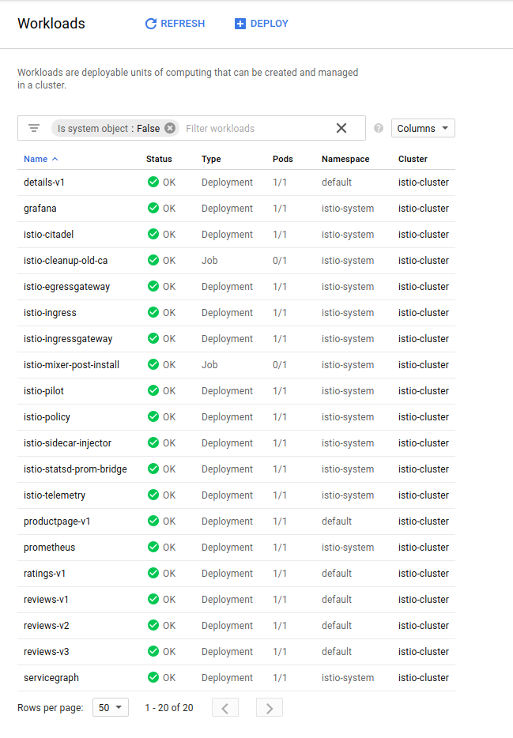

Access the Bookinfo sample

Set up an environment variable for Bookinfo’s external IP address:

$ export GATEWAY_URL=$(kubectl -n istio-system get service istio-ingressgateway -o jsonpath='{.status.loadBalancer.ingress[0].ip}')

$ echo $GATEWAY_URL

Verify you can access the Bookinfo http://${GATEWAY_URL}/productpage:

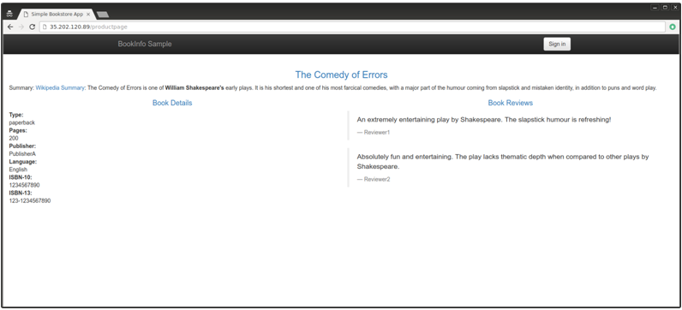

Now send some traffic to it:

$ for i in {1..100}; do curl -o /dev/null -s -w "%{http_code}\n" http://${GATEWAY_URL}/productpage; done

**Verify installed Istio plugins**

Once you have verified that the Istio control plane and sample application are working, try accessing the installed Istio plugins.

If you are using Cloud Shell rather than the installed gcloud client, you can port forward and proxy using its [Web Preview](https://cloud.google.com/shell/docs/using-web-preview#previewing_the_application) feature. For example, to access Grafana from Cloud Shell, change the kubectl port mapping from 3000:3000 to 8080:3000. You can simultaneously preview four other consoles via Web Preview proxied on ranges 8080 to 8084.

**Grafana**

Set up a tunnel to Grafana:

$ kubectl -n istio-system port-forward $(kubectl -n istio-system get pod -l app=grafana

-o jsonpath='{.items[0].metadata.name}') 3000:3000 &

then

http://localhost:3000/dashboard/db/istio-dashboard

You should see some statistics for the requests you sent earlier.

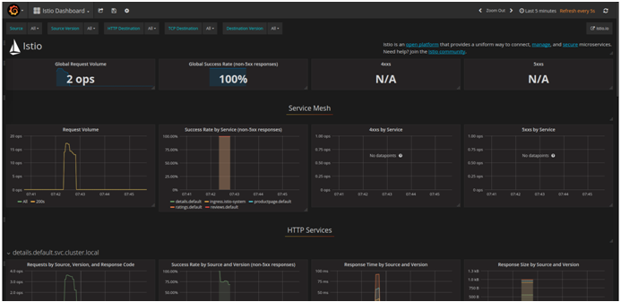

Prometheus

Prometheus is installed with Grafana. You can view Istio and application metrics using the console as follows:

$ kubectl -n istio-system port-forward $(kubectl -n istio-system get pod -l app=prometheus -o jsonpath='{.items[0].metadata.name}') 9090:9090 &

View the console at:

http://localhost:9090/graph

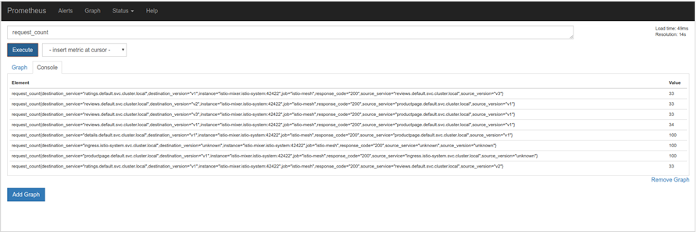

Prometheus

For more details, see [About the Prometheus Add-on](https://istio.io/docs/tasks/telemetry/querying-metrics/#about-the-prometheus-add-on).

**ServiceGraph**

Set up a tunnel to ServiceGraph:

$ kubectl -n istio-system port-forward $(kubectl -n istio-system get pod -l app=servicegraph -o jsonpath='{.items[0].metadata.name}') 8088:8088 &

You should see the Bookinfo service topology at

http://localhost:8088/dotviz

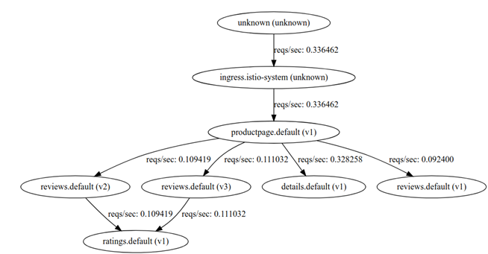

Tracing

Set up a tunnel to the tracing dashboard:

$ kubectl port-forward -n istio-system $(kubectl get pod -n istio-system -l app=jaeger -o jsonpath='{.items[0].metadata.name}') 16686:16686 &

You should see the trace statistics sent earlier on [http://localhost:16686](http://localhost:16686/)

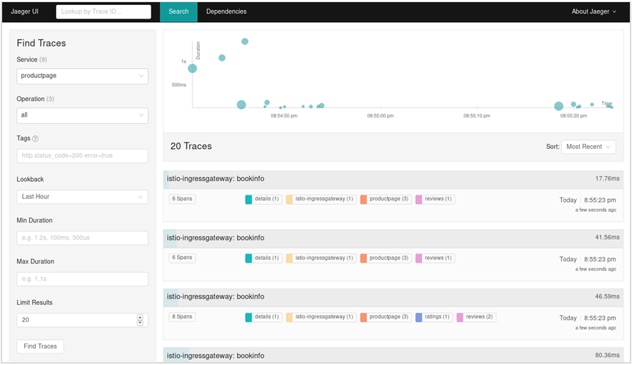

For more details on tracing see [Understanding what happened](https://istio.io/docs/tasks/telemetry/distributed-tracing/#understanding-what-happened).

Jaeger does the open tracing part of this

**Uninstalling**

Navigate to the Deployments section of the Cloud Console at <https://console.cloud.google.com/deployments>

Select the deployment and click **Delete**.

Deployment Manager will remove all the deployed GKE artifacts - however, items such as Ingress and LoadBalancers will remain. You can delete those artifacts by again going to the cloud console under [**Network Services** -> **Load balancing**](https://console.cloud.google.com/net-services/loadbalancing/loadBalancers/list)

Bootstrap gcloud

Once deployment is complete, do the following on the workstation where you’ve installed gcloud:

Bootstrap kubectl for the cluster you just created and confirm the cluster is running and Istio is enabled

$ gcloud container clusters list

NAME LOCATION MASTER_VERSION MASTER_IP MACHINE_TYPE NODE_VERSION NUM_NODES STATUS

istio-cluster us-central1-a 1.9.7-gke.1 35.232.222.60 n1-standard-2 1.9.7-gke.1 4 RUNNING

In this case, the cluster name is istio-cluster.

Now acquire the credentials for this cluster

$ gcloud container clusters get-credentials istio-cluster --zone=us-central1-a

BookInfo Application

Details here > <https://istio.io/docs/examples/bookinfo/>

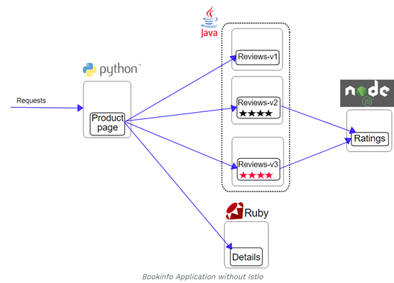

This application is polyglot, i.e., the microservices are written in different languages. It’s worth noting that these services have no dependencies on Istio, but make an interesting service mesh example, particularly because of the multitude of services, languages and versions for the reviews service.

<https://istio.io/docs/examples/bookinfo/#if-you-are-running-on-kubernetes>

We have multiple versions here to understand the intelligent routing and canary releases and introduce fault, fault tolerance and so on.

And the way Istio works is by injecting its own containers into each of the pod for the application. So you will see a pod being added to every single service. And this is where the Envoy Proxy is running along with that. It has added the Ingress controller. So the request will go to Ingress first and from there it will go to the product info application and other things and way Istio manages this is by injecting the proxy that is Envoy into each of the pod and that's what you see here. So when you list the pods you'll see that it is running two containers, each of this is running two containers but only one is related to the application. And if you look at the pod you'll find only one container related to the application. The other one is your proxy.

So this is how it works so if you inject its own proxy into every single part along with your application, that's the Istio proxy container. And that's true for every single application that you're running. For this every single service that is part of your Microservices stack here. So you can use ‘kubectl describe pods’ and the pod information to verify that. So I'm going to go and look at the review the system again. So this is a pod for reviews version 1.

And that is how Istio hijacks the networking and manages it, the routing and everything else is decided using the control plane then.



So that's what you have here in this diagram what you explain is the proxy, that is the container injected and that proxy sends information to the Mixer. Then there are a couple of other control applications including Citadel and Pilot which decide on the routing and fault tolerance and send the telemetry off of this application. And if you look at this application I'm going to start refreshing this there are three different versions of the review system and there's only one service pointing to it. So if you keep on refreshing I have a browser extension which allows me to auto refresh and I'm doing that every three seconds if you examine it is actually it shows you two different versions one with the one with the ratings in red one with just the stars one doubt any ratings. The one in the red is version 3 and it is right now load balancing across it in round robin fashion.

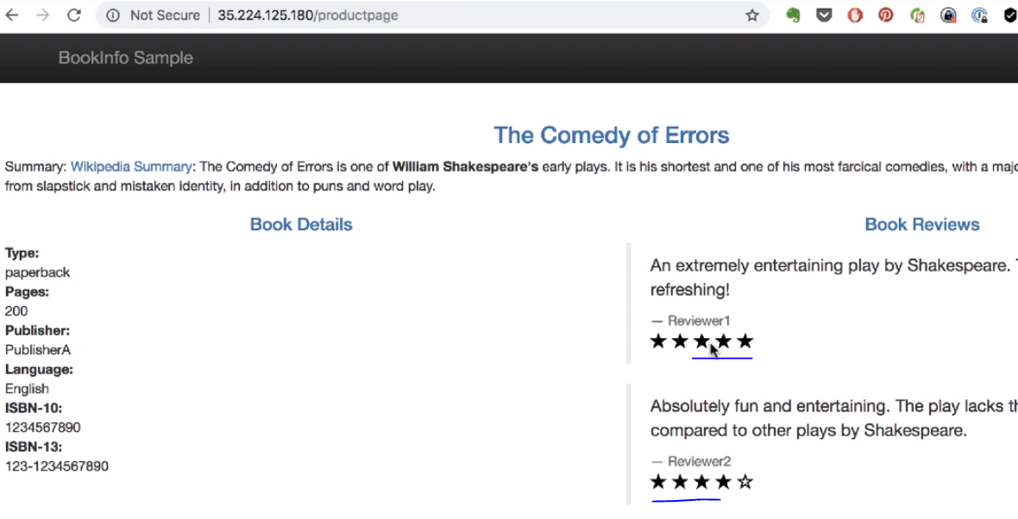

Now that's about the book info application. And what components have been installed and how it works, how you add proxy containers to the application - that was a quick dive into the book info application deployed on our cluster. And this is the same application that we're going to use to examine and understand how it works.

### Deploy Canary Releases with Intelligent Routing

But if I go filter by cluster name then I see nothing here. No work loads, no services running and that's why I'm going to deploy the book info applications. I go back to Istios doc page > examples > book info application.

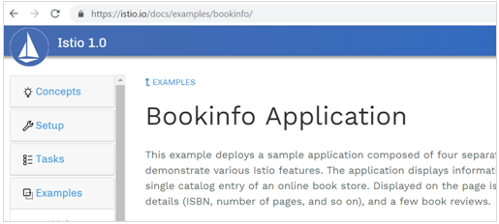

If I scroll down here it talks about the architecture and then it talks about deploying the application either on K8s or using Docker with Consul. I am going to pick K8s option, now he talks about setting up this cluster with Istio installed, we don't want to install Istio, so I'm going to simply purely simply deploy just the application with no Istio injection policies or anything else for that matter. I already have Istio installation here which comes with the samples, samples has book info project for K8s and then I have to deploy that book info.yaml., that is going to create the deployment and the services that I need in order to run this book info application. So I need to do is

kubectl apply –f samples/bookinfo/platform/kube/bookinfo.yaml

and as we see it is creating the deployments, services needed for running that book info application and this is running running without Istio.

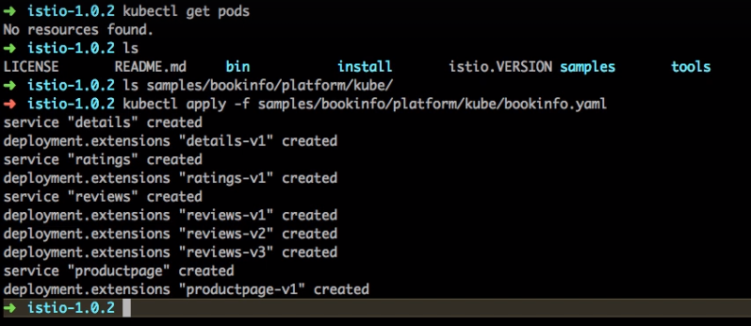

So if we run kubectl get pods, it shows only one - zero out of one - meaning it's only going to create one container in that pod. No Istio proxies, nothing else involved here. And if I refresh this page again I see the services being created and services have been created. The workloads the deployments are probably in progress. You can also again have to filter by cluster name that is k8s even in the workloads. I see some of these applications are ready and some of those review applications is still pending status.

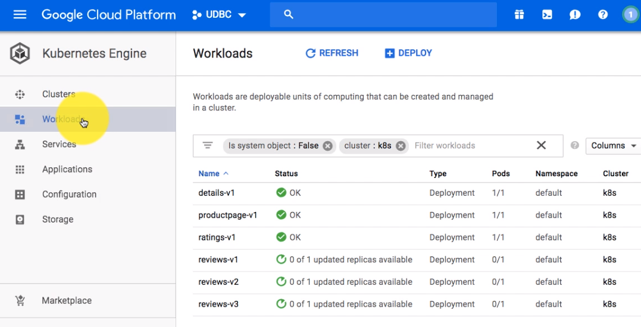

But it will be ready in a couple of minutes. Now the next thing is how do we access this application deployed here. To access the application we need to go to the service, it's this page on the product page is the front end for this application

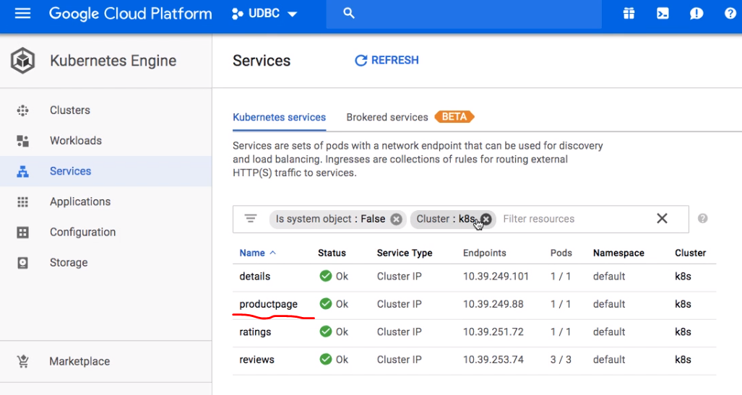

Product Page has been created with cluster IP as the configuration right now. So there are two options either you can use port forwarding or you could simply create a service out here, the service type to be load balancer instead of clustered IP.

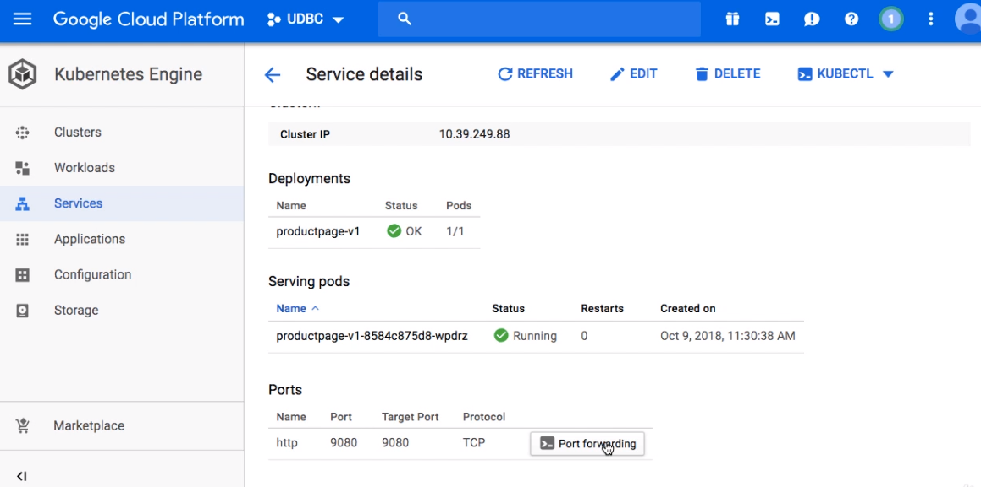

If you change the Service type to load balancer with L and B capital it will automatically go ahead and create a load balancer and expose the application and create and give you the end point in a few minutes time.

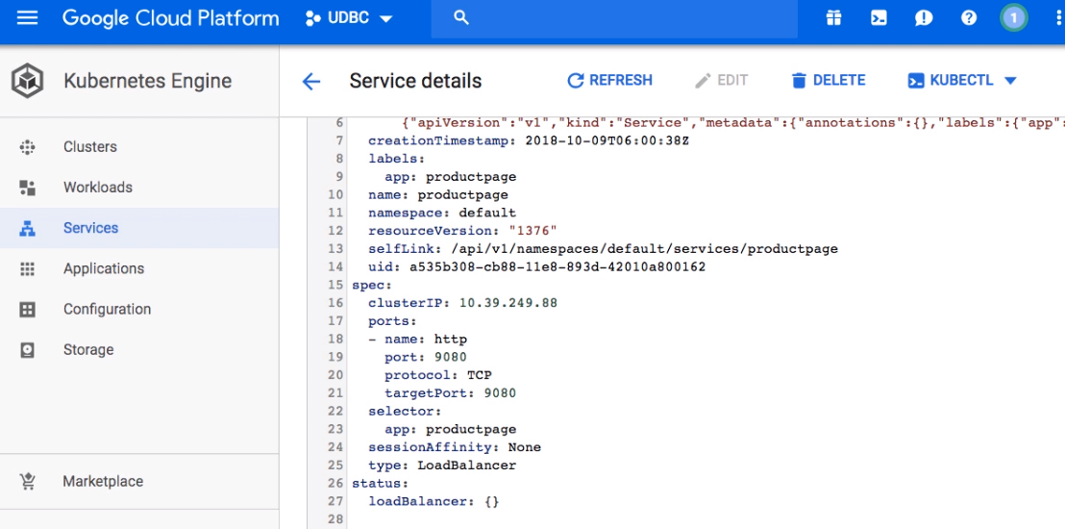

Again I'm going to go back to the services page, come back after a few minutes, and I should see the service and endpoint created with the load balancer

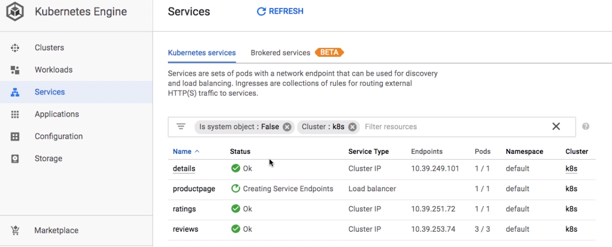

I get that endpoint if I click on that it takes me to this page.

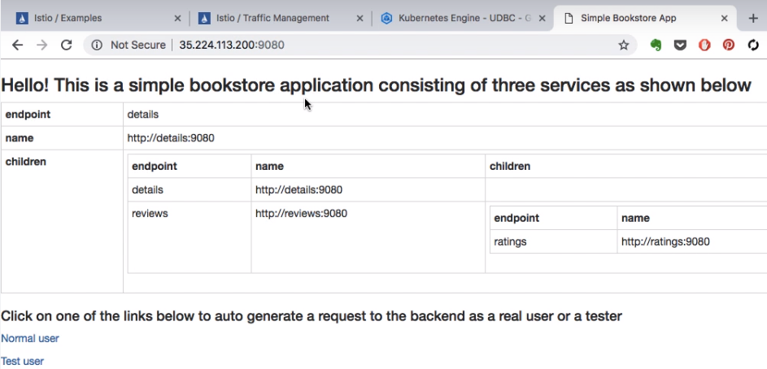

Now from here it has a couple of links at the bottom. Noraml user and test user, you see that on the bottom section here. So if you click on that normal user link, that should take me to the product page and this is the front end for the book info application - the same application that we deployed with Istio earlier. This is without Istio and with pure K8s.

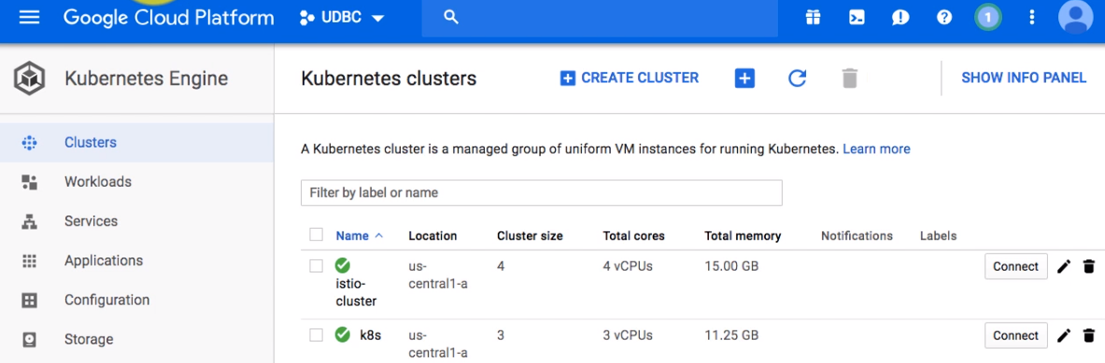

We'll start looking at the differences between these two. And we keep switching back between these two clusters – one with Istio and one without Istio and we are going to see the difference between why we need Istio. What are the additional things it offers. When we start looking at some of the additional examples including the intelligent routing right here and then I'm going to switch back to my is Istio cluster so that I can start playing around with it.

C:\..> kubectl config get-contexts

C:\..> kubectl config use-context gke_udbc_218210_us-central1-a_istio_cluster

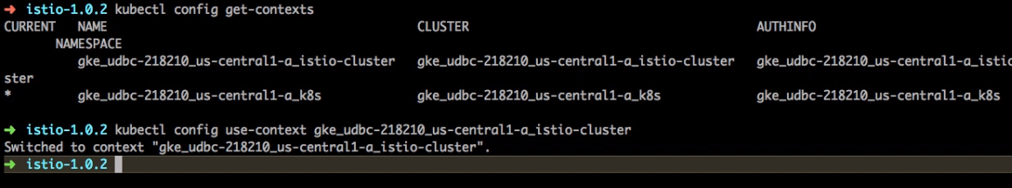

So to do that you have to use the switch context so you can get context. So you have to use kubectl config get context to list the available context and then using use-context as a command or option to config. I would switch the context back to this Istio cluster. After switching we can verify via the asterisk – it should have been switched to the first line. That is my Istio cluster and I can validate that if I don't get pods. I see two out of two for each of that. So that is that is with your proxy.

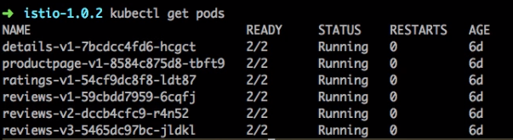

And I can also list the parts in the istio system itself using the namespace. And that shows me there still a namespace so I have created a K8s cluster and then I have switched back now to the Istio cluster so that we can start looking at the features.

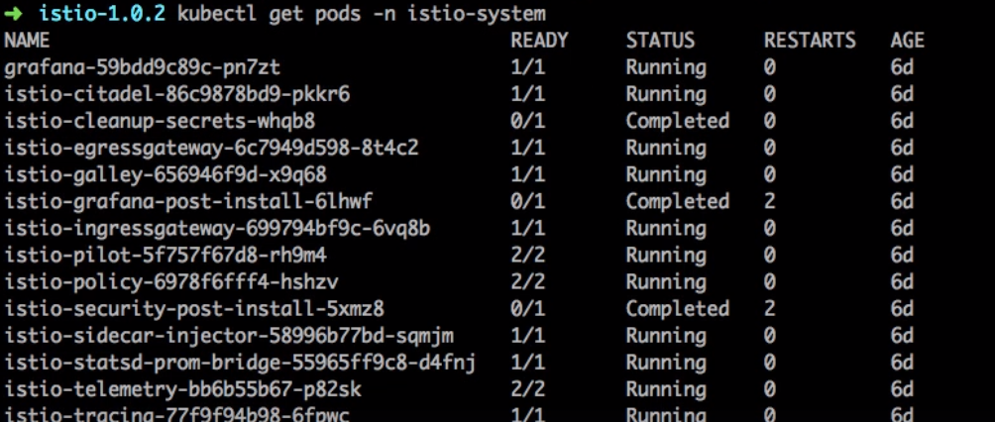

### Testing Application Resiliency by Injecting a Fault

To understand why do we need Istio we are going to do a side by side test between Istio and K8s. I have these two screen. I mean two windows split between the screen and one side of them running Istio and on the other we are just running pure K8s cluster.

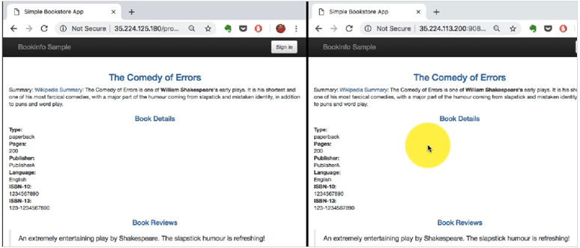

The first test is to check the intelligent routing and basically what we want to do is key - all the traffic should go to one of my application except for one type of request which comes from a particular user Jason. So if the request comes from the Jason it should go to the Canary release that is Version 2, that is where I want to test it. And this is on the live system. And the rest of the requests should go to the Version 1. So the canary release - the whole purpose of the canary is to be able to do live testing on a production kind of environment. And we are going to check which one gives us the best possible option whether Istio or whether it is Kuberenetes.

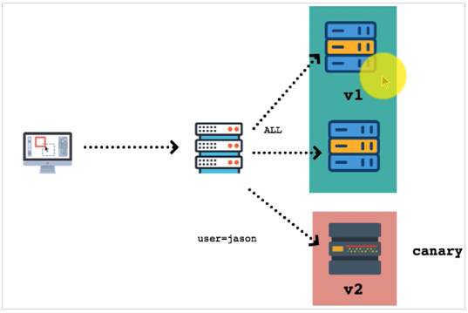

And that's what we're going to be going to begin with. So let's start. I'm going to begin by connecting to the pure Istio cluster. I'm just checking the configurations here using kubectl config get-context command. If you're not sure you can use the use-context and connect to the Kubernetes cluster.

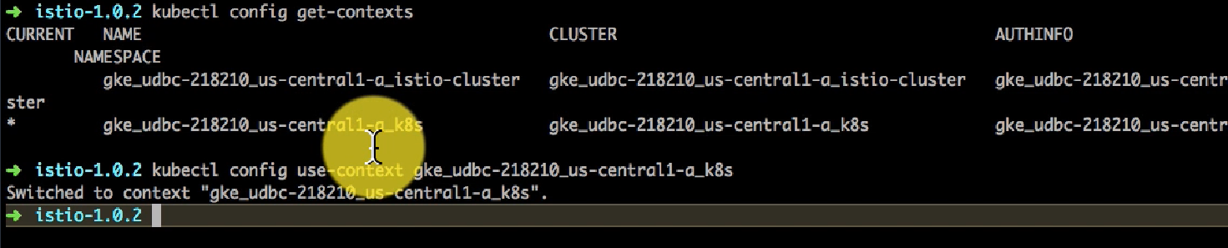

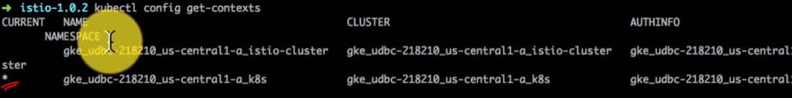

Make sure it is the active cluster right now. And here I'm going to update the configuration for the services. First I'm going to check the configuration by listing pods, svc and deploy. So I see the services. Out of that we have a service called as reviews and that is actually pointing to three different pods created with three different deployments with version 1 and version 2 and version three.

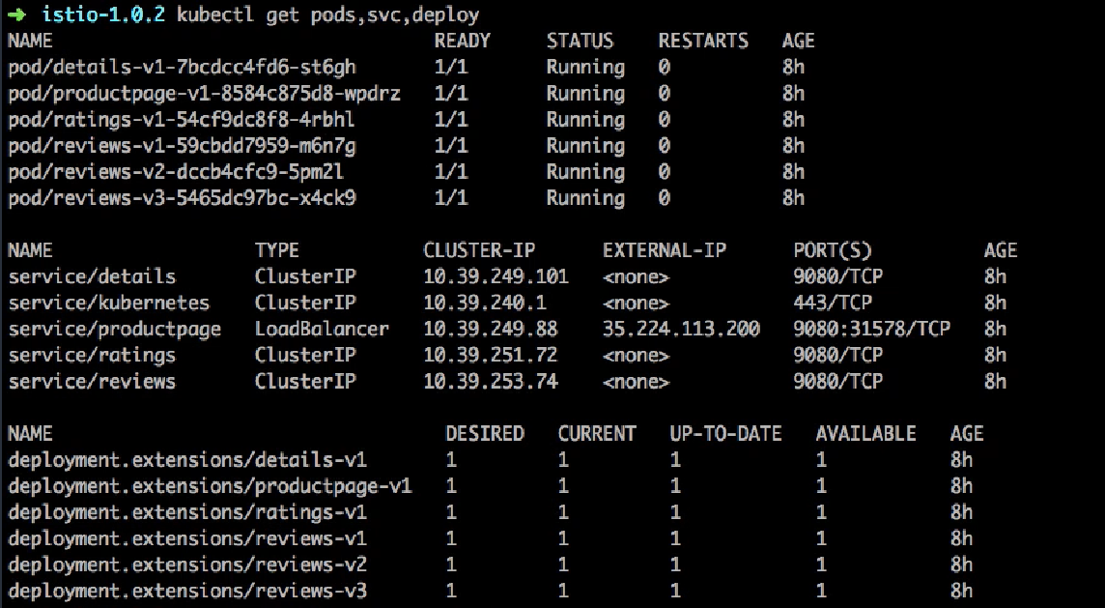

Let's observe this service called as reviews and find out what it is pointing to, currently it is all dependent on the services and the selectors that they use. So if we look at it right now, it is pointing to three different endpoints created by three different deployments. Just to understand where it came from I could also you know use that deployment configuration.

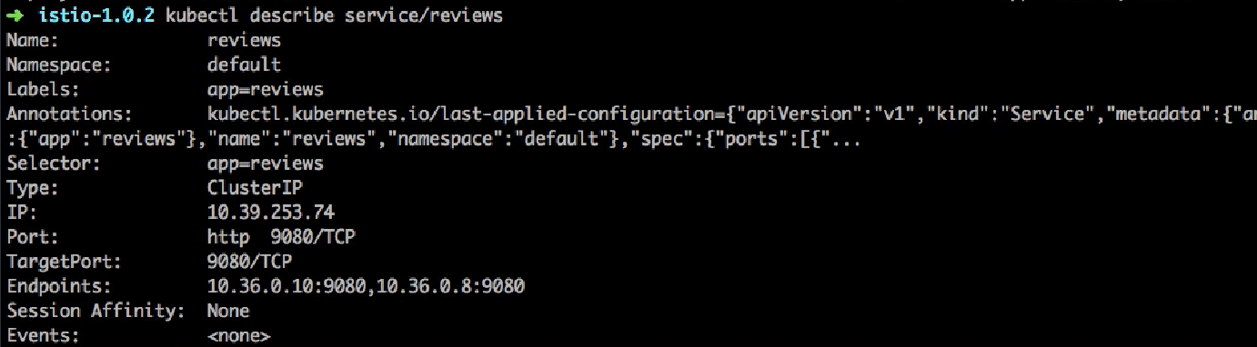

So the only way, I can route the traffic to version one and version two is by deleting version 3, because right now if you look at the selector, it is only going to look for app=reviews. And if you look at your labels right now you have app=reviews for all versions and then we have another version tag which has v1, v2, v3. With selectors, so this Services selector you cannot do a set based selection. So there is a limitation on that.

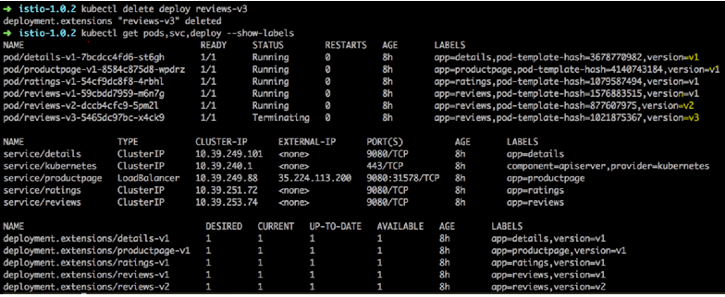

So the only way, it would work right now is by deleting that deployment. And even with that what is going to happen is, it's pointing towards version v1 and v2, and there is no way to differentiate between which request is going to v1 and v2, and it is just doing a round robin mechanism load balancing and that's what you see and this window the right hand side is the K8s and if I start refreshing that, in order to refresh that with a regular user or a logged in user or when you log in as a particular use that is Jason, it doesn't change that.

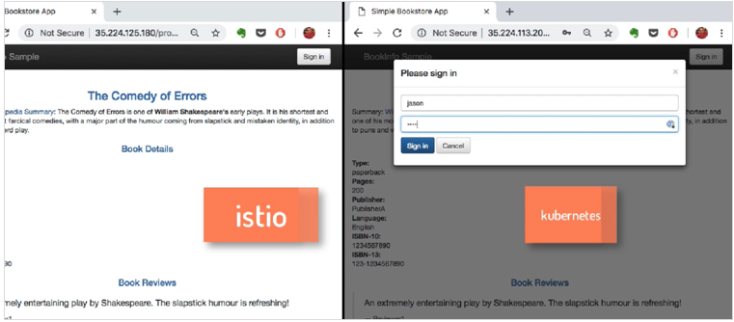

The objective we had was if the user is Jason, it should only point to version two, for every other request it should go to be one, that is not possible. I've changed the windows of K8s, it is on the left hand side and it is still doing the round robin with me, even when I'm logged in as the user Jason and so this is the limitation with K8s, it is what it is is doing just a round robin algorithm and the onus is then on the application to route the request for a particular user or a particular version and so on and so forth which is more complex.

Whereas with Istio you can do intelligent routing with the request routing and that's exactly what we are going to do. So here what we're going to begin with is I'm going to switch to the Istio cluster and run this you know apply this model first which is going to first start pointing all the traffic to version 1. That's what I want to show you, so I need to switch back to that Istio cluster.

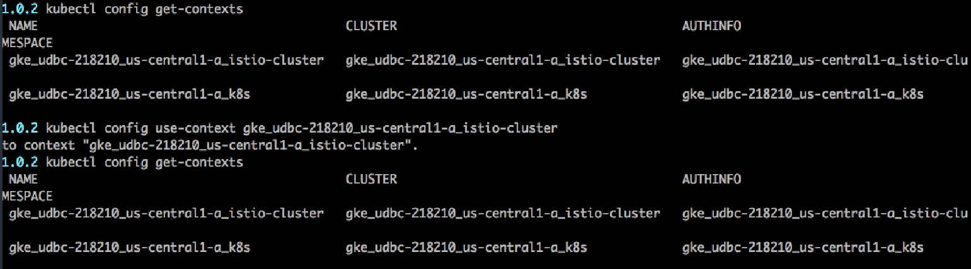

I'm going to use config use context and switch to Istio cluster. The first line is active which means I'm connected to the cluster. And here I'm playing the virtual services.

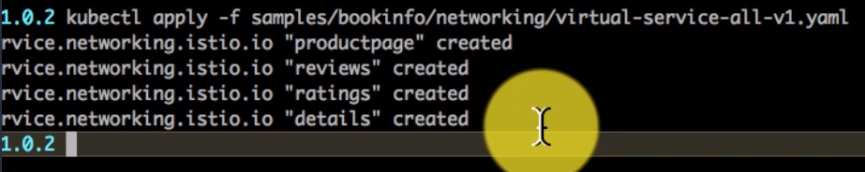

<https://istio.io/docs/examples/intelligent-routing/>

You have configured Istio to route to the v1 version of the Bookinfo microservices, including the ratings service.

The concept of what services is similar or by to the concept of services in K8s, that is what your services are custom resource definitions created by Istio. And here it has created the visual services and I'm going to list the information or get information about all these virtual services by using this command kubectl get virtual-service command.

Apply a virtual service

To route to one version only, you apply virtual services that set the default version for the microservices. In this case, the virtual services will route all traffic to v1 of each microservice.

1. Run the following command to apply the virtual services:

$ kubectl apply -f [samples/bookinfo/networking/virtual-service-all-v1.yaml](https://raw.githubusercontent.com/istio/istio/release-1.0/samples/bookinfo/networking/virtual-service-all-v1.yaml)

Because configuration propagation is eventually consistent, wait a few seconds for the virtual services to take effect.

Display the defined routes with the following command:

C:\..> kubectl get virtualservices -o yaml

apiVersion: networking.istio.io/v1alpha3

kind: VirtualService

metadata:

name: details

...

spec:

hosts:

- details

http:

- route:

- destination:

host: details

subset: v1

---

apiVersion: networking.istio.io/v1alpha3

kind: VirtualService

metadata:

name: productpage

...

spec:

gateways:

- bookinfo-gateway

- mesh

hosts:

- productpage

http:

- route:

- destination:

host: productpage

subset: v1

---

apiVersion: networking.istio.io/v1alpha3

kind: VirtualService

metadata:

name: ratings

...

spec:

hosts:

- ratings

http:

- route:

- destination:

host: ratings

subset: v1

---

apiVersion: networking.istio.io/v1alpha3

kind: VirtualService

metadata:

name: reviews

...

spec:

hosts:

- reviews

http:

- route:

- destination:

host: reviews

subset: v1

---

1. Display the corresponding subset definitions:

$ kubectl get destinationrules -o yaml

kubectl get virtual-services command hyphen o yaml will show me the descriptive YAML for my output and here I see the what services configuration for example if the service with name book info and there are routes defined here for every path based routing hyphen product page hypen login and hyphen logout, it is going to send it to the productpage.

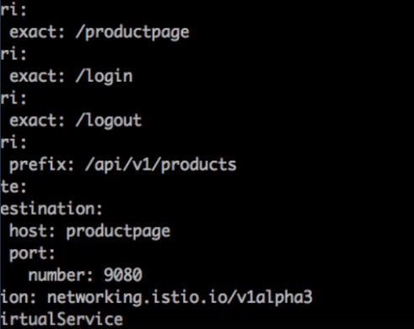

So it's part of the service. And for every application including details reviews in a product page itself. Again it is going to point to a particular route or a particular service here. This is a virtual service for reviews. And right now we have configured it to send all the traffic to just one and one so all traffic is going to go to one will validate that by switching to you know the browser and see how this works.

Apart from that there has to be some destination's rules and I'm going to validate it is there.I can find it.

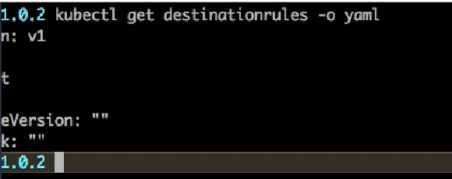

I had created the cluster with Google container engine which unfortunately looks like did not create the destination rules. If I go back to the same page and look at before you begin section the prerequisite, I'm going to go and look at the deploy book info sample application. So this application is deployed. I see all the services running but I don't see the destinations routes, so I'm going to go and find out the relevant sections related to destination routes. If I keep scrolling down I see the configuration apply default destination rules.

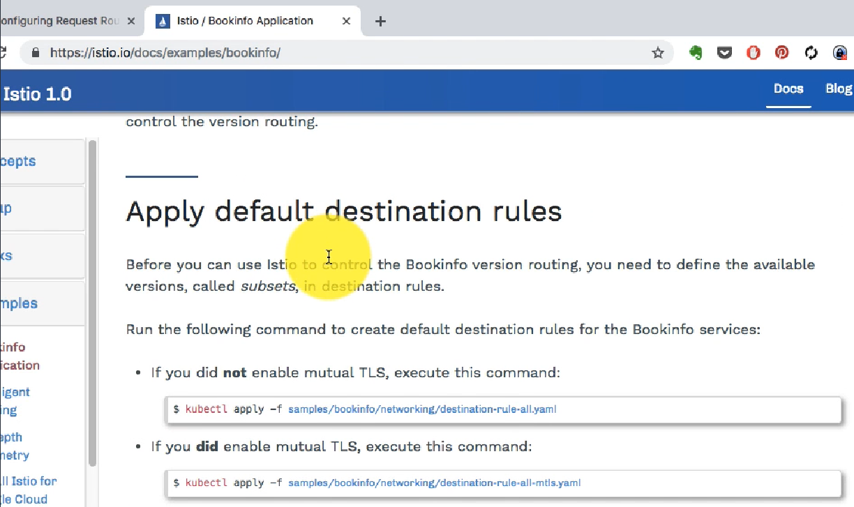

Now if you're using mutual TLS, you have to choose this second line. Since Google container engine has created a TLS setup so I need to apply the second part time, so its time to validate now.So if I go back and look at the page here and all the record, all the traffic for right now the rule is simple all the traffic goes to V-1 and that's what I see here. Right now I'm not logged in as any user but even if I do all the traffic has been configured to be sent to the same version one, that's what I'm going to try here.I'm going to try logging in here. There's no password defined for other users so you can just add any string and it will allow you to log in as user Jason. I've started out very fresh and I'm going to bring it back to that same competitive window.The split screen and here again I see is version two on the left hand side, kubernetes is on the right hand side. Given that it is. Switching back between you know it's doing a round robin between version 1 version 2 because there is no way to differentiate between which and on the other hand for Istion all the traffic has been routed to Version 1 right now.

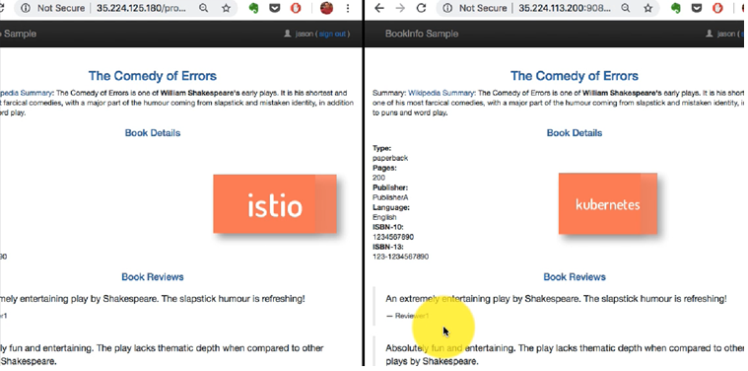

What we also need to do is ensure that we have a route which allows us to send the traffic to version2 if the user is Jason.That's our canary release. And to do that we're going to do is leverage the intelligent routing rules that you know Istio allows us to create. And there is a section which says that you route based on user identity and the rules are defined in this YAML file or you can review the section on that documentation page or you can do it from here once you are applied.

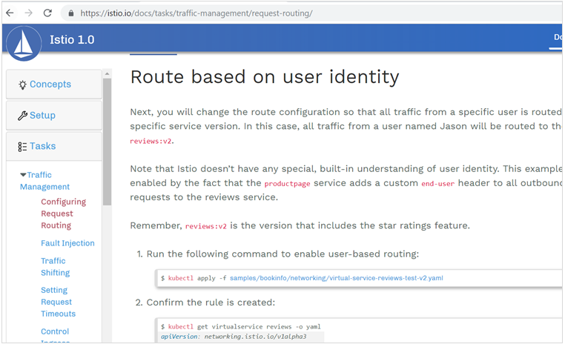

You'll see that the header and it's looking for a header. And if it matches the user as Jason, it is going to send you reviews version 2 and for all the other traffic it's going to go to version 1. So I have applied that rule and you see that in effect. So if you look at that screen, it's been logged in, I have logged in as user Jason and since I have logged in as user Jason - you see the version 2 when I was not logged in. So all the traffic except for when it comes to from the user Jason goes to Version 1 and only the canary is intelligently routing the request for a particular user - if you log in as particular use you will go to the canary release, as you could see it allows us to do more than what Kubernetes offered and that's the reason why we're using it alongside K8s, it is for this additional feature.

### Zero Downtime Deployments with Weight based Routing

In the next test, we're going to take this further and inject a fault and see what happens. And this is the application stack. The request comes to the product page then it goes to the reviews and we have two different versions of it running and we want to test the resiliency of these applications and these applications connect to the rating system, ratings from there and we're going to inject a fault between the reviews and ratings. Remember this is a production environment so we don't want to inject a fault on a live system for all the users.

|  |  |
| --- | --- |
|  | These users will be OK, we're going to inject fault on only this line so that we can test it life in production. And that's the whole purpose of this releases, and so we want to create it out intelligently, that it indicates a fault only for the user Jason and since K8s does not supported at all, we don't want to look at K8s configurations because it does not have anything which does exactly this, so we only look at Istio configuration and inject the fault here. |

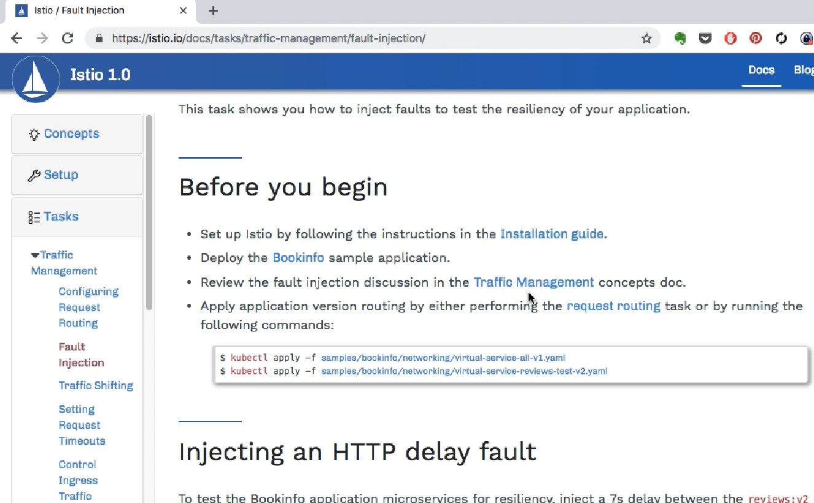

And this is the documentation to do that. The prerequisites we have set up, the route traffic management we've done that tutorial earlier. So we're going to skip the ‘Before you begin’ part and jump right into injecting an issue using HTTP delay fault configuration, so that section is what we're going to look at. However if you have not done it earlier you can go and look at the prerequisites and do that before you continue. It should be at the same state as the last video that we looked at earlier for the traffic routing and I'm going to introduce this followed by applying this configuration. I'll show you what gets applied here. So it might take a few seconds, a few minutes for this configuration to be applied.

Create a fault injection rule to delay traffic coming from the test user jason.

$ kubectl apply -f [samples/bookinfo/networking/virtual-service-ratings-test-delay.yaml](https://raw.githubusercontent.com/istio/istio/release-1.0/samples/bookinfo/networking/virtual-service-ratings-test-delay.yaml)

Confirm the rule was created:

$ kubectl get virtualservice ratings -o yaml

apiVersion: networking.istio.io/v1alpha3

kind: VirtualService

metadata:

name: ratings

...

spec:

hosts:

- ratings

http:

- fault:

delay:

fixedDelay: 7s

percent: 100

match:

- headers:

end-user:

exact: jason

route:

- destination:

host: ratings

subset: v1

- route:

- destination:

host: ratings

subset: v1

And once it is ready, I'm going to examine that by listing the virtual service configuration.So this is where I have injected the fault.



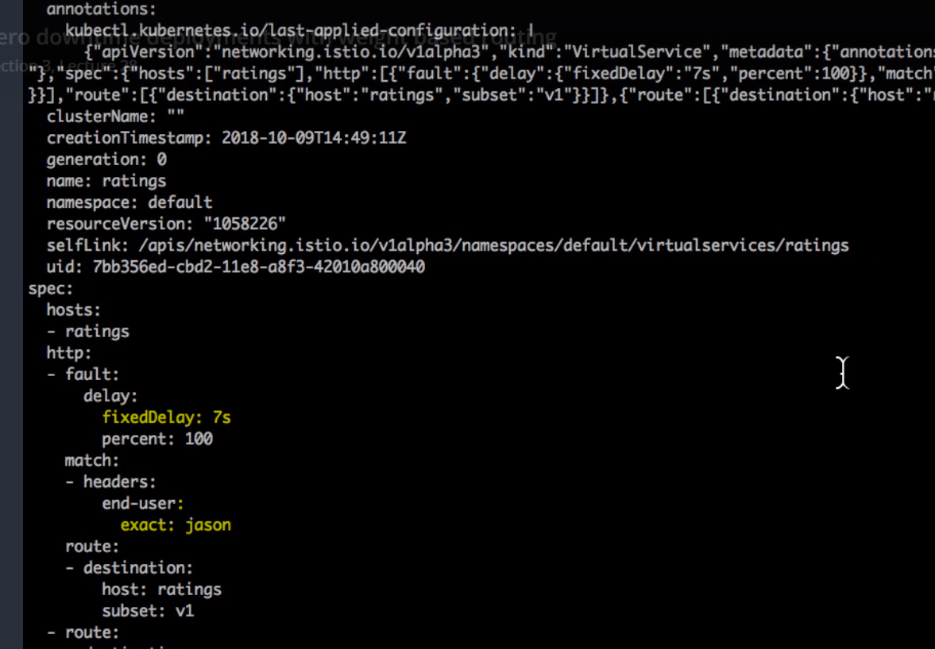

If you look at that there should be follow configuration it has a delay of seven seconds and that delay has been introduced, only for the end user who matches the name Jason. Jason is the name of the end user and this is the virtual configuration for the ratings application. So for the ratings application if the user has been you know logged-in as Jason and we've already routed the Jason user to v2, that is a service configuration we have done a service configuration that we have already done for the previous user. All the other users go to, or do not have that fault rather. Right we are injecting the fault only for a particular kind of canary release application. And once we have done that, you know I can go and look at the, test it here. So if I login as Jason user, it is just waiting because there's a timeout. So it is introduced a delay of seven seconds. It's going to eventurally do a timeout because the timeout has been set Six Seconds in the real version 2 application.

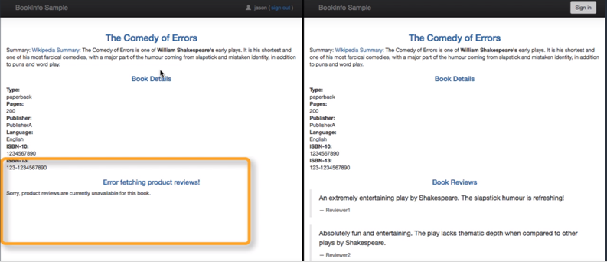

But if I'm not the Jason user, everything else works, so again I'm going to try logging in as Jason user and do a side by side comparison with when I'm logged in as this user and when I'm not logged in as this user. What happens to the rest of the traffic, so I am putting this side by side, on the left hand side I am logged in as the Jason user where the fault is and this application is not tolerant to the fault. That's what I realized because there is a error fetching product reviews and on the right hand side we don't see any error at all because we're not logged in as Jason users and the rest of the traffic which does not have that fault. So we don't have to worry about the right side which is working fine and we're testing it in the canary which is on the left and that's where the fault is. Again if you log in as Jason, I am logged out, you will see the same error and that's how you do the resilience testing. And now that we've realized that this application version of one and possibly one and two as well is not resilient to you know to a fault introduced here.

There are many other type of faults that you get introduced for doing this kind of a test. And for all the other traffic it's still going to the version. I mean there is no false all of that traffic does not get affected at all.

How do you fix this fault?. Also there are many ways you can do that.One is you can go about go ahead and change the application timeouts, make sure it is you know it compatible or there is already a fixed application version which is v3 and we can route all the traffic since once it is fixed, let's assume that it's been fixed v3 and we want to route the traffic to be version three and that should fix our issue. And that's what we're going to do in the next section, where we'll talk about doing the deployments using the traffic shifting task.

Fixing the bug

You would normally fix the problem by:

Either increasing the /productpage timeout or decreasing the reviews to ratings service timeout Stopping and restarting the fixed microservice

Confirming that the /productpage returns its response without any errors.

However, you already have this fix running in v3 of the reviews service, so you can simply fix the problem by migrating all traffic to reviews:v3 as described in the traffic shifting task.

### Traffic Routing and Deployment – Kubernetes vs Istio

This video I'm going to compare Istios traffic routing features against K8s. So I go to examples - intelligent routing and we're going to look at the traffic shifting that's the third feature. In the previous example I've shown you how to request routing can be configured as well as how you can inject a fault into the system using Istios Service configuration and fault configuration.

<https://istio.io/docs/examples/intelligent-routing/>

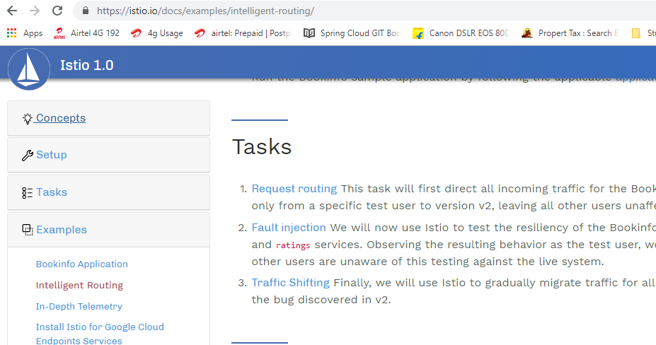

Now we're going to look at the traffic shifting, let's assume that we have done the Canary release and testing.And we found out a bug in one of the version and we wanted transfer the traffic from that version to another. We want to upgrade the version of the application, let's say from version 1 to 2. How do we go about doing that? And this is the skills that we're going to take and see how open it is and has to behave. So here we have two different versions v1 and v2 and we want to route 60 percent of the traffic to V1 versus 40 percent to v2. And let's begin with Kubernetes here and let's find out how we can do that.

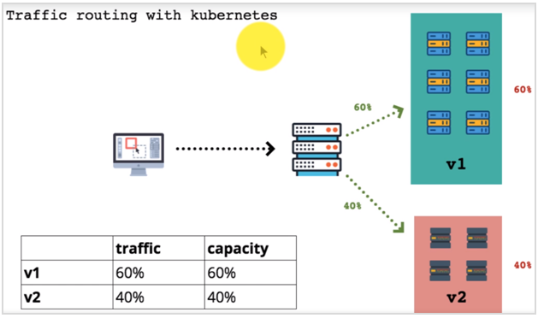

Again both of these tools would use services and virtual services configuration. Here we have two different clusters configured one for K8s and another for Istio.

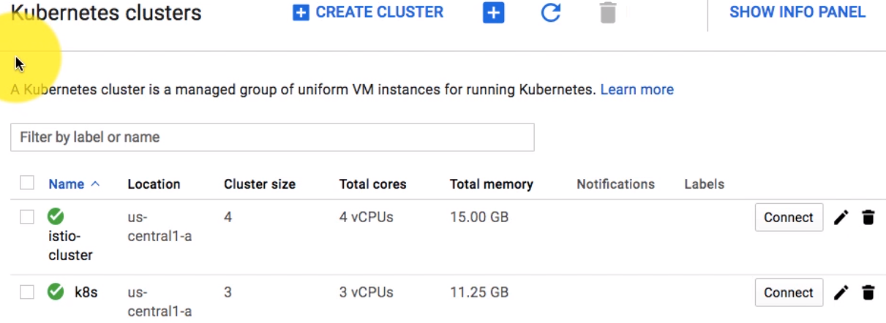

And you know you can see the the web pages for both of these you know installations as well. So I begin by listing my context from the CLI config-get on it.

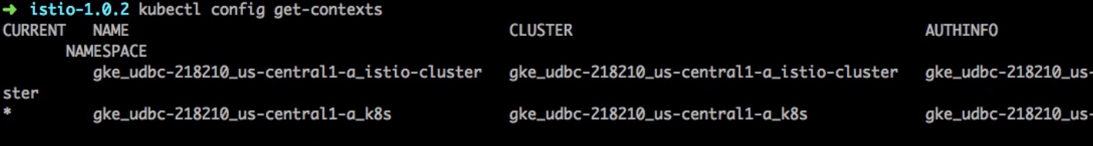

I am already connected to Kubernetes clustered and so I am going to list the existing deployment services and pods which have been configured as part of this cluster, that includes my product and for that it uses to review application and I said review application that we're going to upgrade from v1 to v3. In the previous video I've shown that with the canary test we found that there is a bug with V2. So we want to move to v3 and that's what we want to do here. So first I'm going to apply the samples book info app here, becauseI we have deleted the V3 version for another earlier.

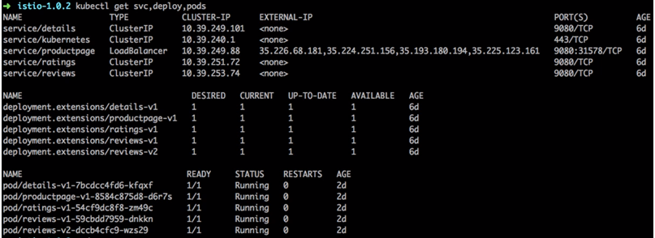

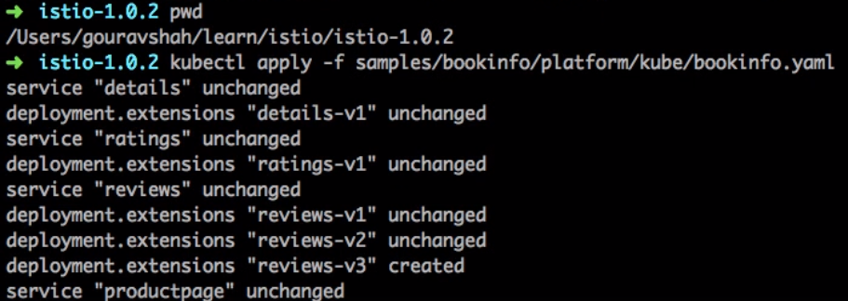

And again if you have not configured it you should launch the book info application first before you begin this testing. So here the v3 reviews has been created which is launched and I would validate that by running the command again. I see v3 applied. And if you look at the count of instances it's all one. Now if you want to route 60 percent of the traffic to v1 versus 40 percent to let's say v3. In this case we're going to use v3 instead of v2. So the only ways you can do that with K8s is by updating the configuration or the deployment scale here.

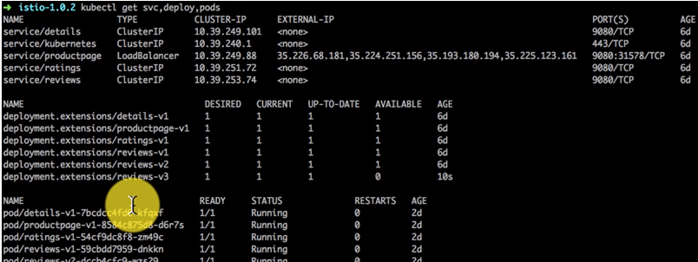

If you look at the service for reviews right now you'd find that it just pointing to three different end points.

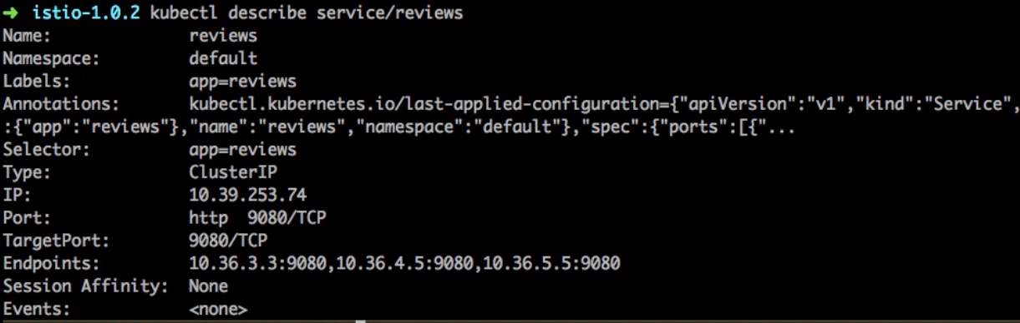

And if you look at the parts with the labels you would find all of those versions.

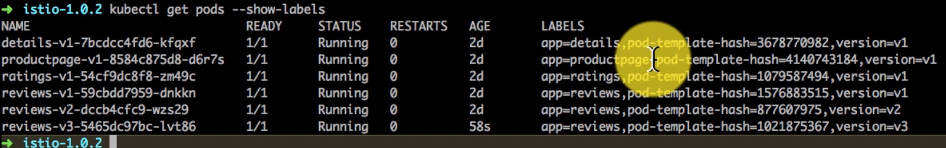

It is sending the traffic to, it is using a selector, simple selector - app reviews so it matches app reviews irrespective of the version number. And that is all you can basically do the canary releases and deployments with multiple versions with one common service. So right now the traffic is being split between v1, v2, v3 and it is working in that round robin manner. So In order for stopping the traffic to v2, I have to delete the deployment for v2, but before that I'm going to show you how this works or this is my K8s book info application page. And if you look at this I'm fast forwarding it. But if you look at it it's rotating around up in between v1, v2 and v3. So I begin by deleting the version that I do not need and that would be reviews v2. Now if I delete the reviews v2, service wil detect that there is no pod running for that so it will stop sending traffic to that which would mean now it would be rotating between the v1 and the v3 only.

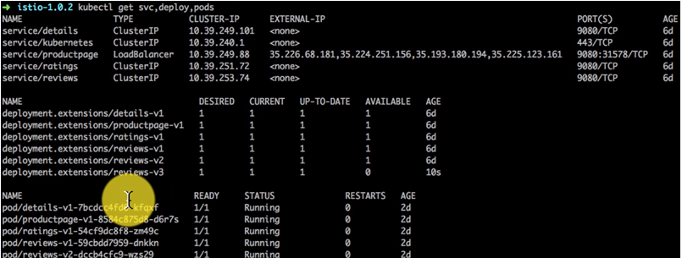

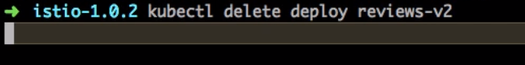

And if I look at the pod size I will only see on v1 and v3. Similarly if I look at the deployment, I only see the version 1 and version 3. So on Kubernetes, if you notice I have to delete the deployment. We will compare this with Istio later.

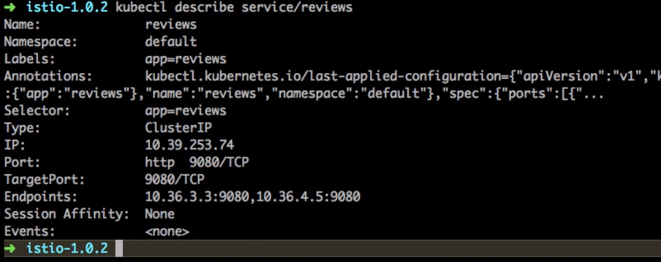

And now to spread the traffic 60 percent and 40 percent I need to create instances or capacity accordingly. So I am scaling using kubectl scale command and scaling the deployment v1 with the replica 6 and replica v3 with 4. That's going to give me the spread because service will keep on pointing to however many parts that are available with that particular selector. In this case v1 is six parts. The v3 has four parts.





So I see that v1 has 6 and for v3 its 4, it takes a while before all instances are up.

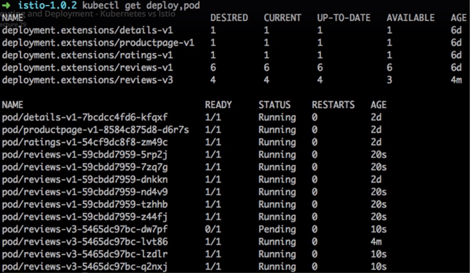

If you compare the desired and available – this is still not up, there are still some to be allocated

Now I actually did this us and kept on watching I'm using watch command. It's a UNIX watch command and it's kubectl get deployment and pods with show label options, so if you observe in the pods list as.



And sometimes this can happen because of the capacity issue and that seems to be the reason here. So I checked that status of the pending pods on the cluster side. That is my K8s cluster, I have set up on Google Cloud. I saw the clear error related to capacity actually.

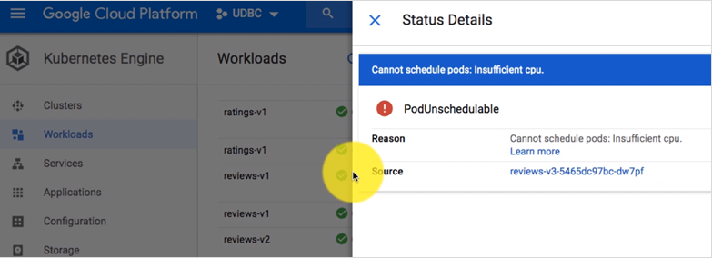

So if I go here look at the workload to actually, it will show you that three or four are available and one is not available and it also shows the reason that is insufficient CPU. You know generally to solve this issue you can just scale up the number of nodes or make capacity by deleting some other application. In this case, I'm just going to add another node to the pool of nodes.

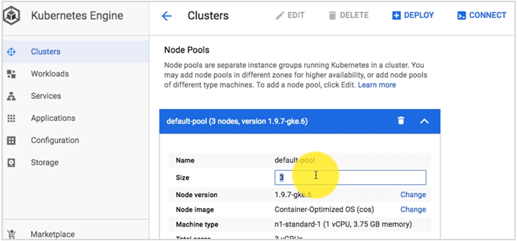

And good thing about K8s is it is scalable infrastructure, so you can add a node, it becomes part of the cluster and immediately starts running that new pod and so that is just amazing. So if you know if you need more capacity just out and or make it part of K8s cluster, and there we go.

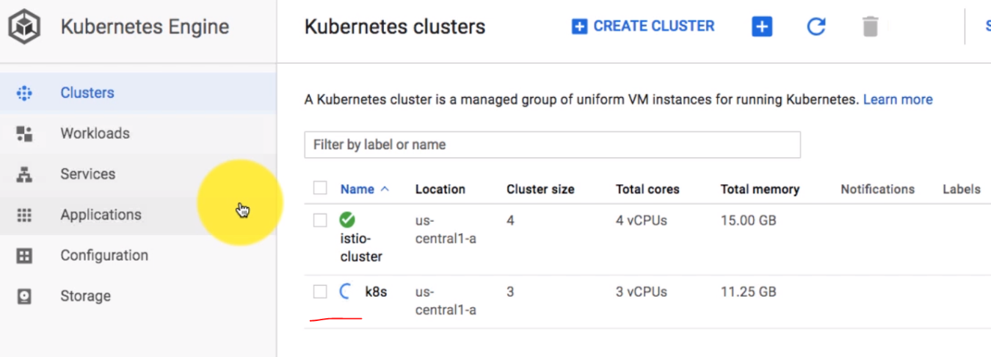

We can immediately scale up. So that makes things easier. In fact you can set up auto scaling at the infrastructure level as well and you suddenly have the complete scalable infrastructure as well as your container as a service. So that fixed my issue. I have four pods available now and I have now a good spread of 60 to 40 percent. I see that issue is gone again. And since I have six instances of v1 and you know 4 instance of V3, I see that being called in round robin fashion. If you look at the traffic pattern you know you will typically notice that it's about 60 percent of the time v1 and 40 percent it is v3.

I have a refresh plug-In running on chrome. And you know I if I observe it for a period of time, that's the pattern I would notice. So if you observe what we did with K8s, we set up the scale the capacity of K8s according to the traffic pattern, so we wanted to have routing of 60 percent of the traffic would mean 60 percent capacity that we have to provision versus if you're routing 40 percent traffic to v3 you would have to have 40 percent capacity available in order to do that. So traffic and capacity goes along linearly in case of K8s.

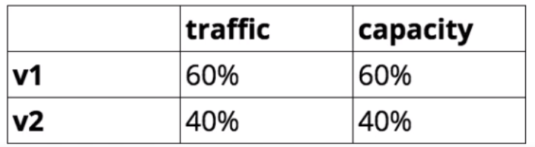

Let's have a look at how Istio works here and Istio gives us more flexibility, that's what I'm going to show you. So first I would switch the cluster to Istio cluster,



I'm connected to Istio cluster now. I would list the existing just like I did last time the services deployments and pods. Now since this is Istio, it's not going to be service but it's going to be the virtual service which is going to decide the traffic routing pattern here. But nevertheless I'm going to begin with listing the steam command as we did with K8s.

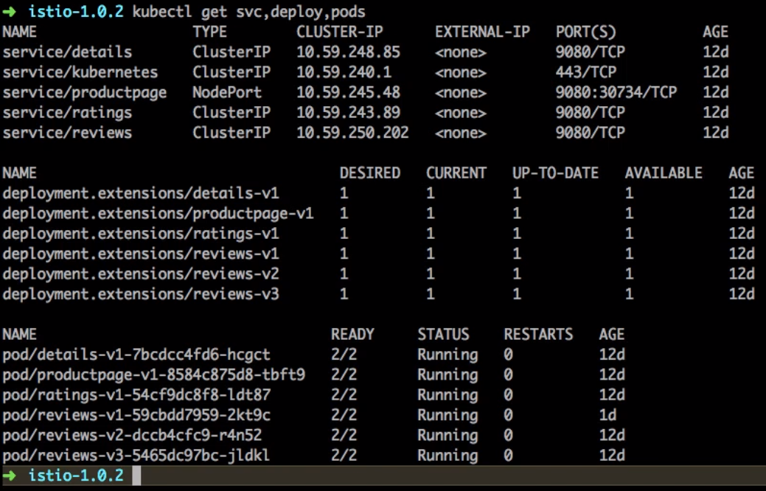

I see three versions running v1, v2 and v3 – instances of the pod the review application that I'm talking about and one instance of the pod. So what I'm going to do here is first I'll show you what I was configuration as well. This is from my previous videos so if you have you know watched the previous videos from this series, you might have known that I actually did the traffic routing based on the header pattern.

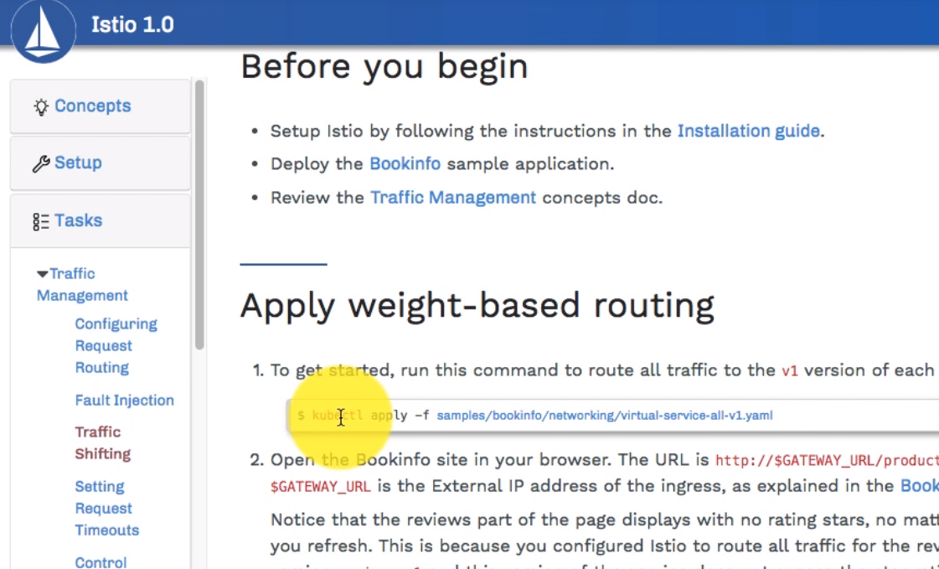

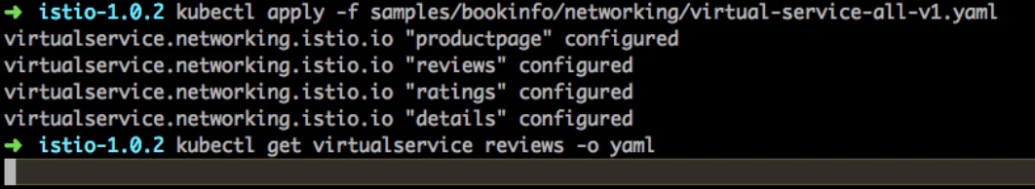

So I'm going to switch it back to the original configuration by running this command here in from the documentation and if I look at the full service now it is back to the original where all the traffic is being sent to the v1.

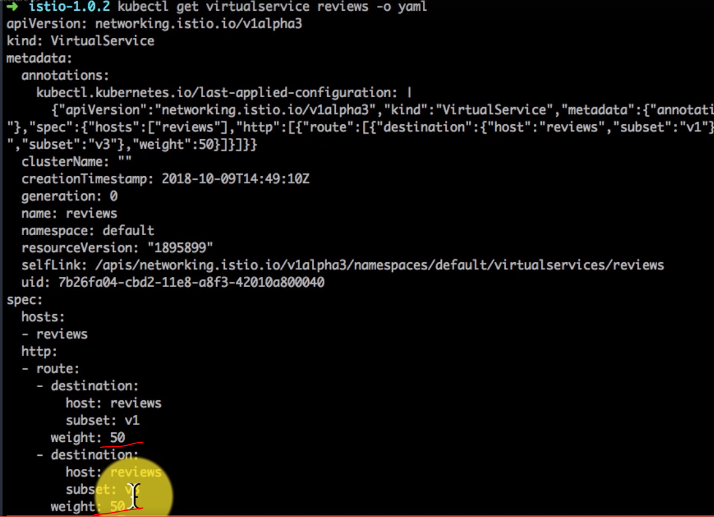

Now we need to change that pattern and select 60 to 40 routing that we want to achieve for this use case. And the way we do that is, we just apply the changes to the virtual service, and if you observed with K8s you do not have a way to do this, you only have a selector and you send the traffic to whoever is available verses with Istio which is a custom resource definition ( CRD ) allows us to defined the weightage for a particular service as well, and here it's 50 50, so I'm going to change it to 60 40 as per our use case. Scroll down to the right section



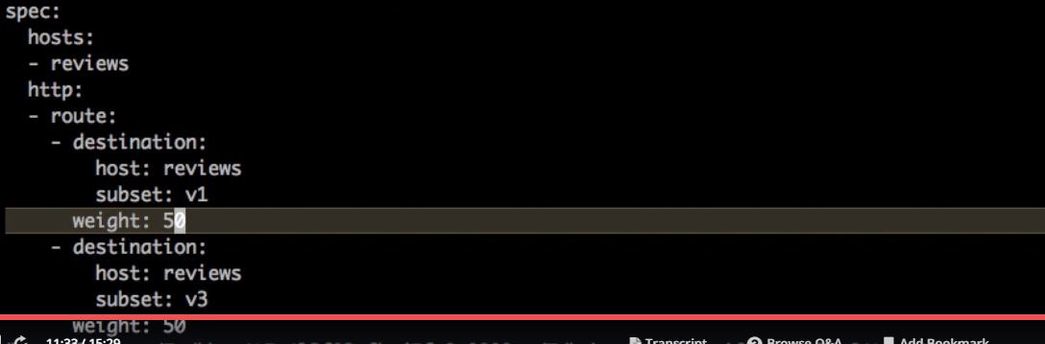

I can do that by running kubectl edit command so I'm editing the virtual service whose name is reviews. And here I'm going to change the way v1 gets 60 and v3 gets 40. I save it. It gets applied on the cluster since I'm using kubectl edit command.

Again if I run that come on I see the 60:40 spread here. Now if you observe this is independent of the underlying capacity. Right now I only have 1 and 1 pods but would be sending to traffic 60 percent of the time to be v1 and 40 percent to v3. Irrespective of the underlying capacity, so you can detach dandling capacity from the routing and that you are to achieve here. And that's something interesting that you can do with this. You cant do that with K8s. So I'm just going to change the scale. Just to give you an idea how this works so I changed. You know v1 runs 4 replicas v3 runs one replica which means 80 percent of the capacity is provision for v1 but it gets only 60 percent of the traffic so it is completely independent of the capacity, that routing and that can be really powerful If you want to you know create canary releases and start deploying and then do a gradual deployment and you might have a scaling feature enabled for two different deployments using horizontally pod autoscaler and you can just move from one version to another and the capacity will automatically scale up as well. So here the capacity is 80 percent traffic is 60 percent and 40 percent traffic goes to 20 percent capacity, so we're not dependent on underlying capacity to do the traffic routing.

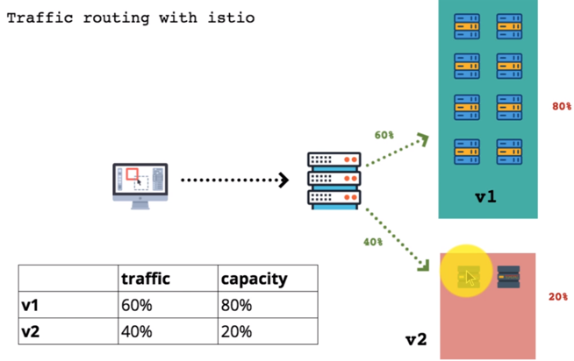

OK it's time to switch 100 percent of all the traffic to V3 and that's what I do here. By playing this configuration. For this again we update the virtual Services configuration. So I go ahead run it as is and then I'm going to list the virtual servers or get information about it. And this time I should see the traffic pattern change to v3. All the traffic is going to v3 now, so I just deployed v3 gradually without any downtime and after doing canary releases. These are the things that you can do with Istio, on top of K8s itself. And this gives some additional features and functionalities to your K8s cluster and makes it more flexible and powerful and you can do things in various ways especially with retesting in production.

Cleaning Up

We had setup both the K8s cluster and the Istio cluster and we have the services, workloads deployed. So we begin with deleting the context and using the kubectl config command

Deleting the context

Run the following command for help

$ kubectl config

C:\Users\Chea>kubectl config

*Modify kubeconfig files using subcommands like "kubectl config set current-context my-context"*

The loading order follows these rules:

1. If the --kubeconfig flag is set, then only that file is loaded. The flag may only be set once and no merging takes

place.

2. If $KUBECONFIG environment variable is set, then it is used a list of paths (normal path delimitting rules for your

system). These paths are merged. When a value is modified, it is modified in the file that defines the stanza. When a

value is created, it is created in the first file that exists. If no files in the chain exist, then it creates the last

file in the list.

3. Otherwise, ${HOME}/.kube/config is used and no merging takes place.

Available Commands:

current-context Displays the current-context

delete-cluster Delete the specified cluster from the kubeconfig

delete-context Delete the specified context from the kubeconfig

get-clusters Display clusters defined in the kubeconfig

get-contexts Describe one or many contexts

rename-context Renames a context from the kubeconfig file.

set Sets an individual value in a kubeconfig file

set-cluster Sets a cluster entry in kubeconfig

set-context Sets a context entry in kubeconfig

set-credentials Sets a user entry in kubeconfig

unset Unsets an individual value in a kubeconfig file

use-context Sets the current-context in a kubeconfig file

view Display merged kubeconfig settings or a specified kubeconfig file

Usage:

kubectl config SUBCOMMAND [options]

Use "kubectl <command> --help" for more information about a given command.

Use "kubectl options" for a list of global command-line options (applies to all commands).

This would remove the local configurations – cleans it up from the local environment

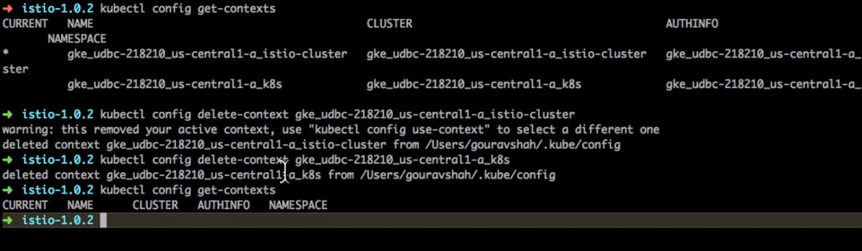

So it has been cleaned up, then we go to the Google Cloud Console and delete the clusters

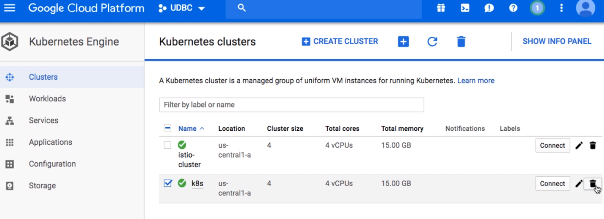

If we are using kubectl then we can delete the yaml file using the kubectl delete –f command. Whatever we have deployed we can delete using the delete command with kubectl

That’s all we need to do the cleanup of your environment

### Kubeadm: Bring Your Own Nodes (BYON)

<https://schoolofdevops.github.io/ultimate-kubernetes-bootcamp/3_install_kubernetes/>

Lets see how to setup kubernetes from scratch on your own nodes, without using a managed service. This setup uses kubeadm to install and configure kubernetes cluster.

Compatibility: Kubernetes is an open-source system for automating deployment, scaling, and management of containerized applications.

We are using Ubuntu 16.04 Xenial

**Base Setup (Skip if using vagrant)**

Skip this step and scroll to Initializing Master if you have setup nodes with vagrant

On all nodes which would be part of this cluster, you need to do the base setup as described in the following steps. To simplify this, you could also download and run this script

Create Kubernetes Repository

We need to create a repository to download Kubernetes.

curl -s https://packages.cloud.google.com/apt/doc/apt-key.gpg | apt-key add -

cat <<EOF > /etc/apt/sources.list.d/kubernetes.list

deb http://apt.kubernetes.io/ kubernetes-xenial main

EOF

Installation of the packages

We should update the machines before installing so that we can update the repository.

apt-get update -y

Installing all the packages with dependencies:

apt-get install -y **docker.io kubelet kubeadm kubectl kubernetes-cni**

rm -rf /var/lib/kubelet/*

Setup sysctl configs

In order for many container networks to work, the following needs to be enabled on each node.

sysctl net.bridge.bridge-nf-call-iptables=1

The above steps has to be followed in all the nodes.

Initializing Master

This tutorial assumes kube-01 as the master and used kubeadm as a tool to install and setup the cluster. This section also assumes that you are using vagrant based setup provided along with this tutorial. If not, please update the IP address of the master accordingly. To initialize master, run this on kube-01

kubeadm init --apiserver-advertise-address 192.168.56.101

--pod-network-cidr=192.168.0.0/16

Initialization of the Nodes (Previously Minions)

After master being initialized, it should display the command which could be used on all worker/nodes to join the k8s cluster. e.g.

kubeadm join --token c04797.8db60f6b2c0dd078 192.168.12.10:6443

--discovery-token-ca-cert-hash

sha256:88ebb5d5f7fdfcbbc3cde98690b1dea9d0f96de4a7e6bf69198172debca74cd0

Copy and paste it on all node.

Troubleshooting Tips

If you lose the join token, you could retrieve it using

kubeadm token list

On successfully joining the master, you should see output similar to following,

root@kube-03:~# kubeadm join --token c04797.8db60f6b2c0dd078 159.203.170.84:6443

--discovery-token-ca-cert-hash sha256:88ebb5d5f7fdfcbbc3cde98690b1dea9d0f96de4a7e6bf69198172debca74cd0

[kubeadm] WARNING: kubeadm is in beta, please do not use it for production clusters.

[preflight] Running pre-flight checks

[discovery] Trying to connect to API Server "159.203.170.84:6443"

[discovery] Created cluster-info discovery client, requesting info from "https://159.203.170.84:6443"

[discovery] Requesting info from "https://159.203.170.84:6443" again to validate TLS against the pinned public key

[discovery] Cluster info signature and contents are valid and TLS certificate validates against pinned roots, will use API Server "159.203.170.84:6443"

[discovery] Successfully established connection with API Server "159.203.170.84:6443"

[bootstrap] Detected server version: v1.8.2

[bootstrap] The server supports the Certificates API (certificates.k8s.io/v1beta1)

Node join complete:

* Certificate signing request sent to master and response

received.

* Kubelet informed of new secure connection details.

Run 'kubectl get nodes' on the master to see this machine join.

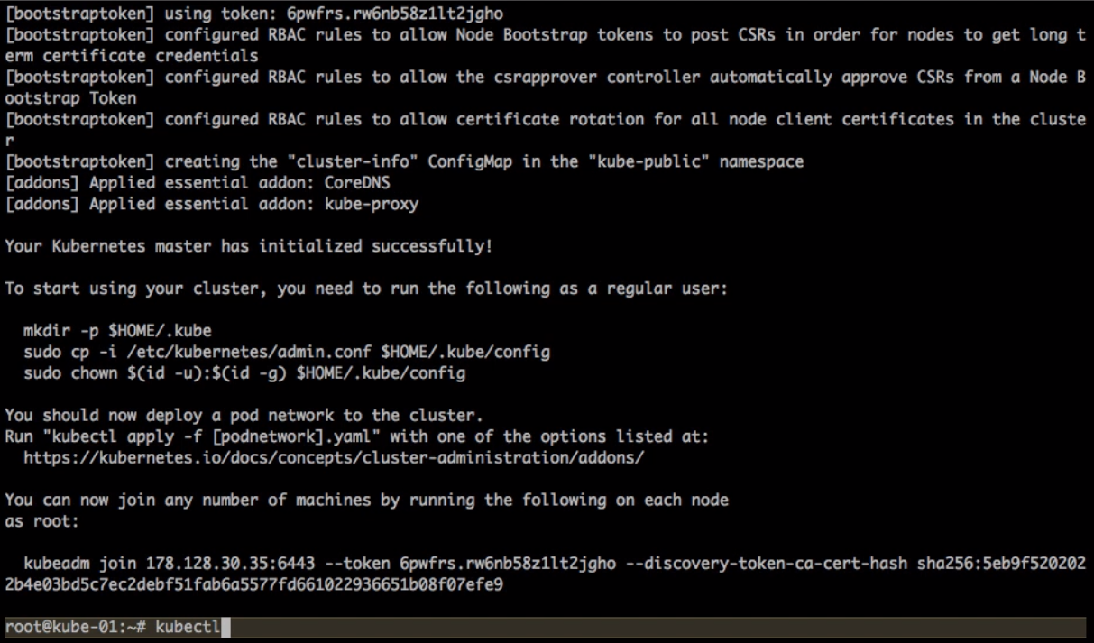

Setup the admin client - Kubectl

On Master Node

mkdir -p $HOME/.kube

sudo cp -i /etc/kubernetes/admin.conf $HOME/.kube/config

sudo chown $(id -u):$(id -g) $HOME/.kube/config

Installing CNI with Weave

Installing overlay network is necessary for the pods to communicate with each other across the hosts. It is necessary to do this before you try to deploy any applications to your cluster.

There are various overlay networking drivers available for kubernetes. We are going to use Weave Net.

export kubever=$(kubectl version | base64 | tr -d '\n')

kubectl apply -f "https://cloud.weave.works/k8s/net?k8s-version=$kubever"

Validating the Setup

You could validate the status of this cluster, health of pods and whether all the components are up or not by using a few or all of the following commands.

To check if nodes are ready

kubectl get nodes

kubectl get cs

[ Expected output ]

root@kube-01:~# kubectl get nodes

NAME STATUS ROLES AGE VERSION

kube-01 Ready master m v1.8.2

kube-02 Ready <none> m v1.8.2

kube-03 Ready <none> m v1.8.2

Additional Status Commands

kubectl version

kubectl cluster-info

kubectl get pods -n kube-system

kubectl get events

It will take a few minutes to have the cluster up and running with all the services.

**Possible Issues**

Nodes are node in Ready status

kube-dns is crashing constantly

Some of the systems services are not up

Most of the times, kubernetes does self heal, unless its a issue with system resources not being adequate. Upgrading resources or launching it on bigger capacity VM/servers solves it. However, if the issues persist, you could try following techniques,

Troubleshooting Tips

**Check events**

kubectl get events

**Check Logs**

kubectl get pods -n kube-system

[get the name of the pod which has a problem]

kubectl logs <pod> -n kube-system

e.g.

root@kube-01:~# kubectl logs kube-dns-545bc4bfd4-dh994 -n kube-system

Error from server (BadRequest): a container name must be specified for pod kube-dns-545bc4bfd4-dh994, choose one of:

[kubedns dnsmasq sidecar]

root@kube-01:~# kubectl logs kube-dns-545bc4bfd4-dh994 kubedns -n kube-system

I1106 14:41:15.542409 1 dns.go:48] version: 1.14.4-2-g5584e04

I1106 14:41:15.543487 1 server.go:70] Using

....

Enable Kubernetes Dashboard

After the Pod networks is installled, We can install another add-on service which is Kubernetes Dashboard.

**Installing Dashboard:**

kubectl apply -f

https://gist.githubusercontent.com/initcron/32ff89394c881414ea7ef7f4d3a1d499

/raw/4863613585d05f9360321c7141cc32b8aa305605/kube-dashboard.yaml

This will create a pod for the Kubernetes Dashboard.

To access the Dashboard in th browser, run the below command

kubectl describe svc kubernetes-dashboard -n kube-system

**Sample output:**

kubectl describe svc kubernetes-dashboard -n kube-system

Name: kubernetes-dashboard

Namespace: kube-system

Labels: app=kubernetes-dashboard

Selector: app=kubernetes-dashboard

Type: NodePort

IP: 10.98.148.82

Port: <unset> 80/TCP

NodePort: <unset> 31000/TCP

Endpoints: 10.40.0.1:9090

Session Affinity: None

Now check for the node port, here it is 31000, and go to the browser, and access the dashboard with the following URL do not use the IP above, use master node IP instead

http://NODEIP:31000

The Dashboard Looks like:

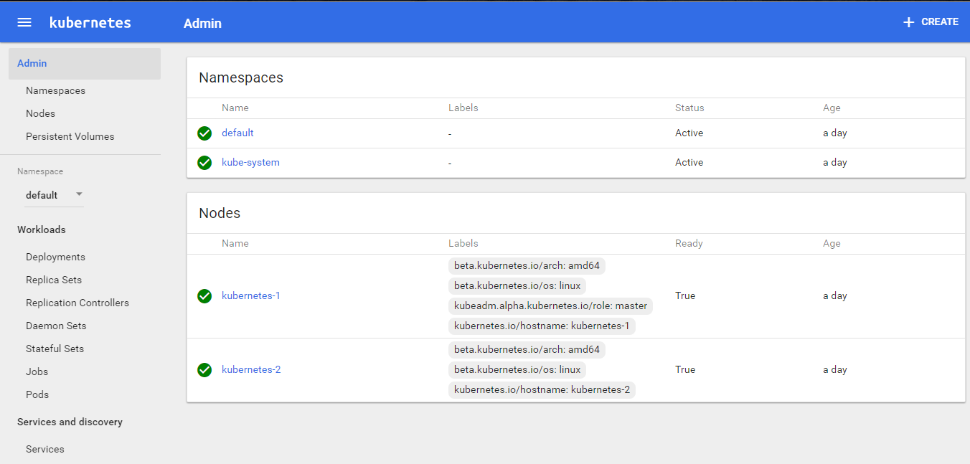

Check out the supporting code

Before we proceed further, please checkout the code from the following git repo. This would offer the supporting code for the exercises that follow.

git clone <https://github.com/schoolofdevops/k8s-code.git>

### Istio – Installation - Quick Start with Kubernetes

<https://istio.io/docs/setup/kubernetes/download-release/>

<https://istio.io/docs/setup/kubernetes/quick-start/>

Download and prepare for the installation

Istio is installed in its own istio-system namespace and can manage services from all other namespaces.

Go to the [Istio release](https://github.com/istio/istio/releases) page to download the installation file corresponding to your OS. On a macOS or Linux system, you can run the following command to download and extract the latest release automatically:

$ curl -L https://git.io/getLatestIstio | sh -

Move to the Istio package directory. For example, if the package is istio-1.0.5:

$ cd istio-1.0.5

The installation directory contains:

* Installation .yaml files for Kubernetes in install/
* Sample applications in samples/
* The istioctl client binary in the bin/ directory. istioctl is used when manually injecting Envoy as a sidecar proxy and for creating routing rules and policies.
* The istio.VERSION configuration file

Add the istioctl client to your PATH environment variable, on a macOS or Linux system:

$ export PATH=$PWD/bin:$PATH

Quick Start with Kubernetes

To install and configure Istio in a Kubernetes cluster, follow these instructions:

Installation steps

Install Istio’s Custom Resource Definitions via kubectl apply, and wait a few seconds for the CRDs to be committed in the kube-apiserver:

$ kubectl apply -f install/kubernetes/helm/istio/templates/crds.yaml

To install Istio’s core components you can choose any of the following four mutually exclusive options described below. However, for a production setup of Istio, we recommend installing with the Helm Chart, to use all the configuration options. This permits customization of Istio to operator specific requirements.

Option 1: Install Istio without mutual TLS authentication between sidecars

Visit our mutual TLS authentication between sidecars concept page for more information.

Choose this option for:

* Clusters with existing applications,
* Applications where services with an Istio sidecar need to be able to communicate with other non-Istio Kubernetes services,
* Applications that use liveness and readiness probes,
* Headless services, or
* StatefulSets

To install Istio without mutual TLS authentication between sidecars:

$ kubectl apply -f install/kubernetes/istio-demo.yaml

Option 2: Install Istio with default mutual TLS authentication

Use this option only on a fresh Kubernetes cluster where newly deployed workloads are guaranteed to have Istio sidecars installed.

To Install Istio and enforce mutual TLS authentication between sidecars by default:

$ kubectl apply -f install/kubernetes/istio-demo-auth.yaml

Option 3: Render Kubernetes manifest with Helm and deploy with kubectl

Follow our setup instructions to render the Kubernetes manifest with Helm and deploy with kubectl.

Option 4: Use Helm and Tiller to manage the Istio deployment

Follow our instructions on how to use Helm and Tiller to manage the Istio deployment.

Verifying the installation

Ensure the following Kubernetes services are deployed: istio-pilot, istio-ingressgateway, istio-policy, istio-telemetry, prometheus, istio-galley, and, optionally, istio-sidecar-injector.

$ kubectl get svc -n istio-system

NAME TYPE CLUSTER-IP EXTERNAL-IP PORT(S) AGE

istio-citadel ClusterIP 10.47.247.12 <none> 8060/TCP,9093/TCP 7m

istio-egressgateway ClusterIP 10.47.243.117 <none> 80/TCP,443/TCP 7m

istio-galley ClusterIP 10.47.254.90 <none> 443/TCP 7m

istio-ingress LoadBalancer 10.47.244.111 35.194.55.10 80:32000/TCP,443:30814/TCP 7m

istio-ingressgateway LoadBalancer 10.47.241.20 130.211.167.230 80:31380/TCP,443:31390/TCP,31400:31400/TCP 7m

istio-pilot ClusterIP 10.47.250.56 <none> 15003/TCP,15005/TCP,15007/TCP,15010/TCP,15011/TCP,8080/TCP,9093/TCP 7m

istio-policy ClusterIP 10.47.245.228 <none> 9091/TCP,15004/TCP,9093/TCP 7m

istio-sidecar-injector ClusterIP 10.47.245.22 <none> 443/TCP 7m

istio-statsd-prom-bridge ClusterIP 10.47.252.184 <none> 9102/TCP,9125/UDP 7m

istio-telemetry ClusterIP 10.47.250.107 <none> 9091/TCP,15004/TCP,9093/TCP,42422/TCP 7m

prometheus ClusterIP 10.47.253.148 <none> 9090/TCP 7m

If your cluster is running in an environment that does not support an external load balancer (e.g., minikube), the EXTERNAL-IP of istio-ingress and istio-ingressgateway will say <pending>. You will need to access it using the service NodePort, or use port-forwarding instead.

Ensure the corresponding Kubernetes pods are deployed and all containers are up and running: istio-pilot-*, istio-ingressgateway-*, istio-egressgateway-*, istio-policy-*, istio-telemetry-*, istio-citadel-*, prometheus-*, istio-galley-*, and, optionally, istio-sidecar-injector-*.

$ kubectl get pods -n istio-system

NAME READY STATUS RESTARTS AGE

istio-citadel-75c88f897f-zfw8b 1/1 Running 0 1m

istio-egressgateway-7d8479c7-khjvk 1/1 Running 0 1m

istio-galley-6c749ff56d-k97n2 1/1 Running 0 1m

istio-ingress-7f5898d74d-t8wrr 1/1 Running 0 1m

istio-ingressgateway-7754ff47dc-qkrch 1/1 Running 0 1m

istio-policy-74df458f5b-jrz9q 2/2 Running 0 1m

istio-sidecar-injector-645c89bc64-v5n4l 1/1 Running 0 1m

istio-statsd-prom-bridge-949999c4c-xjz25 1/1 Running 0 1m

istio-telemetry-676f9b55b-k9nkl 2/2 Running 0 1m

prometheus-86cb6dd77c-hwvqd 1/1 Running 0 1m

Deploy your application

You can now deploy your own application or one of the sample applications provided with the installation like Bookinfo.

Note: The application must use HTTP/1.1 or HTTP/2.0 protocol for all its HTTP traffic because HTTP/1.0 is not supported.

If you started the Istio-sidecar-injector, you can deploy the application directly using kubectl apply.

The Istio-Sidecar-injector will automatically inject Envoy containers into your application pods. The injector assumes the application pods are running in namespaces labeled with istio-injection=enabled

$ kubectl label namespace <namespace> istio-injection=enabled

$ kubectl create -n <namespace> -f <your-app-spec>.yaml

If you don’t have the Istio-sidecar-injector installed, you must use istioctl kube-inject to manually inject Envoy containers in your application pods before deploying them:

$ istioctl kube-inject -f <your-app-spec>.yaml | kubectl apply -f -

Uninstall Istio core components

The uninstall deletes the RBAC permissions, the istio-system namespace, and all resources hierarchically under it. It is safe to ignore errors for non-existent resources because they may have been deleted hierarchically.

If you installed Istio with istio-demo.yaml:

$ kubectl delete -f install/kubernetes/istio-demo.yaml

If you installed Istio with istio-demo-auth.yaml:

$ kubectl delete -f install/kubernetes/istio-demo-auth.yaml

If you installed Istio with Helm, follow the uninstall Istio with Helm steps.

If desired, delete the CRDs:

$ kubectl delete -f install/kubernetes/helm/istio/templates/crds.yaml -n istio-system

### Quick Start with Google Kubernetes Engine

<https://istio.io/docs/setup/kubernetes/quick-start-gke-dm/>

Quick Start instructions to install and run Istio in [Google Kubernetes Engine](https://cloud.google.com/kubernetes-engine/) (GKE) using [Google Cloud Deployment Manager](https://cloud.google.com/deployment-manager/).

This Quick Start creates a new GKE [zonal cluster](https://cloud.google.com/kubernetes-engine/versioning-and-upgrades#available_versions), installs the current release version of Istio and then deploys the [Bookinfo](https://istio.io/docs/examples/bookinfo/) sample application. It uses Deployment Manager to automate the steps detailed in the [Istio on Kubernetes setup instructions](https://istio.io/docs/setup/kubernetes/quick-start/) for Kubernetes Engine

Prerequisites

* This sample requires a valid Google Cloud Platform project with billing enabled. If you are not an existing GCP user, you may be able to enroll for a $300 US [Free Trial](https://cloud.google.com/free/) credit.
* Ensure that the [Google Kubernetes Engine API](https://console.cloud.google.com/apis/library/container.googleapis.com/) is enabled for your project (also found by navigating to “APIs & Services” -> “Dashboard” in the navigation bar). If you do not see “API enabled”, then you may enable the API by clicking the “Enable this API” button.
* You must install and configure the [gcloud command line tool](https://cloud.google.com/sdk/docs/) and include the kubectl component (gcloud components install kubectl). If you don’t want to install the gcloud client on your own machine, you can use gcloud via [Google Cloud Shell](https://cloud.google.com/shell/docs/) to perform the same tasks.
*  You must set your default compute service account to include:
* roles/container.admin (Kubernetes Engine Admin)
* Editor (on by default)

To set this up, navigate to the **IAM** section of the [Cloud Console](https://console.cloud.google.com/iam-admin/iam/project) as shown below and find your default GCE/GKE service account in the following form: projectNumber-compute@developer.gserviceaccount.com: by default it should just have the **Editor** role. Then in the **Roles** drop-down list for that account, find the **Kubernetes Engine** group and select the role **Kubernetes Engine Admin**. The **Roles** listing for your account will change to **Multiple**.

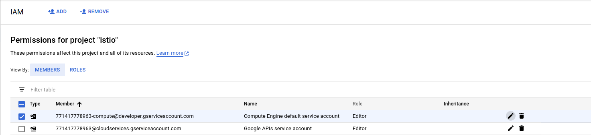

Then add the Kubernetes Engine Admin role:

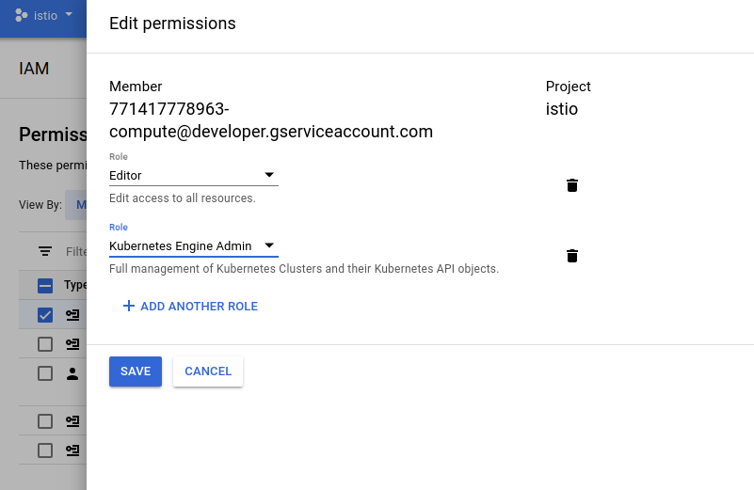

Setup

Launch Deployment Manager

1. Once you have an account and project enabled, click the following link to open the Deployment Manager.

[Istio GKE Deployment Manager](https://accounts.google.com/signin/v2/identifier?service=cloudconsole&continue=https://console.cloud.google.com/launcher/config?templateurl=https://raw.githubusercontent.com/istio/istio/release-1.0/install/gcp/deployment_manager/istio-cluster.jinja&followup=https://console.cloud.google.com/launcher/config?templateurl=https://raw.githubusercontent.com/istio/istio/master/install/gcp/deployment_manager/istio-cluster.jinja&flowName=GlifWebSignIn&flowEntry=ServiceLogin)

We recommend that you leave the default settings as the rest of this tutorial shows how to access the installed features. By default the tool creates a GKE alpha cluster with the specified settings, then installs the Istio [control plane](https://istio.io/docs/concepts/what-is-istio/#architecture), the [Bookinfo](https://istio.io/docs/examples/bookinfo/) sample app, [Grafana](https://istio.io/docs/tasks/telemetry/using-istio-dashboard/) with [Prometheus](https://istio.io/docs/tasks/telemetry/querying-metrics/), [ServiceGraph](https://istio.io/docs/tasks/telemetry/servicegraph/), and [Tracing](https://istio.io/docs/tasks/telemetry/distributed-tracing/). You’ll find out more about how to access all of these below. This script will enable Istio auto-injection on the default namespace only.

1. Click **Deploy**:

|  |  |
| --- | --- |
| *GKE-Istio Launcher* | Wait until Istio is fully deployed. Note that this can take up to five minutes.  Bootstrap **gcloud**  Once deployment is complete, do the following on the workstation where you’ve installed gcloud:   1. Bootstrap kubectl for the cluster you just created and confirm the cluster is running and Istio is enabled   $ gcloud container clusters list  NAME LOCATION MASTER_VERSION MASTER_IP MACHINE_TYPE NODE_VERSION NUM_NODES STATUS  istio-cluster us-central1-a 1.9.7-gke.1 35.232.222.60 n1-standard-2 1.9.7-gke.1 4 RUNNING  In this case, the cluster name is istio-cluster.   1. Now acquire the credentials for this cluster   $ gcloud container clusters get-credentials istio-cluster --zone=us-central1-a |

Verify installation

Verify Istio is installed in its own namespace

$ kubectl get deployments,ing -n istio-system

*NAME DESIRED CURRENT UP-TO-DATE AVAILABLE AGE*

*deploy/grafana 1 1 1 1 4m*

*deploy/istio-citadel 1 1 1 1 4m*

*deploy/istio-egressgateway 1 1 1 1 4m*

*deploy/istio-ingress 1 1 1 1 4m*

*deploy/istio-ingressgateway 1 1 1 1 4m*

*deploy/istio-pilot 1 1 1 1 4m*

*deploy/istio-policy 1 1 1 1 4m*

*deploy/istio-sidecar-injector 1 1 1 1 4m*

*deploy/istio-statsd-prom-bridge 1 1 1 1 4m*

*deploy/istio-telemetry 1 1 1 1 4m*

*deploy/prometheus 1 1 1 1 4m*

*deploy/servicegraph 1 1 1 1 4m*

Now confirm that the Bookinfo sample application is also installed:

$ kubectl get deployments,ing

*NAME DESIRED CURRENT UP-TO-DATE AVAILABLE AGE*

*deploy/details-v1 1 1 1 1 7m*

*deploy/productpage-v1 1 1 1 1 7m*

*deploy/ratings-v1 1 1 1 1 7m*

*deploy/reviews-v1 1 1 1 1 7m*

*deploy/reviews-v2 1 1 1 1 7m*

*deploy/reviews-v3 1 1 1 1 7m*

Now get the istio-ingress IP:

$ kubectl get svc istio-ingressgateway -n istio-system

*NAME TYPE CLUSTER-IP EXTERNAL-IP PORT(S) AGE*

*istio-ingressgateway LoadBalancer 10.59.251.109 35.194.26.85 80:31380/TCP,443:31390/TCP,31400:31400/TCP 6m*

Note down the IP address (EXTERNAL-IP) and port assigned to the Bookinfo product page (in the example above, it’s 35.194.26.85:80).

You can also view the installation using the **Kubernetes Engine -> Workloads** section on the [Cloud Console](https://console.cloud.google.com/kubernetes/workload):



Access the Bookinfo sample

Set up an environment variable for Bookinfo’s external IP address:

$ export GATEWAY_URL=$(kubectl -n istio-system get service istio-ingressgateway -o jsonpath='{.status.loadBalancer.ingress[0].ip}')

$ echo $GATEWAY_URL

Verify you can access the Bookinfo http://${GATEWAY_URL}/productpage:

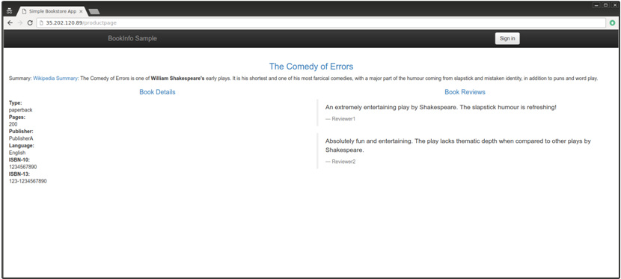

Now send some traffic to it:

$ for i in {1..100}; do curl -o /dev/null -s -w "%{http_code}\n" http://${GATEWAY_URL}/productpage; done

Verify installed Istio plugins

Once you have verified that the Istio control plane and sample application are working, try accessing the installed Istio plugins. If you are using Cloud Shell rather than the installed gcloud client, you can port forward and proxy using its [Web Preview](https://cloud.google.com/shell/docs/using-web-preview#previewing_the_application) feature. For example, to access Grafana from Cloud Shell, change the kubectl port mapping from 3000:3000 to 8080:3000. You can simultaneously preview four other consoles via Web Preview proxied on ranges 8080 to 8084.

Grafana

Set up a tunnel to Grafana:

$ kubectl -n istio-system port-forward $(kubectl -n istio-system get pod -l app=grafana -o jsonpath='{.items[0].metadata.name}') 3000:3000 &

then http://localhost:3000/dashboard/db/istio-dashboard

You should see some statistics for the requests you sent earlier.

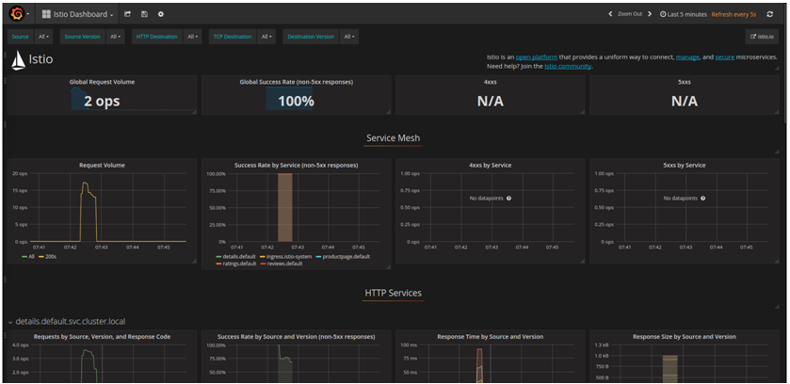

For more details about using Grafana, see [About the Grafana Add-on](https://istio.io/docs/tasks/telemetry/using-istio-dashboard/#about-the-grafana-add-on).

**Prometheus**

Prometheus is installed with Grafana. You can view Istio and application metrics using the console as follows:

$ kubectl -n istio-system port-forward $(kubectl -n istio-system get pod -l app=prometheus -o jsonpath='{.items[0].metadata.name}') 9090:9090 &

View the console at:

http://localhost:9090/graph

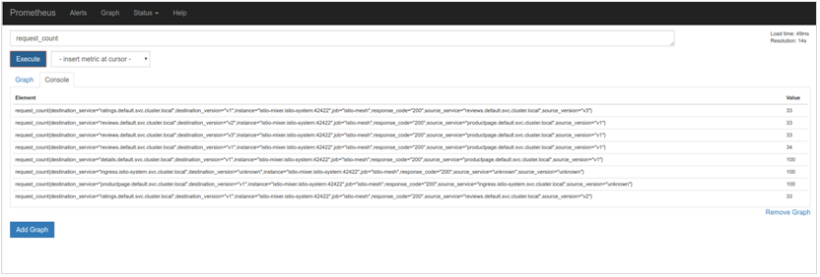

Prometheus For more details, see [About the Prometheus Add-on](https://istio.io/docs/tasks/telemetry/querying-metrics/#about-the-prometheus-add-on).

**ServiceGraph**

Set up a tunnel to ServiceGraph:

$ kubectl -n istio-system port-forward $(kubectl -n istio-system get pod -l app=servicegraph -o jsonpath='{.items[0].metadata.name}') 8088:8088 &

You should see the Bookinfo service topology at http://localhost:8088/dotviz

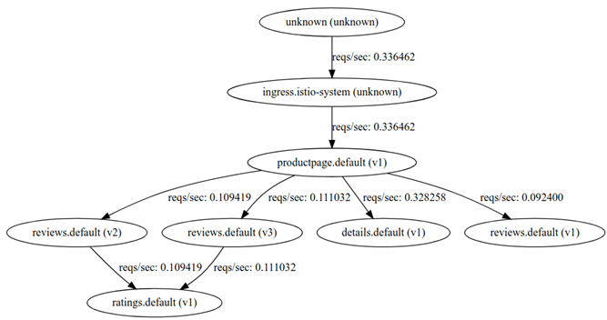

For more details, see [About the ServiceGraph Add-on](https://istio.io/docs/tasks/telemetry/servicegraph/#about-the-servicegraph-add-on).

**Tracing**

Set up a tunnel to the tracing dashboard:

$ kubectl port-forward -n istio-system $(kubectl get pod -n istio-system -l app=jaeger -o jsonpath='{.items[0].metadata.name}') 16686:16686 &

You should see the trace statistics sent earlier on [http://localhost:16686](http://localhost:16686/)

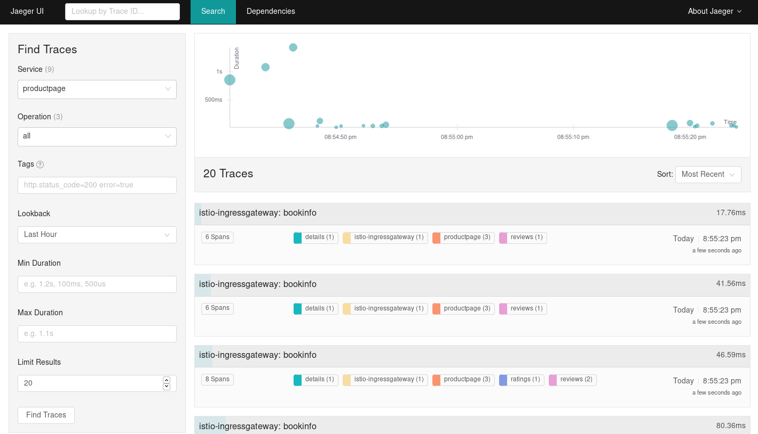

For more details on tracing see [Understanding what happened](https://istio.io/docs/tasks/telemetry/distributed-tracing/#understanding-what-happened).

**Uninstalling**

Navigate to the Deployments section of the Cloud Console at <https://console.cloud.google.com/deployments>

Select the deployment and click **Delete**.

Deployment Manager will remove all the deployed GKE artifacts - however, items such as Ingress and LoadBalancers will remain. You can delete those artifacts by again going to the cloud console under [**Network Services** -> **Load balancing**](https://console.cloud.google.com/net-services/loadbalancing/loadBalancers/list)

### Deploy Sample App – Book Info

<https://istio.io/docs/examples/bookinfo/>

Bookinfo Application

This example deploys a sample application composed of four separate microservices used to demonstrate various Istio features. The application displays information about a book, similar to a single catalog entry of an online book store. Displayed on the page is a description of the book, book details (ISBN, number of pages, and so on), and a few book reviews.

The Bookinfo application is broken into four separate microservices:

* productpage. The productpage microservice calls the details and reviews microservices to populate the page.
* details. The details microservice contains book information.
* reviews. The reviews microservice contains book reviews. It also calls the ratings microservice.
* ratings. The ratings microservice contains book ranking information that accompanies a book review.

There are 3 versions of the reviews microservice:

* Version v1 doesn’t call the ratings service.
* Version v2 calls the ratings service, and displays each rating as 1 to 5 black stars.
* Version v3 calls the ratings service, and displays each rating as 1 to 5 red stars.

The end-to-end architecture of the application is shown below.

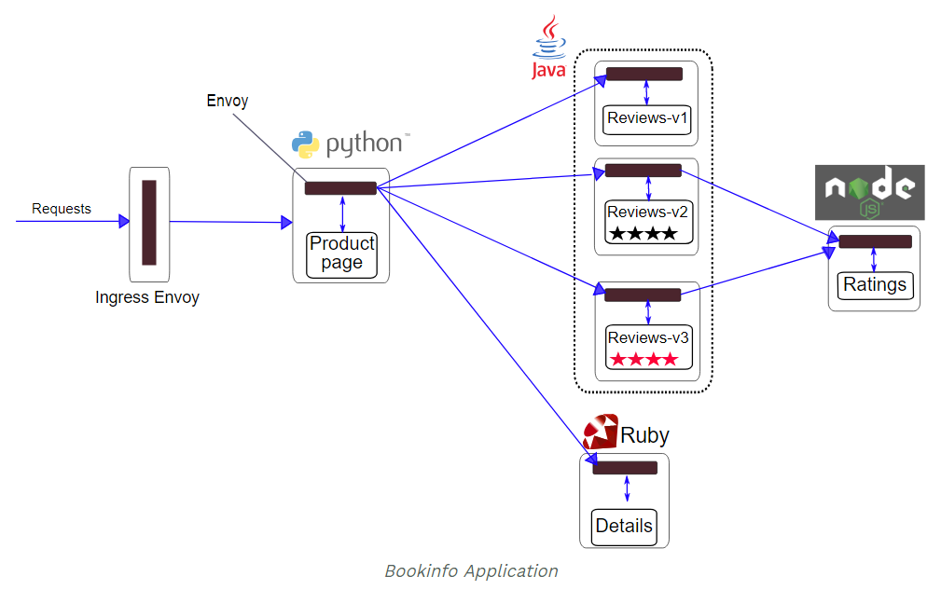

This application is polyglot, i.e., the microservices are written in different languages. It’s worth noting that these services have no dependencies on Istio, but make an interesting service mesh example, particularly because of the multitude of services, languages and versions for the reviews service.

**Before you begin**

If you haven’t already done so, setup Istio by following the instructions corresponding to your platform [installation guide](https://istio.io/docs/setup/).

**Deploying the application**

To run the sample with Istio requires no changes to the application itself. Instead, we simply need to configure and run the services in an Istio-enabled environment, with Envoy sidecars injected along side each service. The needed commands and configuration vary depending on the runtime environment although in all cases the resulting deployment will look like this:

All of the microservices will be packaged with an Envoy sidecar that intercepts incoming and outgoing calls for the services, providing the hooks needed to externally control, via the Istio control plane, routing, telemetry collection, and policy enforcement for the application as a whole.

To start the application, follow the instructions corresponding to your Istio runtime environment.

[If you are running on Kubernetes](https://istio.io/docs/examples/bookinfo/#if-you-are-running-on-kubernetes)

[If you are running on Docker with Consul](https://istio.io/docs/examples/bookinfo/#if-you-are-running-on-docker-with-consul)

**If you are running on Kubernetes**

If you use GKE, please ensure your cluster has at least 4 standard GKE nodes. If you use Minikube, please ensure you have at least 4GB RAM.

* Change directory to the root of the Istio installation directory.
* Bring up the application containers:

If you are using [manual sidecar injection](https://istio.io/docs/setup/kubernetes/sidecar-injection/#manual-sidecar-injection), use the following command

$ kubectl apply -f <(istioctl kube-inject -f

[samples/bookinfo/platform/kube/bookinfo.yaml](https://raw.githubusercontent.com/istio/istio/release-1.0/samples/bookinfo/platform/kube/bookinfo.yaml)

The istioctl kube-inject command is used to manually modify the bookinfo.yaml file before creating the deployments as documented [here](https://istio.io/docs/reference/commands/istioctl/#istioctl-kube-inject).

If you are using a cluster with [automatic sidecar injection](https://istio.io/docs/setup/kubernetes/sidecar-injection/#automatic-sidecar-injection) enabled, label the default namespace with istio-injection=enabled

$ kubectl label namespace default istio-injection=enabled

Then simply deploy the services using kubectl

$ kubectl apply -f [samples/bookinfo/platform/kube/bookinfo.yaml](https://raw.githubusercontent.com/istio/istio/release-1.0/samples/bookinfo/platform/kube/bookinfo.yaml)

Either of the above commands launches all four microservices as illustrated in the above diagram. All 3 versions of the reviews service, v1, v2, and v3, are started.

In a realistic deployment, new versions of a microservice are deployed over time instead of deploying all versions simultaneously.

Confirm all services and pods are correctly defined and running:

$ kubectl get services

*NAME CLUSTER-IP EXTERNAL-IP PORT(S) AGE*

*details 10.0.0.31 <none> 9080/TCP 6m*

*kubernetes 10.0.0.1 <none> 443/TCP 7d*

*productpage 10.0.0.120 <none> 9080/TCP 6m*

*ratings 10.0.0.15 <none> 9080/TCP 6m*

*reviews 10.0.0.170 <none> 9080/TCP 6m*

and

$ kubectl get pods

*NAME READY STATUS RESTARTS AGE*

*details-v1-1520924117-48z17 2/2 Running 0 6m*

*productpage-v1-560495357-jk1lz 2/2 Running 0 6m*

*ratings-v1-734492171-rnr5l 2/2 Running 0 6m*

*reviews-v1-874083890-f0qf0 2/2 Running 0 6m*

*reviews-v2-1343845940-b34q5 2/2 Running 0 6m*

*reviews-v3-1813607990-8ch52 2/2 Running 0 6m*

**Determining the ingress IP and port**

Now that the Bookinfo services are up and running, you need to make the application accessible from outside of your Kubernetes cluster, e.g., from a browser. An [Istio Gateway](https://istio.io/docs/concepts/traffic-management/#gateways) is used for this purpose.

Define the ingress gateway for the application:

$ kubectl apply -f [samples/bookinfo/networking/bookinfo-gateway.yaml](https://raw.githubusercontent.com/istio/istio/release-1.0/samples/bookinfo/networking/bookinfo-gateway.yaml)

Confirm the gateway has been created:

$ kubectl get gateway

*NAME AGE*

*bookinfo-gateway 32s*

Follow [these instructions](https://istio.io/docs/tasks/traffic-management/ingress/#determining-the-ingress-ip-and-ports) to set the INGRESS_HOST and INGRESS_PORT variables for accessing the gateway. Return here, when they are set.

Set GATEWAY_URL:

$ export GATEWAY_URL=$INGRESS_HOST:$INGRESS_PORT

Proceed to [Confirm the app is running](https://istio.io/docs/examples/bookinfo/#confirm-the-app-is-running), below.

Confirm the app is running

To confirm that the Bookinfo application is running, run the following curl command:

$ curl -o /dev/null -s -w "%{http_code}\n" http://${GATEWAY_URL}/productpage

*200*

You can also point your browser to http://$GATEWAY_URL/productpage to view the Bookinfo web page. If you refresh the page several times, you should see different versions of reviews shown in productpage, presented in a round robin style (red stars, black stars, no stars), since we haven’t yet used Istio to control the version routing.

Apply default destination rules

Before you can use Istio to control the Bookinfo version routing, you need to define the available versions, called subsets, in destination rules.

Run the following command to create default destination rules for the Bookinfo services:

If you did **not** enable mutual TLS, execute this command:

$ kubectl apply -f [samples/bookinfo/networking/destination-rule-all.yaml](https://raw.githubusercontent.com/istio/istio/release-1.0/samples/bookinfo/networking/destination-rule-all.yaml)

If you **did** enable mutual TLS, execute this command:

$ kubectl apply -f [samples/bookinfo/networking/destination-rule-all-mtls.yaml](https://raw.githubusercontent.com/istio/istio/release-1.0/samples/bookinfo/networking/destination-rule-all-mtls.yaml)

Wait a few seconds for the destination rules to propagate.

You can display the destination rules with the following command:

$ kubectl get destinationrules -o yaml

What’s next

You can now use this sample to experiment with Istio’s features for traffic routing, fault injection, rate limiting, etc. To proceed, refer to one or more of the [Istio Examples](https://istio.io/docs/examples), depending on your interest. [Intelligent Routing](https://istio.io/docs/examples/intelligent-routing/) is a good place to start for beginners.

Cleanup

When you’re finished experimenting with the Bookinfo sample, uninstall and clean it up using the following instructions corresponding to your Istio runtime environment.

**Uninstall from Kubernetes environment**

Delete the routing rules and terminate the application pods

$ [samples/bookinfo/platform/kube/cleanup.sh](https://raw.githubusercontent.com/istio/istio/release-1.0/samples/bookinfo/platform/kube/cleanup.sh)

Confirm shutdown

$ kubectl get virtualservices #-- there should be no virtual services

$ kubectl get destinationrules #-- there should be no destination rules

$ kubectl get gateway #-- there should be no gateway

$ kubectl get pods #-- the Bookinfo pods should be deleted